Burns Night

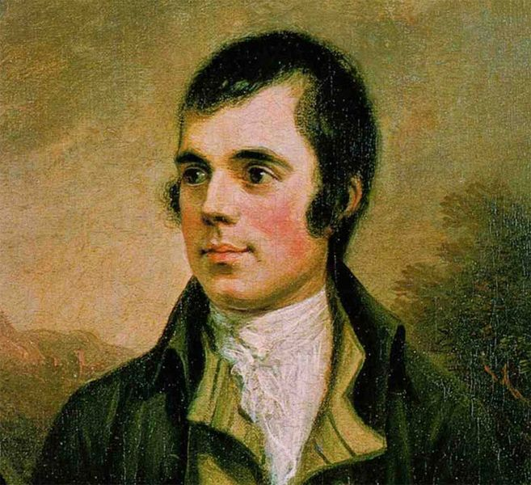
Portrait of Robert Burns, 1787 ¹
About this topic – Learn about the traditions associated with Burns Night and test your memory and knowledge with a quiz and games

Resources for this topic
- Suggested session plan
- Burns Night Facts
- Burns Night Quiz and Answers
- January Word Game
- Burns Night Word Search and Answers

We are happy for you to use the material in this Toolkit exactly as it is or to modify it as required for your purposes. We do however ask that you always acknowledge its source as follows:

“Learning and Sharing Together” Resources (2020)
With thanks to Burnham Health Promotion Trust
Reg. Charity No.1066070 & Reg. Company No.3435602
www.bhpt.org.uk

You may not redistribute, sell or place any part of this Toolkit on any other website or blog without written agreement. Please Contact Us to discuss

Suggested session plan (one and a half hours approx.)
Whilst the plan below has been developed for face to face meetings, all the activities can be used in Virtual meetings too, using the shared screen facility on Zoom for example, and break out rooms for some activities.
- Welcome and introductions
- Working in small groups the children and older people should take turns to read aloud Burns Night Facts. Encourage them to discuss what they have read as there will be a quiz later

- Give out January Word Game to groups as they finish 2)
- When all the groups have finished 2) collect in Burns Night Facts and hand out Burns Night Quiz

- As groups finish the Quiz, they should continue with the January Word Game.

- Go through the Burns Night Quiz Answers when all the groups have finished the Quiz

- Refreshments and Answers to January Word Game

- Thankyous and goodbyes - Before the children and older people leave you may wish to say something about the topic or activity you have planned for the next session. This gives everyone the opportunity to be more prepared and, if appropriate, to bring photographs or other memorabilia

Additional activity if required: Burns Night Word Search

Burns Night
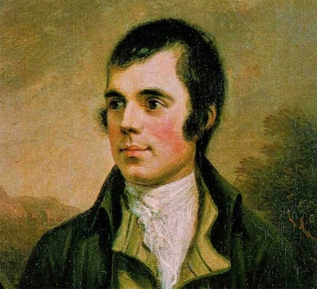
Portrait of Robert Burns, 1787 ¹
25th January is Burns Night when celebrations are held around the world to honour the memory of Robert Burns who is widely regarded as the national poet of Scotland. Robert Burns was born on 25th January 1759 and died just 37 years later on 21st July 1796.
Burns Suppers come in all shapes and sizes, from formal affairs in grand surroundings to smaller, relaxed gatherings in local clubs and pubs. Often guests wear something tartan, perhaps a kilt or a scarf or tie.

Burns Night Menu

The meal traditionally begins with a soup course which could be Scotch broth or cock-a-leekie soup.

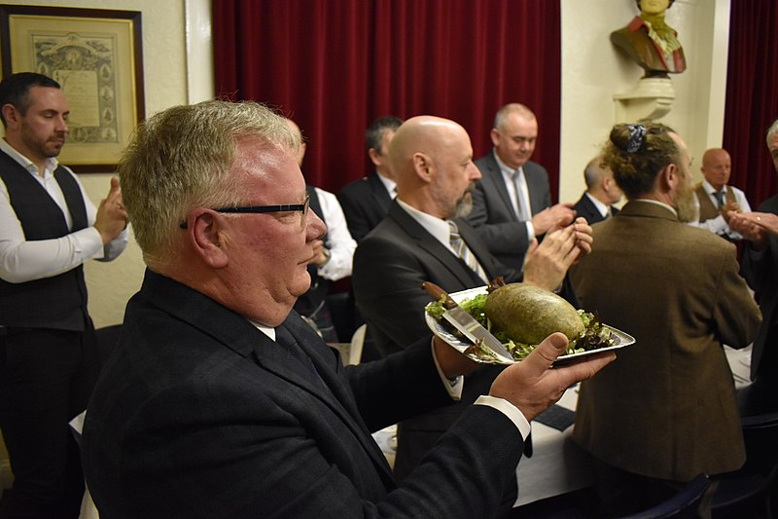
Everyone then stands as the haggis is carried in usually accompanied by a piper playing the bagpipes. The host, or a guest, then recites Burns’s poem, “Address to a Haggis”.

During the reading of this poem the haggis is traditionally stabbed and cut open from end to end.

Burns himself described haggis as the 'great chieftain o' the puddin'-race'.

A haggis being brought in at Dundee Burns Club's 160th annual Burns Supper on 25 January 2020 ²
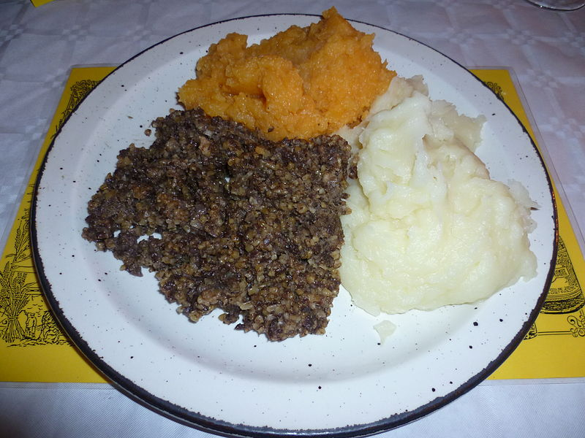
Haggis is made by stuffing a sheep’s or cow’s stomach with offal (e.g. liver and kidneys), oatmeal and an assortment of spices.
Traditional accompaniments are neeps (turnips) and tatties (potatoes), both of which are normally served mashed. A vegetarian version of haggis is also available.
Haggis served with tatties and neeps at an Edinburgh Burns Supper in 2012 ³
Traditional puddings at a Burns Supper could include a Clootie Dumpling which is a type of suet pudding or a classic Cranachan made with raspberries and oatmeal and cream. Whisky is the traditional drink at Burns Night suppers. During the evening there are generally speeches and there may be recitals of some more of Burns’ poems such as the “Selkirk Grace” and “To a Louse”. The evening ends with a rousing chorus of 'Auld Lang Syne' which was written as a poem by Robert Burns in 1788 and set to the tune of a traditional folk song.

Auld Lang Syne'
"Should auld acquaintance be forgot,
And never brought to mind?
Should auld acquaintance be forgot,
And auld lang syne!"
For auld lang syne, my dear
for auld lang syne
We’ll take a cup of kindness yet
For auld lang syne
These are the first four lines and chorus of the English version of 'Auld Lang Syne'. They are amongst the most frequently sung lines in the English language and are associated particularly with New Year celebrations.
With thanks to https://en.wikipedia.org/wiki/Auld_Lang_Syne

The Scottish flag is often displayed at Burns Night celebrations. It is known as the Saltire and consists of a rectangular blue background with thick white bars on the diagonals. The diagonals form a cross that represents Saint Andrew, the patron saint of Scotland.
Burns’ Poems
As well as writing many original poems, Burns also collected folk songs from across Scotland, often revising or adapting them. For example Auld Lang Syne was most likely based on an earlier ballad by James Watson. Here are some extracts from a few of Burns’ best known poems:

'My Love is Like a Red, Red Rose' – This was Burns' most famous love poem written in 1794.
"Oh, my luve's like a red, red rose, That's newly sprung in June;
Oh, my luve's like the melodie, That's sweetly played in tune."

'To a Louse'
“Oh wad some power the giftie gie us, To see oursel's as others see us! It wad frae monie a blunder free us, And foolish notion.”
These are the final lines from another famous poem 'To A Louse'. The story behind the poem is that the poet had spotted a well to do lady in church who had not noticed that there was a louse roaming around in her bonnet. The morale of this poem is that we would all lose our pretensions about ourselves if we were to see ourselves through each other’s eyes.

'To a Mouse'
"The best laid schemes o' mice and men
Gang aft a-gley; (go oft askew)
And leave us naught but grief and pain,
For promised joy."
These famous lines are said to have inspired the title of John Steinbeck's 1937 classic novel 'Of Mice and Men'.
With thanks to https://en.wikipedia.org/wiki for information on Burns
Night and Burns’ poems
With thanks to Wikipedia for images and photos
¹ Portrait of Robert Burns, 1787 https://commons.wikimedia.org/wiki/File:PG_1063Burns_Naysmithcrop.jpg
Portrait of Robert Burns by Alexander Nasmyth/Public domain

² A haggis being brought in at Dundee Burns Club's 160th annual Burns Supper on 25 January 2020 ² https://commons.wikimedia.org/wiki/File:Bringing_in_the_haggis.jpg

Connor Beaton / CC BY-SA https://creativecommons.org/licenses/by-sa/4.0

³ Haggis served with tatties and neeps at an Edinburgh Burns Supper in 2012 https://commons.wikimedia.org/wiki/File:A_haggis_serving.JPG
Kim Traynor / CC BY-SA https://creativecommons.org/licenses/by-sa/3.0

Burns Night Quiz (15 possible points)
- When is Burns Night celebrated? 1 point
- In which year did Robert Burns die and how old was he? 2 points

- Name two of the ingredients found in a traditional haggis. 2 points
- What vegetables are normally served with haggis? 2 points
- What is the traditional drink at Burns Night suppers? 1 point
- What is a Clootie dumpling? 1 point
- What musical instrument is traditionally played on Burns Night? 1 point
- What is the second line of Auld Lang Syne? 1 point

- Which poem is traditionally read out before people start eating at Burns Night Suppers? 1 point
- Which month is mentioned in the poem “My love is like a red, red rose”?
1 point

- What is the name of the flag which is traditionally displayed on Burns Night? 1 point

- Who is the Patron Saint of Scotland? 1 point

Burns Night Quiz with answers (15 possible points)
- When is Burns Night celebrated? 1 point
25th January
- In which year did Robert Burns die and how old was he? 2 points
1796 age 37
- Name two of the ingredients found in a traditional haggis? 2 points
offal (e.g. liver and kidneys), oatmeal, assortment of spices

- What vegetables are normally served with haggis? 2 points
Turnips (neeps) and potatoes (tatties)
- What is the traditional drink at Burns Night suppers? 1 point
Whisky
- What is a Clootie dumpling? 1 point
Type of suet pudding
- What musical instrument is traditionally played on Burns Night? 1 point
Bagpipes
- What is the second line of Auld Lang Syne? 1 point
And never brought to mind

- Which poem is traditionally read out before people start eating at Burns Night Suppers? 1 point
“Address to a Haggis”

- Which month is mentioned in the poem “My love is like a red, red rose”?
1 point
June

- What is the name of the flag which is traditionally displayed on Burns Night? 1 point
The Saltire

- Who is the Patron Saint of Scotland? 1 point
St Andrew
January Word Game
In your groups try and think of a word for each category and for each letter of the word January e.g. Something you find in a kitchen beginning with J could be Jam.
Try and think of unusual words because you will only get a point if no one else has the same word.

 | Animal or Bird | Something you find  in a school | Something you find in a kitchen | Total
J
A
N
U
A
R
Y

Burns Night Word Search
Can you find these 12 words related to Burns Night ? They may be going forwards or backwards in a horizontal, vertical or diagonal direction.
Auld Lang Syne Dumpling Neeps Robert Kilt Saltire
Cranachan Whisky Bagpipes Tartan Tatties Haggis
G | N | I | L | P | M | U | D | Z | T | A | T | T | I | E | S | Z
S | L | I | S | I | G | G | A | H | X | M | D | T | U | R | E | K
G | U | G | P | R | W | O | G | N | S | K | X | O | W | W | N | S
M | N | S | A | L | T | I | R | E | T | G | A | W | J | O | L | G
I | E | Q | U | N | L | H | K | G | N | A | Y | K | S | I | H | W
C | E | N | F | F | V | O | L | X | O | Q | P | G | H | G | E | Y
C | P | S | Y | V | P | E | J | H | Z | U | K | T | P | L | C | X
I | S | M | C | S | Z | U | C | W | K | K | G | M | D | O | T | N
U | H | G | H | D | G | P | Y | I | W | E | E | F | D | F | M | N
G | I | S | L | E | I | N | H | O | P | T | S | X | T | U | A | B
K | E | P | E | Y | H | K | A | I | T | T | M | A | G | H | M | K
O | E | S | O | P | M | S | M | L | R | L | R | B | C | P | T | F
K | K | W | T | V | I | H | P | E | D | T | I | A | J | U | S | H
I | W | H | V | G | Q | P | B | F | A | L | N | K | L | B | L | A
D | K | W | W | Y | A | O | G | N | O | A | U | B | Y | N | I | Q
O | D | Z | E | U | R | U | P | A | R | O | F | A | G | Z | Z | X
W | C | T | H | N | Q | O | W | C | B | E | T | Y | U | V | W | K

Burns Night Word Search Answers
Auld Lang Syne Dumpling Neeps Robert Kilt Saltire
Cranachan Whisky Bagpipes Tartan Tatties Haggis
G | N | I | L | P | M | U | D | Z | T | A | T | T | I | E | S | Z
S | L | I | S | I | G | G | A | H | X | M | D | T | U | R | E | K
G | U | G | P | R | W | O | G | N | S | K | X | O | W | W | N | S
M | N | S | A | L | T | I | R | E | T | G | A | W | J | O | L | G
I | E | Q | U | N | L | H | K | G | N | A | Y | K | S | I | H | W
C | E | N | F | F | V | O | L | X | O | Q | P | G | H | G | E | Y
C | P | S | Y | V | P | E | J | H | Z | U | K | T | P | L | C | X
I | S | M | C | S | Z | U | C | W | K | K | G | M | D | O | T | N
U | H | G | H | D | G | P | Y | I | W | E | E | F | D | F | M | N
G | I | S | L | E | I | N | H | O | P | T | S | X | T | U | A | B
K | E | P | E | Y | H | K | A | I | T | T | M | A | G | H | M | K
O | E | S | O | P | M | S | M | L | R | L | R | B | C | P | T | F
K | K | W | T | V | I | H | P | E | D | T | I | A | J | U | S | H
I | W | H | V | G | Q | P | B | F | A | L | N | K | L | B | L | A
D | K | W | W | Y | A | O | G | N | O | A | U | B | Y | N | I | Q
O | D | Z | E | U | R | U | P | A | R | O | F | A | G | Z | Z | X
W | C | T | H | N | Q | O | W | C | B | E | T | Y | U | V | W | K

