Chinese New Year

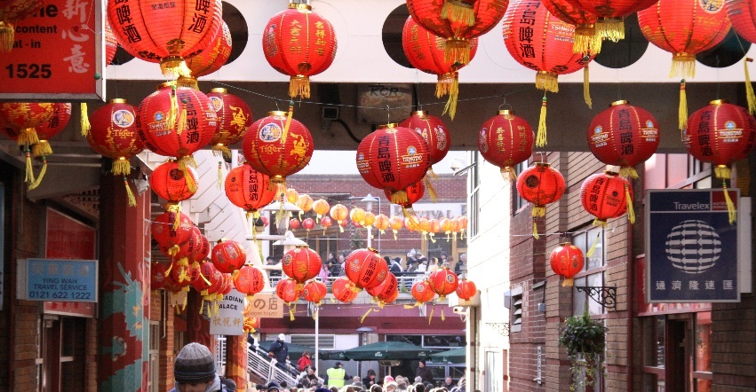
Chinese New Year street scene ¹
About this topic – Learn about the traditions and beliefs associated with this time of year, test your memory with a quiz and game and have fun with animals!
Resources for this topic
- Suggested session plan
- Chinese New Year Traditions and Beliefs
- Chinese New Year Traditions and Beliefs Quiz and Answers
- Animals of the Chinese Zodiac
- Chinese New Year Dates
- Chinese New Year Word Scramble and Answers
We are happy for you to use the material in this Toolkit exactly as it is or to modify it as required for your purposes. We do however ask that you always acknowledge its source as follows:
“Learning and Sharing Together” Resources (2020)
With thanks to Burnham Health Promotion Trust
Reg. Charity No.1066070 & Reg. Company No.3435602
www.bhpt.org.uk
You may not redistribute, sell or place any part of this Toolkit on any other website or blog without written agreement. Please Contact Us to discuss
Suggested session plan (one and a half hours approx.)
Whilst the plan below has been developed for face to face meetings, all the activities can be used in Virtual meetings too, using the shared screen facility on Zoom for example, and break out rooms for some activities.
- Welcome and introductions

- Working in small groups the children and older people should take turns to read aloud Chinese New Year Traditions and Beliefs. Encourage them to discuss what they have read as there will be a quiz later
- As groups finish reading the Chinese New Year Traditions and Beliefs hand out the “Chinese New Year dates” and “Animals of the Chinese Zodiac” for them to read and discuss in their groups. Ask everyone to identify which animal is associated with their year of birth
- When all the groups have finished 2) collect in Chinese New Year Traditions and Beliefs and hand out Chinese New Year Quiz
- As groups finish Quiz, they should continue looking at the “Chinese New Year dates” and “Animals of the Chinese Zodiac”. Hand out Chinese New Year Word Scramble to groups when they have finished the Quiz and have identified which animal is associated with their year of birth
- Go through the Quiz Answers when all the groups have finished the Quiz
- Refreshments. During refreshments check that everyone has identified which animal is associated with their year of birth. Count how many different “animals” there are in the room. Do people recognise themselves and/or one another in the descriptions?
- Drawings – If there is time encourage everyone to draw a picture of the animal associated with the year of their birth and add a greeting
- Thankyous and goodbyes – Before the children and older people leave you may wish to say something about the topic or activity you have planned for the next session. This gives everyone the opportunity to be more prepared and, if appropriate, to bring photographs or other memorabilia
Chinese New Year Traditions and Beliefs
New Year Celebrations
Chinese New Year, also known as Spring Festival or Lunar New Year, is one of the most important holidays in China with many people having at least seven days off work to celebrate. Unlike the universal New Year observed on January 1st, Chinese New Year is not on a fixed date. The date varies according to the Chinese lunar calendar, but usually falls on a day between January 21st and February 20th.
To celebrate the Chinese New Year many streets are decorated with red lanterns and houses are traditionally decorated with Spring Festival couplets.

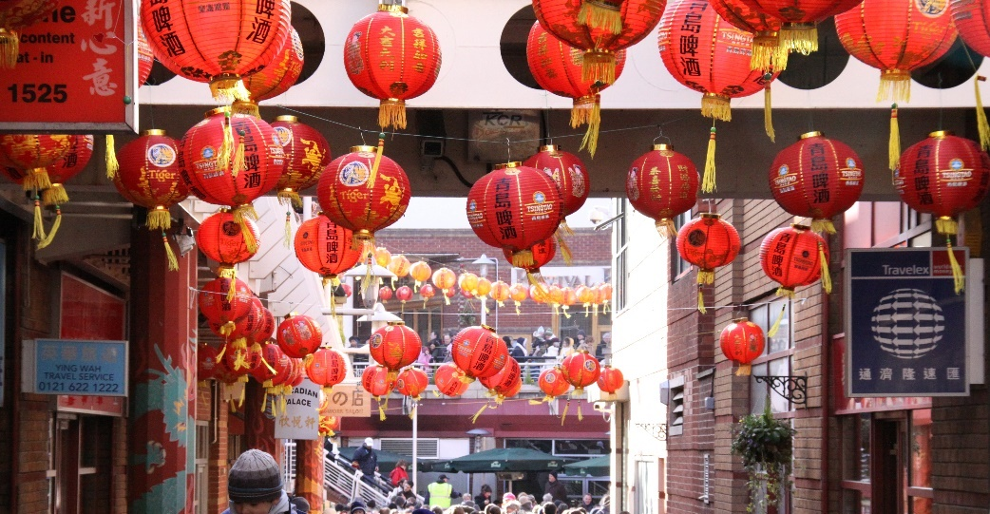

Chinese New Year street scene ¹

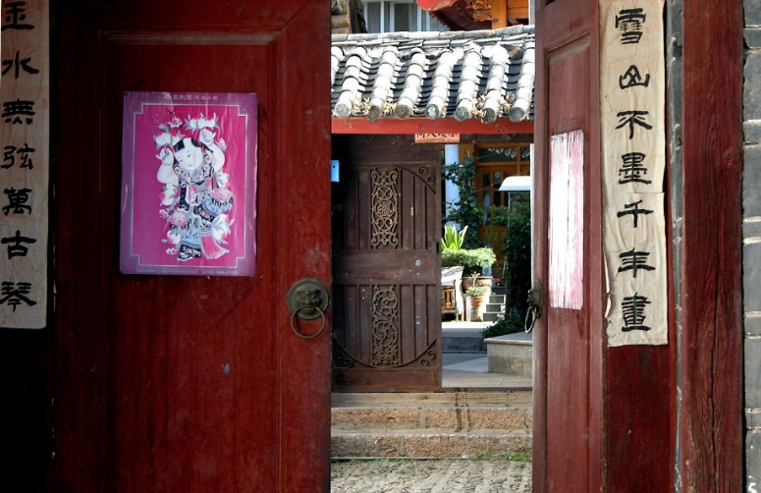
A couplet is a two line poem. It is an ancient Chinese tradition to paste Spring Festival couplets around doorways. People do this to express their feelings of life’s renewal and the return of spring and to convey their wishes for peace, fortune and good luck in the new year.

Hand written Chinese New Year poetry around doorways leading to people’s houses, Old Town, Lijiang, Yunnan, China ²
Many people also dress in red at New Year. In Chinese culture the colour red is associated with happiness and prosperity and it is believed it can ward off evil spirits and bring good luck.

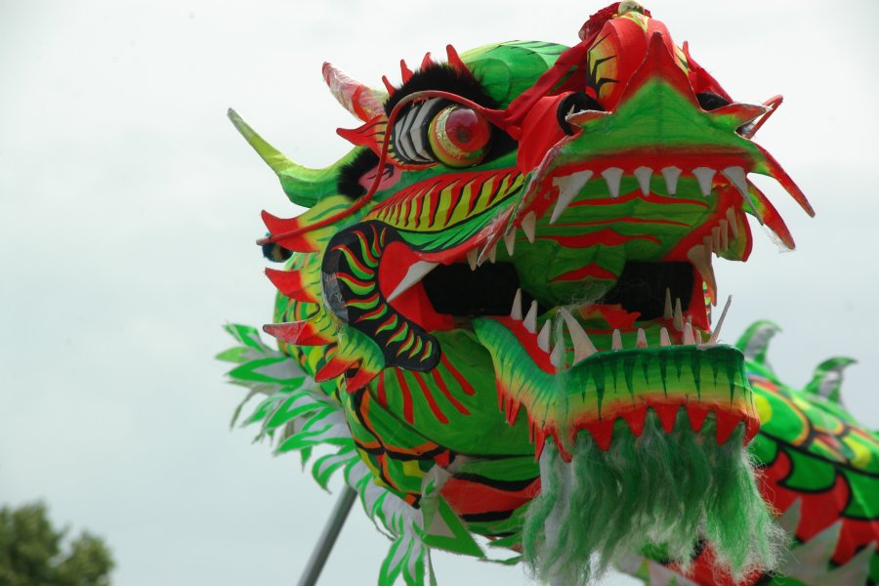
Another New Year tradition is to parade an ornamental dragon through the streets often accompanied by drumming. The dragon represents wisdom, strength, benevolence and good fortune.
It is believed that the loud beats of the drum and the deafening sounds of the cymbals together with the aggressive face of the dragon can evict bad or evil spirits.

A Chinese dragon in a dragon-dance for Chinese New Year 2000 ³

The biggest event of any Chinese New Year's Eve is the annual reunion dinner when family members get together to celebrate. A popular food, often eaten at midnight on New Year’s Eve is jiaozi, or dumplings. These typically consist of a ground meat and/or vegetable filling wrapped into a thinly rolled piece of dough, which is then sealed by pressing the edges together. Finished jiaozi can be boiled, steamed or pan-fried and are traditionally served with a black vinegar and sesame oil dip. They can also be served with soup.
Serving jiaozi is believed to bring prosperity because their shape resembles the silver or gold ingots which were traditionally used as currency in China. Often a coin will be hidden in one of the dumplings and it is thought to be lucky if you find the coin.
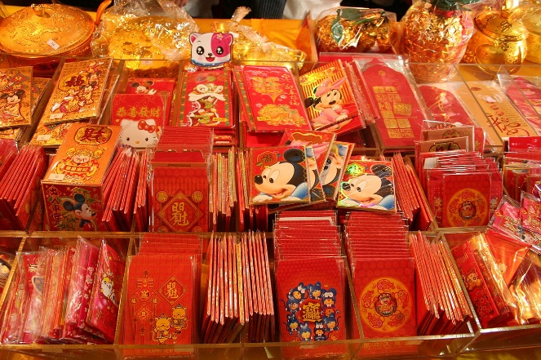
After dinner, some families go to local temples to pray for a prosperous new year by lighting the first incense of the year. Many households hold parties including a countdown to the new year. Traditionally, firecrackers were lit to scare away evil spirits with the household doors sealed, not to be reopened until the new morning in a ritual called "opening the door of fortune."
On New Year’s Eve or early on New Year’s Day it is traditional for children to be given lucky red packets called ‘Hong Bao’ containing sweets or money. They usually receive them from their parents or grandparents but it is considered rude to open the envelopes in front of the person who has given it.
A display of Hong Bao or red packets for sale ⁴

New Year Greetings

“Guo Nian Hao” is one of the most popular New Year greetings and means “Happy New Year”. Here some other New Year greetings:

“Gong hey fat choi” or“ Kung Hei Fat Choy” - “Congratulations and be prosperous"

“Dàzhǎnhóngtú” – "May you realize your ambitions"

“Jíqìngyǒuyú” – "May your happiness be without limit"

“Jīnyùmǎntáng” – "May your wealth [gold and jade] come to fill a hall"

“Jīlíng huópō” - “A bright and lively spirit” (especially used for children aged
under 10, wishing them to be active and smart)
The Chinese Calendar
In western astrology each year is divided into 12 periods with a different sign of the Zodiac for each e.g. Aquarius and Pisces. By comparison the Chinese Zodiac is based on a twelve-year cycle, with each year in that cycle represented by an animal. These animals in order are the rat, ox, tiger, rabbit, dragon, snake, horse, goat, monkey, rooster, dog and pig. There are several legends about how the animals were chosen for the Chinese Zodiac. Here is one of them.

Long ago, in China, the Jade Emperor decided there should be a way of measuring time. On his birthday he told the animals that there was to be a swimming race. The first twelve animals to get across the fast flowing river would be the winners and they would each have a year of the Zodiac named after them. The rat was the first animal to reach the other side of the river and so the first year of the Zodiac became the Year of the Rat.
With thanks to

Mandy Barrow http://www.projectbritain.com/calendar/january/chinese.html
https://en.wikipedia.org/wiki/Chinese_New_Year
https://en.wikipedia.org/wiki/Jiaozi
https://en.wikipedia.org/wiki/Chinese_New_Year#Greetings
for information

With thanks to Wikipedia for photos

¹ Chinese New Year Street scene
https://commons.wikimedia.org/wiki/File:Chinese_New_Year.jpg

Flickr user: ahisgett / CC BY https://creativecommons.org/licenses/by/2.0

² Hand written Chinese New Year poetry around doorways leading to people’s houses, Old Town, Lijiang, Yunnan, China https://commons.wikimedia.org/wiki/File:Chinese_New_Year%27s_poetry.jpg#/media/File:Chinese_New_Year's_poetry.jpg

Peter Morgan from Beijing, China/CC BY https://creativecommons.org/licenses/by/2.0

³ Chinese dragon
https://en.wikipedia.org/wiki/Dragon_dance#/media/File:Chinese_draak.jpg
Caseman / Public domain

⁴ A display of Hong Bao or red packets for sale https://commons.wikimedia.org/wiki/File:DihuaMarketRat.jpg
BCody80 / Public domain

Chinese New Year Quiz (20 possible points)

- What other two names are there for Chinese New Year? 2 points

- Between which dates does Chinese New Year usually fall? 2 points

- How much time do most Chinese people have off work at New Year? 1 point

- How are streets decorated at New Year? 1 point
- How do many people decorate their doorways at New Year? 1 point

- What three things do people often wish for in the coming year? 3 points

- Why is the colour red so popular at New Year? Up to 4 points

- What do people hope to find when eating ‘jiaozi’ at New Year? 1 point

- What do Chinese children receive on New Year’s Day? 2 points

- What do the following Chinese greetings mean in English? 3 points
“Guo Nian Hao”
“Gong hey fat choi” or “Kung Hei Fat Choy”
“Jīlíng huópō”

Chinese New Year Quiz Answers 20 possible points if full answers given

- What other two names are there for Chinese New Year? 2 points
Spring Festival or Lunar New Year

- Between which dates does Chinese New Year usually fall? 2 points
January 21st and February 20th

- How much time do most Chinese people have off work at New Year?
1 point
at least 7 days
- How are streets decorated at New Year? 1 point
With red lanterns
- How do people decorate their doorways at New Year? 1 point
They paste Spring Festival couplets around them

- What three things do people often wish for in the coming year? 3 points
Peace, fortune and good luck
- Why is the colour red so popular at New Year? Up to 4 points
Red is the symbol of happiness and prosperity and it is believed it can ward off evil spirits and bring good luck.

- What do people hope to find when eating ‘jiaozi’ at New Year? 1 point
Coins

- What do Chinese children receive on New Year’s Day? Up to 2 points
Lucky red packets called ‘Hong Bao’ containing money and/or sweets

- What do the following Chinese greetings mean in English? 3 points
Guo Nian Hao - Happy New Year
Gong hey fat choi or Kung Hei Fat Choy - Congratulations and be prosperous
Jīlíng huópō - A bright and lively spirit

The Animals of the Chinese Zodiac
The year when a person was born is called his or her “Ben Ming Nian” which translates as Zodiac Year of Birth. Traditionally people believe that people born in a particular year will have some of the characteristics of the animal associated with that year. Here are some of the characteristics that are thought to be associated with each of the twelve animals of the Chinese Zodiac. From the list of Chinese New Year dates find which animal is associated with your birth year. Do you think this description is right for you? Would your family and friends agree?
Rats: honest, hardworking and charming | 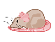
Oxen: calm, modest and patient | 
Tigers: strong, daring, generous | 
Rabbits: kind, sensitive, artistic | 
Dragons: strong , proud, direct | 
Snakes: wise, graceful, calm | 
Horses: cheerful, popular, responsible | 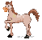
Goats: honest, artistic, understanding | 
Monkeys: witty, curious, sociable | 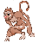
Roosters: organised, alert, responsible | 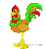
Dogs: honest, loyal, affectionate | 
Pigs: peace loving, hardworking, strong | 
With thanks to https://simple.wikipedia.org/wiki/Chinese_Zodiac for information and to Mandy Barrow http://www.projectbritain.com/calendar/january/chinese.html for illustrations

Chinese New Year dates 1920 – 2021
Find the year of your birth and the animal associated with it.
(For example in 1920 Chinese New Year began on 20th February so anyone born from 20th February 1920 to 7th February 1921 was born in the Year of the Monkey)
1920 - Feb. 20 | Monkey |  | 1955 - Jan. 24 | Goat
1921 - Feb. 08 | Rooster |  | 1956 - Feb. 12 | Monkey
1922 - Jan. 28 | Dog |  | 1957 - Jan. 31 | Rooster
1923 - Feb. 16 | Pig |  | 1958 - Feb. 18 | Dog
1924 - Feb. 05 | Rat |  | 1959 - Feb. 08 | Pig
1925 - Jan. 25 | Ox |  | 1960 - Jan. 28 | Rat
1926 - Feb. 13 | Tiger |  | 1961 - Feb. 15 | Ox
1927 - Feb. 02 | Rabbit |  | 1962 - Feb. 05 | Tiger
1928 - Jan. 23 | Dragon |  | 1963 - Jan. 25 | Rabbit
1929 - Feb. 10 | Snake |  | 1964 - Feb. 13 | Dragon
1930 - Jan. 30 | Horse |  | 1965 - Feb. 02 | Snake
1931 - Feb. 17 | Goat |  | 1966 - Jan. 21 | Horse
1932 - Feb. 06 | Monkey |  | 1967 - Feb. 09 | Goat
1933 - Jan. 26 | Rooster |  | 1968 - Jan. 30 | Monkey
1934 - Feb. 14 | Dog |  | 1969 - Feb. 17 | Rooster
1935 - Feb. 04 | Pig |  | 1970 - Feb. 06 | Dog
1936 - Jan. 24 | Rat |  | 1971 - Jan. 27 | Pig
1937 - Feb. 11 | Ox |  | 1972 - Feb. 15 | Rat
1938 - Jan. 31 | Tiger |  | 1973 - Feb. 03 | Ox
1939 - Feb. 19 | Rabbit |  | 1974 - Jan. 23 | Tiger
1940 - Feb. 08 | Dragon |  | 1975 - Feb. 11 | Rabbit
1941 - Jan. 27 | Snake |  | 1976 - Jan. 31 | Dragon
1942 - Feb. 15 | Horse |  | 1977 - Feb. 18 | Snake
1943 - Feb. 05 | Goat |  | 1978 - Feb. 07 | Horse
1944 - Jan. 25 | Monkey |  | 1979 - Jan. 28 | Goat
1945 - Feb. 13 | Rooster |  | 1980 - Feb. 16 | Monkey
1946 - Feb. 02 | Dog |  | 1981 - Feb. 05 | Rooster
1947 - Jan. 22 | Pig |  | 1982 - Jan. 25 | Dog
1948 - Feb. 10 | Rat |  | 1983 - Feb. 13 | Pig
1949 - Jan. 29 | Ox |  | 1984 - Feb. 02 | Rat
1950 - Feb. 17 | Tiger |  | 1985 - Feb. 20 | Ox
1951 - Feb. 06 | Rabbit |  | 1986 - Feb. 09 | Tiger
1952 - Jan. 27 | Dragon |  | 1987 - Jan. 29 | Rabbit
1953 - Feb. 14 | Snake |  | 1988 - Feb. 17 | Dragon
1954 - Feb. 03 | Horse |  | 1989 - Feb. 06 | Snake
1990 - Jan. 27 | Horse
1991 - Feb. 15 | Goat
1992 - Feb. 04 | Monkey
1993 - Jan. 23 | Rooster
1994 - Feb. 10 | Dog
1995 - Jan. 31 | Pig
1996 - Feb. 19 | Rat
1997 - Feb. 07 | Ox
1998 - Jan. 28 | Tiger
1999 - Feb. 16 | Rabbit
2000 - Feb. 05 | Dragon
2001 - Jan. 24 | Snake
2002 - Feb. 12 | Horse
2003 - Feb. 01 | Goat
2004 - Jan. 22 | Monkey
2005 - Feb. 9 | Rooster
2006 - Jan. 29 | Dog
2007 - Feb. 18 | Pig
2008 - Feb. 7 | Rat
2009 - Jan. 26 | Ox
2010 - Feb. 14 | Tiger
2011 - Feb. 3 | Rabbit
2012 - Jan. 23 | Dragon
2013 - Feb. 10 | Snake
2014 - Jan. 31 | Horse
2015 - Feb. 19 | Goat
2016 - Feb. 8 | Monkey
2017 - Jan. 28 | Rooster
2018 - Feb. 16 | Dog
2019 - Feb. 5 | Pig
2020 – Jan. 25 | Rat
2021 – Feb 12 | Ox

Chinese New Year Word Scramble
Here are 15 words associated with Chinese New Year
but the letters have been mixed up
Can you unscramble them?
1. CELTOUSP __________________________________________
2. NTSAELNR __________________________________________
3. GPMLUDNSI _________________________________________
4. INLECSOEBTAR ______________________________________
5. WSESTE ____________________________________________
6. DOCZAI ____________________________________________
7. RCKEAEICSRRF ______________________________________
8. DROAGN ____________________________________________
9. REORISWFK _________________________________________
10. IOTTNAIDSR ________________________________________
11. ERREMOP ___________________________________________
12. GOU NNIA OAH ______________________________________
13. ISLAANM ___________________________________________
14. NPRIGS ASLVEIFT ___________________________________
15. ETEIGGSNR _________________________________________

Chinese New Year Word Scramble Answers
1. CELTOUSP Couplets
2. NTSAELNR Lanterns
3. GPMLUDNSI Dumplings
4. INLECSOEBTAR Celebrations
5. WSESTE Sweets
6. DOCZAI Zodiac
7. RCKEAEICSRRF Firecrackers
8. DROAGN Dragon
9. REORISWFK Fireworks
10. IOTTNAIDSR Traditions
11. ERREMOP Emperor
12. GOU NNIA OAH Guo Nian Hao
13. ISLAANM Animals
14. NPRIGS ASLVEIFT Spring Festival
15. ETEIGGSNR Greetings

Chinese New Year Additional Activity

Encourage everyone to draw the appropriate animal for this Chinese New Year and write a couplet
At Chinese New Year people traditionally decorate their houses with couplets
(2 line poems) to express their feelings of life’s renewal and the return of Spring and to convey their wishes for peace, fortune and good luck in the new year.

