Christmas Games and Songs

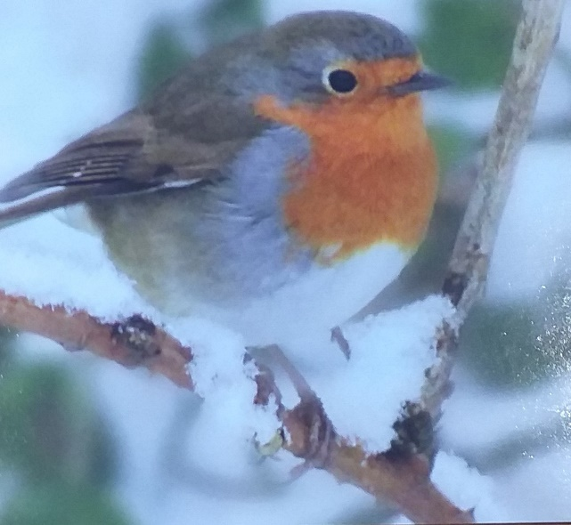
About this topic – Have fun playing some Christmas themed games and singing Christmas songs together
Resources for this topic
- Suggested session plan
- Christmas Drawing Game
- Christmas Songs Crossword and Answers
- Christmas Word Search and Answers
- Christmas Sing Song
- Alternative activities for virtual projects

We are happy for you to use the material in this Toolkit exactly as it is or to modify it as required for your purposes. We do however ask that you always acknowledge its source as follows:

“Learning and Sharing Together” Resources (2020)
With thanks to Burnham Health Promotion Trust
Reg. Charity No.1066070 & Reg. Company No.3435602
www.bhpt.org.uk

You may not redistribute, sell or place any part of this Toolkit on any other website or blog without written agreement. Please Contact Us to discuss
Suggested session plan (one and a half hours approx.)
The plan below has been developed for face to face meetings, and not all the activities would work so well in Virtual meetings. Instead of the Christmas Drawing game you could do a Christmas themed art or craft activity (see suggestions at end of this module). Instead of singing out loud together you could “mute” everyone and play Christmas songs which everyone could listen to or sing along to if they wished. The Christmas Songs Crossword and Christmas Word Search would work well in virtual projects using the shared screen and break out rooms.
- Welcome and introductions
- Divide the children and older people into mixed groups of 5 or 6

- Hand out paper and pencils to each group and explain the rules of the Christmas Drawing Game. Try and make sure that everyone gets a chance to do a drawing if they would like to.

- When you have finished the Christmas Drawing Game hand out Christmas Songs Crossword and Christmas Word Search

- Refreshments and Crossword Answers

- Christmas Sing Song – Jingle Bells, The Twelve Days of Christmas, Rudolph the red nosed reindeer, We wish you a merry Christmas

- Thankyous and goodbyes – Unless this is the last session before the school holidays you may wish to say something about the topic you have planned for the next session. This gives everyone the opportunity to be more prepared and, if appropriate, to bring photographs or other memorabilia

Christmas Drawing Game
Before the session - Cut out the 33 Christmas words below.
How to play - Divide the children and older people into mixed groups of 5 or 6. One child from each group collects a word and goes back to their group and draws the word without speaking. The other members of the group try and guess what is being drawn. The person doing the drawing can only answer ‘Yes’, ‘No’ or ‘Getting Warm’. When someone guesses correctly, one of the children goes to collect another word for their group. The children and older people should take it in turns to do the drawings so that everyone who wants can have a go. Carry on playing the game until all the words have been given out. The winning team is the one that has guessed the most words correctly.
Christmas Lights | Robin | Santa’s Sleigh
Reindeer | Father Christmas | Snowman
Christmas tree baubles | Christmas Crackers | Chocolate Coins
Angel Gabriel | Holly and Ivy | Three Wise Men
Mary and Joseph | Pigs in Blankets  (Sausages in bacon) | The Queen’s Speech
Yule Log | Christmas Tree | Snowflakes
Christmas Pudding | Turkey | Mistletoe
Mince Pies | Elves | Christmas Carols
Icicles | Christmas Stocking | Christmas Decorations
Advent Calendar | Christmas Card | Baby Jesus
Tinsel | Shepherds | Carol Singers
Christmas Songs Crossword
Can you add the next word to the Christmas carols or songs below?
 | 1
 |  |  |  |  |  |  |  |  |  | 2 |  |  |  |  | 3
 | 4 |  |  |  |  |  |  |  |  |  |  |  | 5
6 |  |  |  |  |  |  | 7
 |  |  |  |  | 8
9 |  |  |  |  |  | 10
 |  |  |  |  | 11
 |  |  |  | 12
 |  | 13
 |  | 14
Across  1. O come all ye  6. Silent  7. Rudolph the red nosed  8. Five gold  9. Dashing through the  10. All I want for Christmas is  12. While shepherds  13. We three  14. I wish it could be Christmas |  |  |  |  |  |  |  | Down  2. I saw three  3. Hark! the  4. In the bleak  5. O little town of  11. Away in a

Christmas Songs Crossword Answers

 | 1 F | A | I | T | H | F | U |  | L
 |  |  |  |  |  |  |  |  |  | 2 S |  |  |  |  | 3 H
 | 4 M |  |  |  |  |  |  |  |  | H |  |  | 5 B |  | E
6 N | I | G | H | T |  |  | 7 R |  | E | I | N | D | E | E | R
 | D |  |  |  |  |  |  |  |  | P |  |  | T |  | A
 | W |  |  |  | 8 R | I | N |  | G | S |  |  | H |  | L
 | I |  |  |  |  |  |  |  |  |  |  |  | L |  | D
9 S | N | O | W |  |  | 10 Y | O |  | U |  |  |  | E
 | T |  |  |  | 11M |  |  |  |  |  |  |  | H
 | E |  |  | 12W | A | T | C |  | H | E | D |  | E
 | R |  |  |  | N |  |  |  |  |  |  |  | M
 |  | 13 K | I | N | G | S
 |  |  |  |  | E
 |  | 14E | V | E | R | Y | D |  | A | Y
Across  1. O come all ye  6. Silent  7. Rudolph the red nosed  8. Five gold  9. Dashing through the  10. All I want for Christmas is  12. While shepherds  13. We three  14. I wish it could be Christmas |  |  |  |  |  |  |  | Down  2. I saw three  3. Hark! the  4. In the bleak  5. O little town of  11. Away in a

Christmas Word Search
Can you find these 12 words related to Christmas in the grid below.
They may be going forwards or backwards in a horizontal,
vertical or diagonal direction.
Stockings Rudolph White Christmas Sleigh
Robin Cracker Christmas Tree The Nutcracker
Charles Dickens Turkey Wise Men Mary
V | S | N | E | K | C | I | D | S | E | L | R | A | H | C | S | U
U | D | K | K | H | F | B | V | I | Q | H | A | L | T | L | A | G
N | Z | X | X | N | G | B | A | N | O | E | U | M | P | A | M | S
Y | N | J | Q | U | L | I | T | U | G | W | K | X | O | D | T | U
R | O | T | F | L | F | I | E | O | H | U | R | W | K | T | S | B
A | S | M | L | D | Q | R | L | L | O | F | I | Y | H | J | I | G
M | G | R | Y | E | K | R | U | T | S | H | F | E | H | H | R | V
T | N | G | L | E | B | L | V | H | K | Z | N | C | R | T | H | D
V | I | H | V | N | U | E | X | P | P | U | L | O | A | V | C | B
Q | K | J | Q | K | P | A | J | G | T | L | B | Q | N | W | E | P
X | C | F | O | H | X | B | R | C | E | I | O | E | V | T | T | P
H | O | J | C | Z | A | C | R | E | N | U | M | D | P | N | I | C
Q | T | M | U | X | H | A | C | Q | K | E | Z | R | U | T | H | G
C | S | Q | A | W | C | I | M | T | S | C | T | N | Z | R | W | P
X | E | G | Z | K | S | J | X | I | L | B | A | V | Q | O | A | U
Y | K | I | E | I | E | O | W | U | Y | G | A | R | F | U | H | X
C | H | R | I | S | T | M | A | S | T | R | E | E | C | N | A | Q

Christmas Word Search Answers
Stockings Rudolph White Christmas Sleigh
Robin Cracker Christmas Tree The Nutcracker
Charles Dickens Turkey Wise Men Mary
V | S | N | E | K | C | I | D | S | E | L | R | A | H | C | S | U
U | D | K | K | H | F | B | V | I | Q | H | A | L | T | L | A | G
N | Z | X | X | N | G | B | A | N | O | E | U | M | P | A | M | S
Y | N | J | Q | U | L | I | T | U | G | W | K | X | O | D | T | U
R | O | T | F | L | F | I | E | O | H | U | R | W | K | T | S | B
A | S | M | L | D | Q | R | L | L | O | F | I | Y | H | J | I | G
M | G | R | Y | E | K | R | U | T | S | H | F | E | H | H | R | V
T | N | G | L | E | B | L | V | H | K | Z | N | C | R | T | H | D
V | I | H | V | N | U | E | X | P | P | U | L | O | A | V | C | B
Q | K | J | Q | K | P | A | J | G | T | L | B | Q | N | W | E | P
X | C | F | O | H | X | B | R | C | E | I | O | E | V | T | T | P
H | O | J | C | Z | A | C | R | E | N | U | M | D | P | N | I | C
Q | T | M | U | X | H | A | C | Q | K | E | Z | R | U | T | H | G
C | S | Q | A | W | C | I | M | T | S | C | T | N | Z | R | W | P
X | E | G | Z | K | S | J | X | I | L | B | A | V | Q | O | A | U
Y | K | I | E | I | E | O | W | U | Y | G | A | R | F | U | H | X
C | H | R | I | S | T | M | A | S | T | R | E | E | C | N | A | Q

Christmas Sing Song
Jingle Bells
Dashing through the snow
In a one horse open sleigh
O'er the fields we go
Laughing all the way
Bells on bob tails ring
Making spirits bright
What fun it is to laugh and sing
A sleighing song tonight
Oh, jingle bells, jingle bells
Jingle all the way
Oh, what fun it is to ride
In a one horse open sleigh
Jingle bells, jingle bells
Jingle all the way
Oh, what fun it is to ride
In a one horse open sleigh.
Rudolph the Red Nosed Reindeer

Rudolph, the red-nosed reindeer
had a very shiny nose.
And if you ever saw him,
you would even say it glows.
All of the other reindeer
used to laugh and call him names.
They never let poor Rudolph
join in any reindeer games.
Then one foggy Christmas Eve
Santa came to say:
"Rudolph with your nose so bright,
won't you guide my sleigh tonight?"
Then all the reindeer loved him
as they shouted out with glee,
Rudolph the red-nosed reindeer,
you'll go down in history!
The Twelve Days of Christmas
On the first day of Christmas,
my true love sent to me
A partridge in a pear tree.
On the second day of Christmas,
my true love sent to me
Two turtle doves,
And a partridge in a pear tree.
On the third day of Christmas,
my true love sent to me
Three French hens,
Two turtle doves,
And a partridge in a pear tree.
On the fourth day of Christmas,
my true love sent to me
Four calling birds,
Three French hens,
Two turtle doves,
And a partridge in a pear tree.
On the fifth day of Christmas,
my true love sent to me
Five golden rings,
Four calling birds,
Three French hens,
Two turtle doves,
And a partridge in a pear tree.
On the sixth day of Christmas,
my true love sent to me
Six geese a-laying,
Five golden rings,
Four calling birds,
Three French hens,
Two turtle doves,
And a partridge in a pear tree.
On the seventh day of Christmas,
my true love sent to me
Seven swans a-swimming,
Six geese a-laying,
Five golden rings,
Four calling birds,
Three French hens,
Two turtle doves,
And a partridge in a pear tree.
On the eighth day of Christmas,
my true love sent to me
Eight maids a-milking,
Seven swans a-swimming,
Six geese a-laying,
Five golden rings,
Four calling birds,
Three French hens,
Two turtle doves,
And a partridge in a pear tree.
On the ninth day of Christmas,
my true love sent to me
Nine ladies dancing,
Eight maids a-milking,
Seven swans a-swimming,
Six geese a-laying,
Five golden rings,
Four calling birds,
Three French hens,
Two turtle doves,
And a partridge in a pear tree.
On the tenth day of Christmas,
my true love sent to me
Ten lords a-leaping,
Nine ladies dancing,
Eight maids a-milking,
Seven swans a-swimming,
Six geese a-laying,
Five golden rings,
Four calling birds,
Three French hens,
Two turtle doves,
And a partridge in a pear tree.
On the eleventh day of Christmas,
my true love sent to me
Eleven pipers piping,
Ten lords a-leaping,
Nine ladies dancing,
Eight maids a-milking,
Seven swans a-swimming,
Six geese a-laying,
Five golden rings,
Four calling birds,
Three French hens,
Two turtle doves,
And a partridge in a pear tree.
On the twelfth day of Christmas,
my true love sent to me
Twelve drummers drumming,
Eleven pipers piping,
Ten lords a-leaping,
Nine ladies dancing,
Eight maids a-milking,
Seven swans a-swimming,
Six geese a-laying,
Five golden rings,
Four calling birds,
Three French hens,
Two turtle doves,
And a partridge in a pear tree!

We wish you a Merry Christmas

We wish you a Merry Christmas;
We wish you a Merry Christmas;
We wish you a Merry Christmas and a Happy New Year.
Good tidings we bring to you and your kin;
Good tidings for Christmas and a Happy New Year.
Oh, bring us a figgy pudding;
Oh, bring us a figgy pudding;
Oh, bring us a figgy pudding and a cup of good cheer

We won't go until we get some;
We won't go until we get some;
We won't go until we get some, so bring some out here

We wish you a Merry Christmas;
We wish you a Merry Christmas;
We wish you a Merry Christmas and a Happy New Year

Alternative activities for Virtual Projects

We have enjoyed making and decorating Christmas Crowns
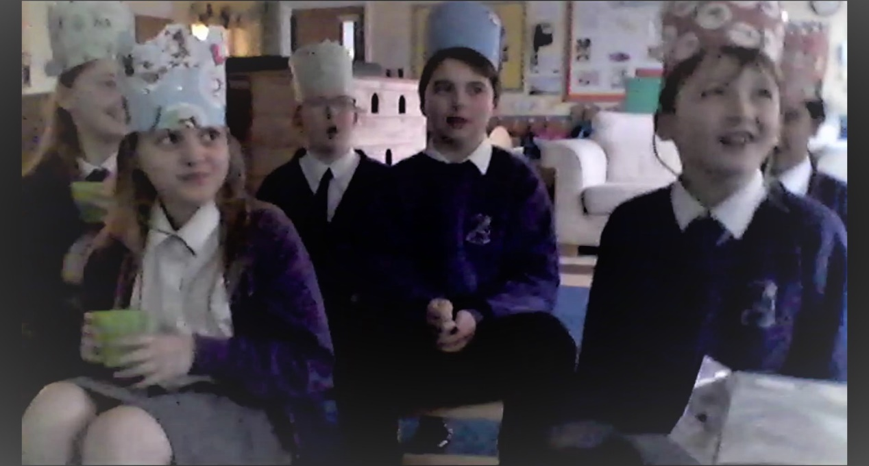

We have had lots of laughs with Christmas Jokes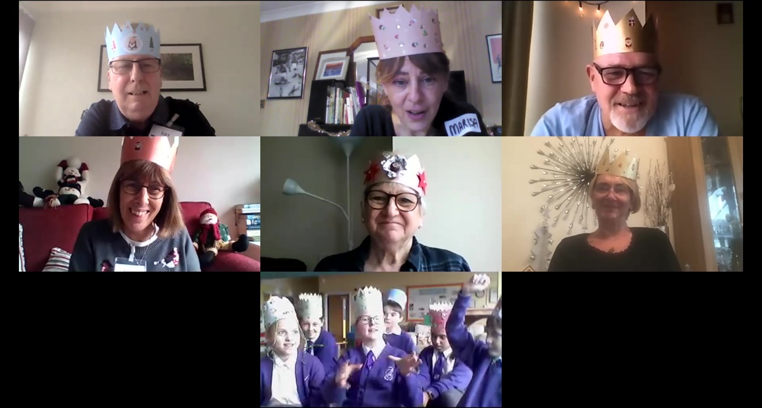

Drawing Christmas pictures or making Christmas cards is always popular – see https://printablefreecoloring.com/search/?q=christmas for a large selection of pictures to copy or colour in

