Christmas Traditions

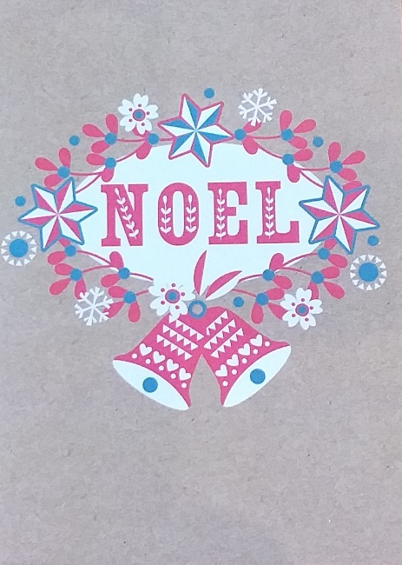
About this topic – Learn about the traditions associated with this time of year, test your memory and knowledge with a quiz and a game and design a Christmas jumper
Resources for this topic
- Suggested session plan
- Christmas Traditions
- Christmas Traditions Quiz and Answers
- Christmas Word Scramble and Answers
- Christmas Jumper Design
We are happy for you to use the material in this Toolkit exactly as it is or to modify it as required for your purposes. We do however ask that you always acknowledge its source as follows:

“Learning and Sharing Together” Resources (2020)
With thanks to Burnham Health Promotion Trust
Reg. Charity No.1066070 & Reg. Company No.3435602
www.bhpt.org.uk

You may not redistribute, sell or place any part of this Toolkit on any other website or blog without written agreement. Please Contact Us to discuss
Suggested session plan (one and a half hours approx.)
Whilst the plan below has been developed for face to face meetings, all the activities can be used in Virtual meetings too, using the shared screen facility on Zoom for example, and break out rooms for some activities.
- Welcome and introductions
- Working in small groups the children and older people should take turns to read aloud Christmas Traditions. Encourage them to discuss what they have read as there will be a quiz later.
- Give out Christmas Word Scramble to groups as they finish 2)
- When all the groups have finished 2) collect in Christmas Traditions and hand out Christmas Traditions Quiz

- As groups finish the Quiz, they should continue with the Christmas Word Scramble. Hand out Christmas Jumper Design to groups as they finish the Quiz and Word Scramble

- Go through the Christmas Traditions Quiz Answers when all the groups have finished the Quiz

- Refreshments – for a change you may like to offer mince pies or Christmas biscuits or small slices of Christmas cake or Chocolate log

- If there is time continue with Christmas Jumper Design or the children can take them home to complete

- Thankyous and goodbyes – Before the children and older people leave you may wish to say something about the topic or activity you have planned for the next session. This gives everyone the opportunity to be more prepared and, if appropriate, to bring photographs or other memorabilia

Christmas Traditions
The Advent Wreath
Advent comes from the Latin word "Adventus" which means arrival. Advent begins on the Sunday nearest to November 30th and lasts until midnight on Christmas Eve. The Christian year begins with "Advent Sunday." Advent is a time of preparation in the Christian Church for the celebration of the birth of Jesus over 2000 years ago.
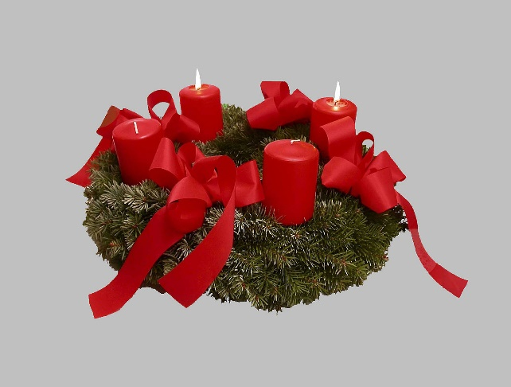
The Advent wreath is the widely recognised symbol of Advent. The wreath is made of a circle of evergreen branches laid flat to symbolise eternal life. Four candles, traditionally red, stand in the circle and one is lit on each of the four Sundays of Advent. In the centre of the wreath is a fifth candle that is traditionally white. This is the Christ candle which is only lit on Christmas Day.
An advent wreath on the second Sunday in Advent ¹
'Stir-up Sunday'
The last Sunday of the Church Year, the Sunday before Advent, is often called 'Stir-up Sunday'. This is the traditional day for everyone in the family to take a turn at stirring the Christmas pudding, whilst making a secret wish. There are several associated traditions. A Christmas pudding is traditionally made with 13 ingredients to represent Christ and His Disciples. A proper Christmas pudding is always stirred from East to West in honour of the three Wise Men who travelled from the East to visit the baby Jesus.
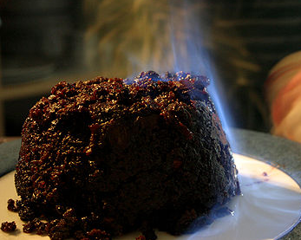
A coin was traditionally added to the ingredients and cooked in the pudding. It was supposed to bring wealth to whoever found it on their plate on Christmas Day. The traditional coin was an old silver sixpence or threepenny bit. Other traditional additions to the pudding included a ring, to foretell a marriage, and a thimble for a lucky life. On Christmas Day the pudding is traditionally decorated with a spray of holly, then dowsed in brandy, flamed, and brought to the table ceremonially.
A Christmas pudding being flamed after brandy has been poured over it ²
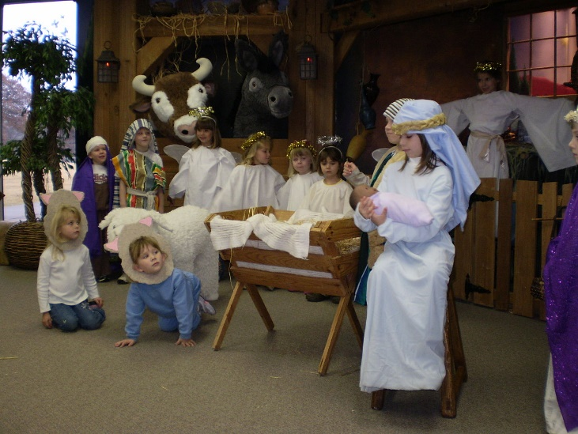
The Nativity Play
St Francis of Assisi is said to have created the first Nativity performance in Italy in about 1223. In those days, many people were unable to read or write so they couldn't read the Christmas story in the Bible themselves. Also many Church services were in Latin which many people didn't understand. St Francis decided to change all that. He wanted not only to tell the story of the first Christmas but to show people what it must have been like on that night in Bethlehem when Jesus what born so he set up a nativity scene. He got hold of some live animals, a manger and some hay. Then he asked people from his village to take the parts of Mary and Joseph and the Shepherds.
Nativity plays continue to be performed every Christmas by many primary schools and Sunday schools, usually with a doll as the Baby Jesus and children playing all the other parts, including the animals.
A children’s nativity play ³
Christmas cards
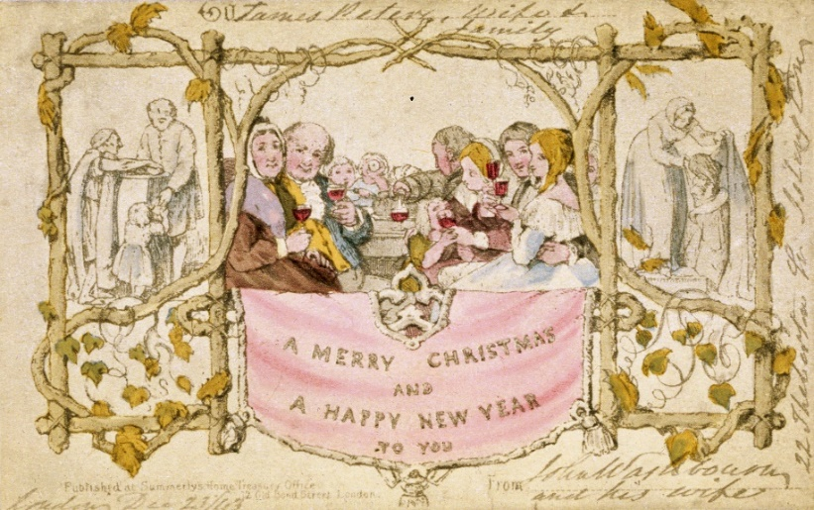
It is believed that the first Christmas card to be produced and sold to the public was created by a man called John Calcott Horsley in 1843. He printed the first Christmas card for a friend Sir Henry Cole. Sir Henry Cole was a wealthy British businessman and he wanted a card he could proudly send to friends and professional acquaintances to wish them a "Merry Christmas."
The card depicted a typical English family enjoying the holiday, and people performing acts of charity which was an important part of Victorian Christmas spirit. A thousand copies of the card were printed and sold for one shilling.

The first Christmas card, 1843 ⁴
The Twelve days of Christmas
Traditionally it has been said that it took the Three Kings or Wise Men twelve days to find the baby Jesus. Their arrival led centuries later to the Feast of Epiphany. The term epiphany means "to show" or "to make known" or "to reveal." In Western churches, it remembers the coming of the Wise Men bringing gifts to the baby Jesus, and by so doing to "reveal" Jesus to the world as Lord and King.
The Twelve days of Christmas begin the day after Christmas Day (December 26th) and continue until January 6th. Christmas Day was traditionally considered holy and not suitable for partying. But in England in years gone by the next 12 days would be filled with merrymaking, dancing and feasting. This was at a time when most people worked on the land and apart from looking after the animals all work on the land would stop for these twelve days.
To our ancient ancestors the end of the day was when the sun went down, not midnight as it is now. So whereas for us night follows day, for our ancient ancestors it was the other way round and day followed night. Christmas Day therefore started as night fell on the evening of December 24th and the Twelfth Day started as night fell on the evening of the Twelfth Night, January 5th.
It is still believed by many that Twelfth Night (5th January) is when all Christmas decorations should be removed so as not to bring bad luck upon the home. It is said if they are not removed then they should stay up all year.
Long ago it was thought that leaving the decorations up would cause a disaster. People believed that tree-spirits lived in the greenery such as holly and ivy that they decorated their houses with. The greenery was brought into the house to provide a safe haven for the tree-spirits during the harsh midwinter days. Once this period was over it was necessary to return the greenery back outside to release the tree-spirits into the countryside once again. It was believed that failure to do this would mean that spring would not return, leading to an agricultural disaster. It was also thought that, if you left the greenery in the house, the tree-spirits would cause mischief until they were released. Today many people still feel uneasy about leaving Christmas decorations up after Twelfth Night.
Yule logs
It is traditional to light a special 'Yule log' on Christmas Eve and keep it burning through the 12 nights of Christmas until Twelfth Night. Traditionally, a huge log would be selected in the forest on Christmas Eve, decorated with ribbons, and dragged back home. This was known as 'Bringing in the Yule Log'. The magical properties of the Yule Log were said to ensure good luck in the coming year to all those who lent a hand at pulling it over the rough ground.
Once the Yule log was brought to the fireplace, a blessing was said over it, asking that it should last forever. Wine was poured over the log at this point to make it feel welcome. It was then placed on the fire and lit with a torch made from a piece of wood left over from last year's Yule Log.
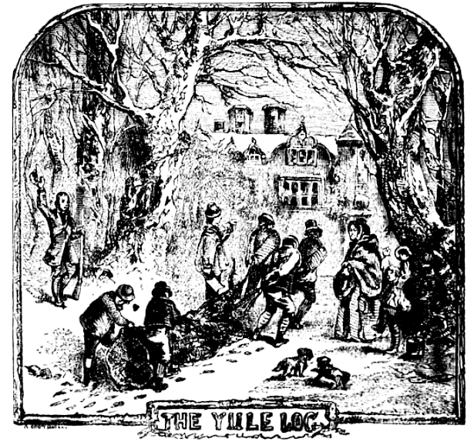
The log was then kept burning throughout the twelve days of Christmas. This dates back to the time of the Celts who believed that, for twelve days at the end of December, the sun stood still (which is why the days grew shorter and shorter). If they could keep Yule logs burning bright for those twelve days, then the sun would be persuaded to move again, and make the days grow longer.
If a Yule Log went out, it was believed that there would be terrible luck.
For Christians, the symbolism of the Yule log was that it represented the need to keep the stable warm for the Infant Christ.
“Bringing in the Yule Log” ⁵
Christmas Trees
The Christmas tree became popular in England in 1841 when Queen Victoria's husband, Prince Albert, brought a Christmas tree over from Germany and put it in Windsor Castle. The Royal family were illustrated in a newspaper standing around the Christmas tree, and the tradition of decorating a tree became fashionable.
During Victorian times, Christmas trees were decorated with candles to remind children of the stars in the sky at the time of the birth of Jesus. Using candles was, of course, a great fire hazard. Today, candles have been replaced by little coloured electric lights. Christmas trees were also traditionally decorated with sweets and cakes hung with ribbon. In 1880, Woolworths first sold manufactured Christmas tree ornaments which quickly proved to be very popular. An angel or star is usually put on the very top of the tree. The angel reminds Christians of the angel who brought glad tidings of great joy to the shepherds in the field when Jesus was born.
In London, near the statue of Lord Nelson in Trafalgar Square, a giant Christmas tree is set up and decorated each year.
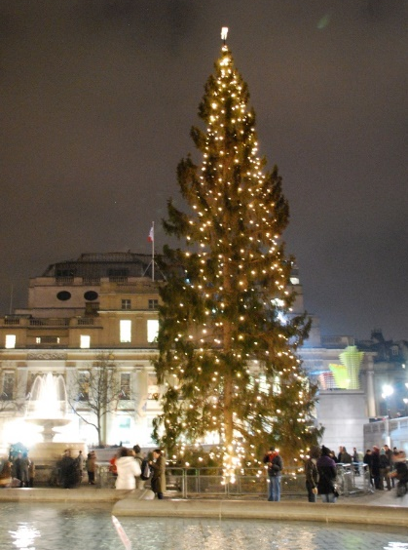
The tree is a thank you gift from the people of Oslo, the capital of Norway. During the Second World War, King Haakon of Norway was forced into exile in England when the Germans occupied his country.
Since 1947, Norway has expressed its thanks for the help of the British people by continuing to send a huge Norwegian spruce to be shared by all.
Trafalgar Square Christmas tree, 2008 ⁶
Mince Pies
Mince pies became a regular part of Christmas celebrations as early as the 16th century. At that time, they contained shredded meat as well as the usual mixture of dried fruits.It was also considered important to add three spices (cinnamon, cloves and nutmeg) for the three gifts given to Jesus by the three Wise Men.
There are a number of other traditions and superstitions surrounding mince pies.
- It was thought lucky to eat one mince pie on each of the Twelve days of Christmas. Alternatively, to refuse one would lead to bad luck.
- The mincemeat mixture should only be stirred in a clockwise direction. To stir it anticlockwise is believed to bring bad luck for the coming year.
- A wish should be made whilst eating one's first mince pie of the festive season, and mince pies should always be eaten in silence.
- It is considered very unlucky to cut a mince pie with a knife.
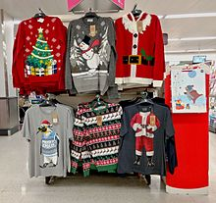
Christmas Jumpers
Some traditions are much more recent like Christmas jumpers. They first became popular in the UK in the 1980’s but then seemed to fall out of favour until about 2011. By 2012 they were described by one British newspaper as “this season’s must have” and a survey conducted in that year showed that 41% of the British population owned a Christmas-themed jumper.
A display of Christmas jumpers ⁷
With thanks to Mandy Barrow for permission to include information from the Project Britain website http://projectbritain.com/Xmas/index.html#top
(links to many pages)
With thanks to Wikipedia for photos
¹ Advent wreath https://commons.wikimedia.org/wiki/File:Advent_wreath.jpg#/media/File:Advent_wreath.jpg
Attribution: Clemens PFEIFFER
Licensed under the Creative Commons Attribution 2.5 Generic license.
² Christmas Pudding
https://commons.wikimedia.org/wiki/File:Christmas-pudding-flames.jpg
Matt Riggott from Edinburgh, Scotland / CC BY-SA
https://creativecommons.org/licenses/by-sa/2.0
³ Children’s Nativity Play
https://en.wikipedia.org/wiki/Nativity_play#/media/File:Childrens_Nativity_
Play_2007.jpg
Wesley Fryer from Edmond, Oklahoma / CC BY-SA (https://creativecommons.org/licenses/by-sa/2.0)
⁴ First Christmas card
https://commons.wikimedia.org/wiki/File:Firstchristmascard.jpg
Public domain
⁵ Bringing in the Yule log
https://commons.wikimedia.org/wiki/File:Chambers_Yule_Log.png
Robert Chambers /Public domain
⁶ Trafalgar Square Christmas tree https://en.wikipedia.org/wiki/Trafalgar_Square_Christmas_tree#/media/File:Trafalgar_Square_Christmas_tree8.jpg
Laura Bittner / CC BY https://creativecommons.org/licenses/by/2.0
⁷ Christmas Jumpers in a British Supermarket, 2016
https://en.wikipedia.org/wiki/Christmas_jumper#/media/
File:Christmas_jumpers,_Sainsbury's_2016.jpg
Philafrenzy / CC BY-SA https://creativecommons.org/licenses/by-sa/4.0

Christmas Traditions Quiz (30 points)
1. What should you do when eating your first mince pie of the festive season?
1 point
2. What should you not do when you have a mince pie? 2 points

3. Traditionally what colour are the candles on an Advent wreath? 1 point
4. What name is often given to the last Sunday before Advent? 1 point
5. When was the first Christmas card created and by whom? 2 points
6. What was the scene on the card? 2 points

7. How much was the card sold for? 1 point
8.When and where was the first Nativity play said to have been created?
2 points
9. When are the Twelve days of Christmas? 1 point
10. Why did the Celts think it was so important for their Yule logs to keep burning during the Twelve days of Christmas? 2 points

11. Traditionally what did people think would happen if decorations were left up after Twelfth Night? Up to 3 points

12. When did Christmas trees first become fashionable in England and who was responsible? 2 points

13. Which shop first sold Christmas tree ornaments and when? 2 points

14. Why do the people of Norway send a giant Christmas tree to England each year? 1 point

15. Which three spices were traditionally added to mince pies and why was it considered important? 4 points

16. Apart from the all the fruit and other ingredients what else might you traditionally find in your Christmas pudding and why might you be pleased?
Up to 3 points

Christmas Traditions Quiz with answers (30 points)
1. What should you do when eating your first mince pie of the festive season?
1 point Make a wish
2. What should you not do when you have a mince pie? 2 points
i) Talk ii) Cut it with a knife
3. Traditionally what colour are the candles on an Advent wreath? 1 point
4 red and 1 white
4. What name is often given to the last Sunday before Advent? 1 point
Stir-up Sunday
5. When was the first Christmas card created and by whom? 2 points
i) in 1843 ii) by John Calcott Horsley (for Sir Henry Cole)
6. What was the scene on the card? 2 points
i) Typical English family enjoying the holiday ii) People performing acts of charity
7. How much was the card sold for? 1 point One shilling
8.When and where was the first Nativity play said to have been created? 2 points i) 1223 ii) in Italy
9. When are the Twelve days of Christmas? 1 point Dec 26th to Jan 6th
10. Why did the Celts think it was so important for their Yule logs to keep burning during the Twelve days of Christmas? 2 points
i) They thought the sun would be persuaded to start moving again which would make the days longer ii) If a Yule log went out, then there would be terrible luck.
11. Traditionally what did people think would happen if decorations were left up after Twelfth Night? Up to 3 points
i) It would bring bad luck upon the home.
ii) They thought the tree spirits which lived in the greenery would get up to mischief in the house if they were not released after Twelfth Night.
iii) They thought there would be an agricultural disaster because spring would not return
12. When did Christmas trees first become fashionable in England and who was responsible? 2 points i) 1841 ii) Prince Albert
13. Which shop first sold Christmas tree ornaments and when? 2 points
i) Woolworths ii) in 1880
14. Why do the people of Norway send a giant Christmas tree to England each year? 1 point
To give thanks to England for keeping their King Haakon safe during World War II when he was forced into exile.
15. Which three spices were traditionally added to mince pies and why was it considered important? 4 points
i) cinnamon ii) cloves iii) nutmeg iv) they represent the 3 gifts given to Jesus by the three wise men
16. Apart from the all the fruit and other ingredients what else might you traditionally find in your Christmas pudding and why might you be pleased?
3 points
i) coin for wealth ii) thimble for a lucky life iii) ring to foretell a marriage

Christmas Word Scramble
Here are 20 words associated with Christmas but the letters are all jumbled up. Can you unscramble them?
1. BIONR ________________________________________
2. KCCARSRE ______________________________________
3. SNLTEI ________________________________________
4. AENLG AREGLIB ____________________________________
5. YAMR NAD OEJPHS _________________________________
6. NIMEC EPSI ________________________________________
7. TEIOLTEMS ________________________________________
8. TSEERSPN ________________________________________
9. LCRAO CVESEIR _____________________________________
10. YTTANIVI LYAP _____________________________________
11. NAGMER ________________________________________
12. IARFY GSTILH __________________________________
13. SIPG NI BSNTKAEL _________________________________
14. LYOHL DNA VIY ____________________________________
15. CIGESHINTLR ___________________________________
16. PDEEHHSSR ___________________________________
17. FUINSGFT ________________________________________
18. GANERSO ________________________________________
19. EYLU OLG ________________________________________
20. HAFRTE ARMTCSSIH ________________________________

Christmas Word Scramble Answers
1. BIONR Robin
2. KCCARSRE Crackers
3. SNLTEI Tinsel
4. AENLG AREGLIB Angel Gabriel
5. YAMR NAD OEJPHS Mary and Joseph
6. NIMEC EPSI Mince Pies
7. TEIOLTEMS Mistletoe
8. TSEERSPN Presents
9. LCRAO CVESEIR Carol Service
10. YTTANIVI LYAP Nativity Play
11. NAGMER Manger
12. IARFY GSTILH Fairy Lights
13. SIPG NI BSNTKAEL Pigs in Blankets
14. LYOHL DNA VIY Holly and Ivy
15. CIGESHINTLR Christingle
16. PDEEHHSSR Shepherds
17. FUINSGFT Stuffing
18. GANERSO Oranges
19. EYLU OLG Yule Log
20. HAFRTE ARMTCSSIH Father Christmas

Design a Christmas Jumper
What colours, pictures or patterns would you choose for a Christmas jumper?
