Easter
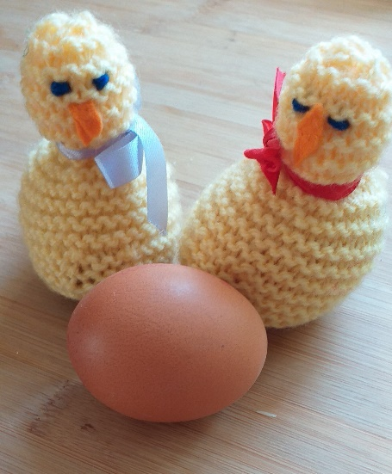
About this topic – Learn about some facts, traditions and superstitions associated with Easter, test your memory and knowledge with a quiz and games and make an Easter card
Resources for this topic
- Suggested session plan
- Easter Facts, Traditions and Superstitions
- Easter Quiz and Answers
- Easter Word Search and Answers
- Easter Card making Activity

We are happy for you to use the material in this Toolkit exactly as it is or to modify it as required for your purposes. We do however ask that you always acknowledge its source as follows:

“Learning and Sharing Together” Resources (2020)
With thanks to Burnham Health Promotion Trust
Reg. Charity No.1066070 & Reg. Company No.3435602
www.bhpt.org.uk

You may not redistribute, sell or place any part of this Toolkit on any other website or blog without written agreement. Please Contact Us to discuss

Suggested session plan (one and a half hours approx.)
Whilst the plan below has been developed for face to face meetings, all the activities can be used in Virtual meetings too, using the shared screen facility on Zoom for example, and break out rooms for some activities.
- Welcome and introductions
- Working in small groups the children and older people should take turns to read aloud Easter Facts, Traditions and Superstitions. Encourage them to discuss what they have read as there will be a quiz later.
- Give out Easter Word Search to groups as they finish 2)
- When all the groups have finished 2) collect in Easter Facts, Traditions and Superstitions and hand out Easter Quiz

- As groups finish the quiz, they should continue with the Easter Word Search.

- Hand out sample pictures (for example from https://printablefreecoloring.com/search/?q=Easter) and plain paper and/or card for Easter cards as groups finish the Quiz and Word Search.

- Go through the Easter Quiz Answers when all the groups have finished the quiz

- Refreshments – continue making Easter cards

- Thankyous and goodbyes– Before the children and older people leave you may wish to say something about the topic or activity you have planned for the next session. This gives everyone the opportunity to be more prepared and, if appropriate, to bring photographs or other memorabilia
Some Easter Facts, Traditions and Superstitions
Why does the date of Easter change?
Easter is called a moveable feast because the date of Easter changes every year. Easter Sunday can fall on any date from 22 March to 25 April. The reason for this variation in the date of Easter is based on the lunar calendar rather than our more well-known solar one.
Easter always falls on the first Sunday following the full Moon (the Paschal Full Moon) after 21 March. If the Full Moon falls on a Sunday then Easter is the next Sunday.
It was on Easter Sunday that Jesus rose from the dead. Jesus had told his disciples before he was arrested that he would be crucified and on the third day he would rise from the dead. Sunday was the third day from Good Friday (Good Friday, Holy Saturday, Easter Day)
Good Friday
On Good Friday, Christians remember the day when Jesus was crucified.
There are several superstitions relating to Good Friday:
- A child born on Good Friday and baptised on Easter Sunday was believed to have the gift of healing
- It was said that eggs laid on Good Friday would never go bad and bread or cakes baked on Good Friday would not go mouldy
- It was thought that having your hair cut on Good Friday would prevent toothaches for the rest of the year
- Many fishermen would not set out on Good Friday as they considered it to be unlucky
- The planting of crops was not advised on Good Friday as there was a belief that no iron (e.g. a fork or spade) should enter the ground on this day
Origins of colouring eggs at Easter
Decorating and colouring eggs for Easter was a common custom in England in the Middle Ages. Eggs were brightly coloured to mimic the new fresh colours of Spring. The practice of decorating eggs was made even more famous by King Edward I of England who ordered 450 eggs to be gold leafed and coloured for Easter gifts in 1290.

Pace Egging
What are Pace Eggs? - Pace Eggs are hard boiled eggs with coloured and patterned shells. They are traditional in northern parts of England at Easter, with local variants in the name, such as Paste Eggs.
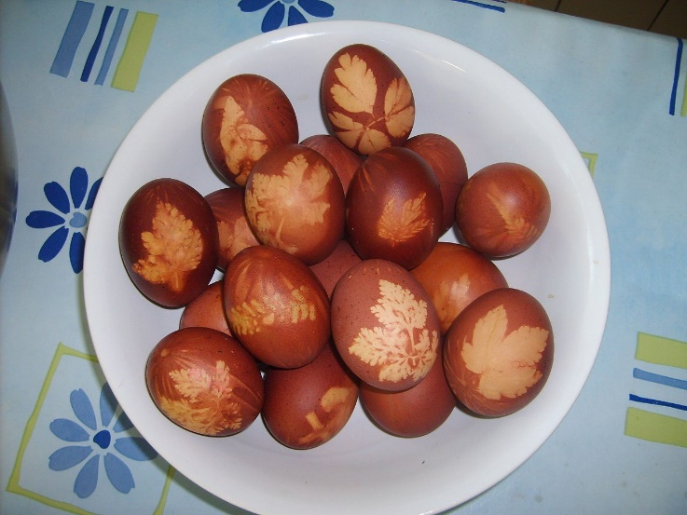
Pace eggs boiled with onion skins and leaf patterns - G Sfasie
By Waelsch, CC BY-SA 3.0, https://commons.wikimedia.org/w/index.php?curid=2493850
With thanks to https://commons.wikimedia.org/wiki/File:Oeufs.jpg
Where does the name Pace Egg come from? - The name is derived from Pesach (Passover). For many centuries before Jesus' birth, the Jewish people had their own special spring festival, called Passover (Pesach).
Passover commemorates the time when God rescued the people of Israel from slavery and Moses led them out of Egypt. It was the Israelite's liberation from Egypt that led to the beginning of Judaism.
Both Easter and Passover revolve around the idea of rebirth. Jesus is resurrected, or born again, and the slaves are reborn into freedom. Both festivals draw on the idea of birth or rebirth with Easter eggs and the hard-boiled eggs served on Passover.
The design of Pace Eggs - The patterns on the shells are created by leaves and flowers placed next to the eggshell. The background colour is created by wrapping the egg in onion skins. The eggs are then hard boiled. All kinds of fun may be had with the hard-boiled decorated pace eggs.
Egg rolling
Egg rolling has traditionally been a popular Easter Monday sport in parts of England. Hard-boiled eggs are rolled down a hill. Customs differ from place to place. The winner's egg may be the one that rolls the farthest, survives the most rolls, or is rolled between two pegs.
Egg Jarping (Egg Tapping)
Another traditional activity is the playing of a game with the eggs known as "jarping", It's a bit like playing conkers, with players tapping their opponents' eggs until one breaks. The winner goes through to the next round, and so on until there is only one egg left unbroken.
A good hit by a jarper is called a "dunch". The game is popular in County Durham, where it is played on Easter Sunday.
Special Easter foods
Some special foods associated with Easter include hot cross buns which are traditionally eaten on Good Friday and Simnel Cake which is eaten for tea on Easter Day.
Simnel cake is a rich fruit cake covered with a thick layer of marzipan and decorated with 11 marzipan balls representing the eleven true disciples (excluding Judas who betrayed Jesus)
There are some superstitions relating to hot cross buns:
It was believed that hardened old hot cross buns would protect a house from fire
Sailors took hot cross buns to sea with them because they believed they would prevent shipwrecks
With thanks to Mandy Barrow for permission to include information from Project Britain website http://projectbritain.com/easter.html
and http://projectbritain.com/easter/superstitions.htm

Easter Quiz (15 possible points)
- What is the earliest date that Easter Sunday could be?

- What did people believe would happen if you had your hair cut on Good Friday?

- What did people think was special about eggs laid on Good Friday?

- What is another name for egg tapping?

- Where is this game popular?

- How is a simnel cake decorated and why? (2 points)

- Why did sailors take hot cross buns to sea?

- Where in England are pace eggs traditionally found?

- Where does the name Pace Egg come from?

- Who gave eggs as gifts in 1290?

- How many eggs did he order and how were they decorated? (2 points)

- What two things do Easter and the Jewish festival of Passover have in common? (2 points)

Easter Quiz Answers (15 possible points)
- What is the earliest date that Easter Sunday could be?
March 22nd

- What did people believe would happen if you had a hair cut on Good Friday?
No tooth ache for a year

- What did people think was special about eggs laid on Good Friday?
They would never go bad

- What is another name for egg tapping?
Egg jarping

- Where is this game popular?
County Durham

- How is a simnel cake decorated and why? (2 points)
With 11 marzipan balls representing the 11 true disciples

- Why did sailors take hot cross buns to sea?
To prevent shipwrecks
- Where in England are pace eggs traditionally found?
Northern England

- Where does the name Pace Egg come from?
Jewish festival of Passover (Pesach)

- Who gave eggs as gifts in 1290?
King Edward 1

- How many eggs did he order and how were they decorated? (2 points)
- eggs - gold leafed and coloured

- What two things do Easter and the Jewish festival of Passover have in common? (2 points)
Both revolve around rebirth and have eggs

Easter Word Search
Can you find these 15 words related to Easter in the grid below. They may be going forwards or backwards in a horizontal, vertical or diagonal direction.
Easter egg hunt |  |  |  |  |  | Easter Sunday |  |  |  |  | Spring flowers |  |  |  |  | Holidays Chocolate
Easter bunny |  |  |  |  |  | Chicks |  |  |  |  | Easter bonnet |  |  |  |  | Crucifixion Jesus
Simnel Cake |  |  |  |  |  | Hot cross buns |  |  |  |  | Good Friday |  |  |  |  | Pace eggs Church
V | Q | T | S | I | H |  | H | Y | D | T | M | A | L | L | H | C | O
J | G | E | E | F | Y |  | P | V | C | H | O | C | O | L | A | T | E
S | Z | N | S | A | E |  | A | S | T | E | R | B | U | N | N | Y | P
N | S | N | P | J | S |  | E | D | R | K | Q | H | B | D | A | G | U
U | U | O | R | M | E |  | T | R | N | O | E | D | C | D | Q | S | V
B | S | B | I | K | P |  | A | E | Y | U | X | C | I | R | E | B | J
S | E | R | N | Q | A |  | C | C | R | K | S | R | B | S | U | K | X
S | J | E | G | V | C |  | N | R | P | E | F | R | K | N | Z | H | S
O | E | T | F | S | E |  | D | W | U | D | G | C | E | R | N | T | C
R | L | S | L | Y | E |  | F | Z | O | C | I | G | H | T | E | G | J
C | X | A | O | A | G |  | S | O | N | H | I | L | H | S | S | K | D
T | D | E | W | D | G |  | G | Q | C | P | Z | F | K | U | B | A | Q
O | P | I | E | I | S |  | V | C | P | Q | S | F | I | U | N | Q | E
H | F | N | R | L | X |  | M | V | O | F | K | Z | Y | X | V | T | Q
T | Y | W | S | O | Z |  | W | J | Q | F | U | M | I | G | I | P | Q
C | T | J | F | H | U |  | T | X | K | R | C | B | H | K | S | O | P
Y | E | K | A | C | L |  | E | N | M | I | S | P | V | M | P | U | N
Easter Word Search Answers
Church |  |  |  |  |  | Easter Sunday |  |  |  |  | Spring flowers |  |  |  |  | Holidays
Jesus |  |  |  |  |  | Chicks |  |  |  |  | Easter bonnet |  |  |  |  | Crucifixion
Simnel Cake |  |  |  |  |  | Hot cross buns |  |  |  |  | Good Friday |  |  |  |  | Pace eggs
Easter egg hunt |  |  |  |  |  | Easter bunny |  |  |  |  | Chocolate
V | Q | T | S | I | H |  | H | Y | D | T | M | A | L | L | H | C | O
J | G | E | E | F | Y |  | P | V | C | H | O | C | O | L | A | T | E
S | Z | N | S | A | E |  | A | S | T | E | R | B | U | N | N | Y | P
N | S | N | P | J | S |  | E | D | R | K | Q | H | B | D | A | G | U
U | U | O | R | M | E |  | T | R | N | O | E | D | C | D | Q | S | V
B | S | B | I | K | P |  | A | E | Y | U | X | C | I | R | E | B | J
S | E | R | N | Q | A |  | C | C | R | K | S | R | B | S | U | K | X
S | J | E | G | V | C |  | N | R | P | E | F | R | K | N | Z | H | S
O | E | T | F | S | E |  | D | W | U | D | G | C | E | R | N | T | C
R | L | S | L | Y | E |  | F | Z | O | C | I | G | H | T | E | G | J
C | X | A | O | A | G |  | S | O | N | H | I | L | H | S | S | K | D
T | D | E | W | D | G |  | G | Q | C | P | Z | F | K | U | B | A | Q
O | P | I | E | I | S |  | V | C | P | Q | S | F | I | U | N | Q | E
H | F | N | R | L | X |  | M | V | O | F | K | Z | Y | X | V | T | Q
T | Y | W | S | O | Z |  | W | J | Q | F | U | M | I | G | I | P | Q
C | T | J | F | H | U |  | T | X | K | R | C | B | H | K | S | O | P
Y | E | K | A | C | L |  | E | N | M | I | S | P | V | M | P | U | N

Easter Cards
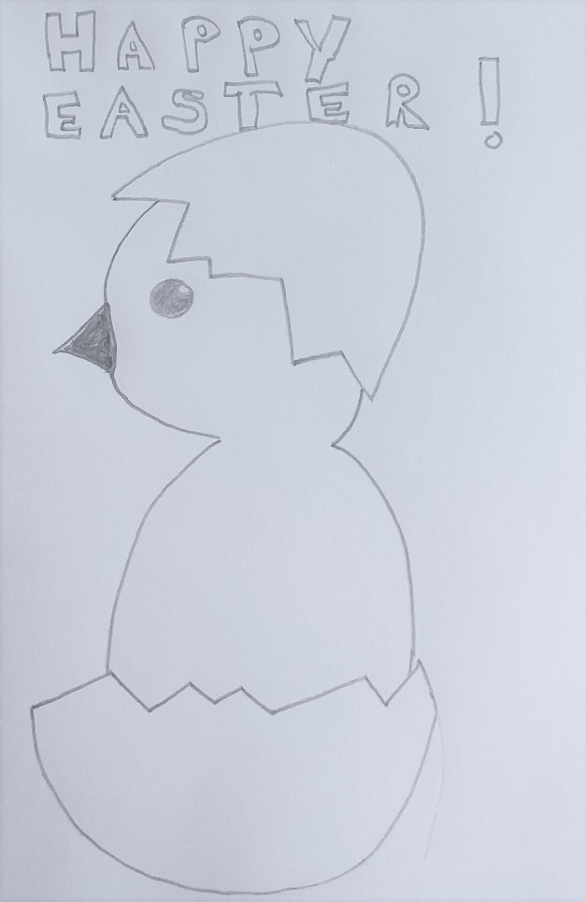
Encourage the children and older people to each make an Easter card, either to their own design or using one of the many Easter themed illustrations available from https://printablefreecoloring.com/search/?q=Easter
Print off a selection before the session.
As well as copies of these pictures you will need: Thin white and coloured card, plain paper, scissors, glue, pencils, coloured pencils, erasers.
You could provide envelopes if the children and older people wish to send their card to a friend or relative. Or perhaps, as in our experience, you may find the children and older people like to exchange their cards with each other at the end of the session.

