Holiday Memories
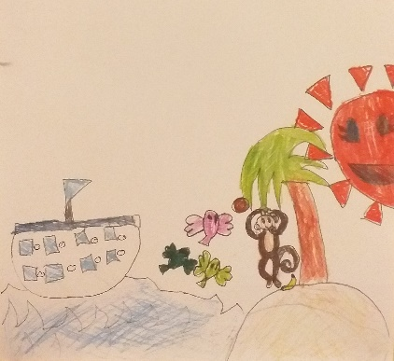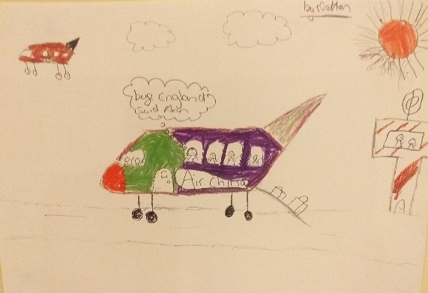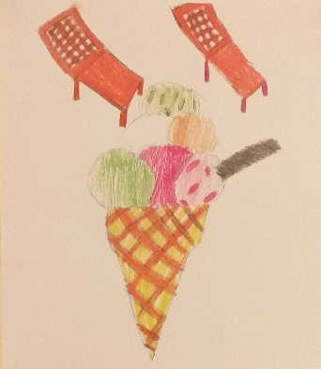
About this topic – The aim of this session is for the children to find out as much as they can about the older people’s different holiday experiences. The children act as reporters, interviewing the older people and then writing and illustrating reports of what they have learnt.
Resources for this topic
- Suggested session plan
- Holiday Memories Worksheet and Questions
- Holidays Word Scramble and Answers

We are happy for you to use the material in this Toolkit exactly as it is or to modify it as required for your purposes. We do however ask that you always acknowledge its source as follows:

“Learning and Sharing Together” Resources (2020)
With thanks to Burnham Health Promotion Trust
Reg. Charity No.1066070 & Reg. Company No.3435602
www.bhpt.org.uk

You may not redistribute, sell or place any part of this Toolkit on any other website or blog without written agreement. Please Contact Us to discuss

Suggested session plan (one and a half hours approx.)
Whilst the plan below has been developed for face to face meetings, the activities can be modified for use in Virtual meetings too. Instead of working individually the children could take turns to find out which of the older people had experienced the 10 types of holiday listed on the Interview Sheet. The older people could then take turns to describe a particular holiday or special holiday memory. The Holidays Word Scramble could be done in break out rooms using the shared screen facility on Zoom.
- Welcome and introductions
- “Holiday Memories” interviews – Each child is given an Interview sheet, preferably on a clipboard, which lists 10 different types of holiday. The idea is for each child to walk around the room and for each holiday type to try and find at least one adult who has been on that type of holiday at some time in their life.
- When all the children have filled in as many boxes as they can they are each paired up with an older person to find out as much as they can about one of their holiday experiences. Give each child a Holiday Memories Question Sheet which gives examples of the sorts of questions the children can ask their partner. The children make notes about what their partner tells them and then write them up neatly before doing a drawing.
- Having completed one account, the children are then paired up with another older person to find out as much as they can about another holiday memory. If there is time the children may be able to interview a third person.
NB You may need to help match the children with the older people to ensure that everyone is involved and also to make sure that the older people have the opportunity to talk about as many of their previous holidays as possible. Depending on numbers the children may need to work in pairs.
- Refreshments and Holidays Word Scramble

- If there is time the children could each take turns to say something about the type of holiday they would like to have in the future
- Thankyous and goodbyes – Before the children and older people leave you may wish to say something about the topic you have planned for the next session. This gives everyone the opportunity to be more prepared and, if appropriate, to bring photographs or other memorabilia.

Holiday Memories Interview Sheets

For each type of holiday try and find at least one adult who has had that sort of holiday at some time in their life
Type of holiday | Name of Adult/s
A holiday by the seaside
A holiday in the mountains

A holiday on a farm

A holiday by train

A holiday with friends

A holiday on a boat

An activity holiday e.g. walking, skiing, sailing, riding
A holiday with a pet
A holiday when you were very young
Your first holiday abroad

Holiday Memories Question Sheet
Children – Try and find out as much as you can about your partner’s holiday. Here are some questions you can ask
- When was it?
- Where was it?
- Who did you travel with?
- What special memories do you have of the holiday?
- Did anything unexpected or unusual happen on the holiday?
Make notes about what your partner tells you and then write it up neatly before doing a drawing.
…………………………… interviewed by ……………………………….
about ………………………………………………………………….

Holidays Word Scramble
Here are 12 words associated with holidays but the letters are all muddled up. Can you unjumble them?
1. IDASSEE ___________________________________________
2. SECARNUM __________________________________________
3. LBCBLEHAA _________________________________________
4. RITORAP ___________________________________________
5. IETOTNADNIS _______________________________________
6. ICRUES ____________________________________________
7. GLGGAEU ___________________________________________
8. KUTCEB ____________________________________________
9. SSTPRAPO __________________________________________
10. RCEIMEAC __________________________________________
11. STIEKCT ___________________________________________
12. APCNGIK ___________________________________________

Holidays Word Scramble Answers

1. IDASSEE Seaside

2. SECARNUM Suncream

3. LBCBLEHAA Beachball

4. RITORAP Airport

5. IETOTNADNIS Destination

6. ICRUES Cruise

7. GLGGAEU Luggage

8. KUTCEB Bucket

9. SSTPRAPO Passport

10. RCEIMEAC Icecream

11. STIEKCT Tickets

12. APCNGIK Packing

