New Year Celebrations

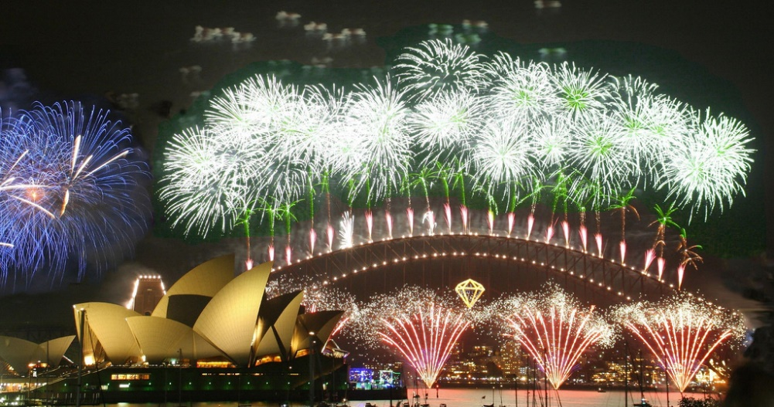
Sydney Fireworks New Year, 2006 – The Opera House and Harbour ²
About this topic – Find out about some different ways of celebrating New Year and think what New Year means to you. Have fun with a word game and write an acrostic poem.
Resources for this topic
- Suggested session plan
- New Year Traditions
- New Year Acrostic Poem
- New Year Word Scramble and Answers

We are happy for you to use the material in this Toolkit exactly as it is or to modify it as required for your purposes. We do however ask that you always acknowledge its source as follows:

“Learning and Sharing Together” Resources (2020)
With thanks to Burnham Health Promotion Trust
Reg. Charity No.1066070 & Reg. Company No.3435602
www.bhpt.org.uk

You may not redistribute, sell or place any part of this Toolkit on any other website or blog without written agreement. Please Contact Us to discuss
Suggested session plan (one and a half hours approx.)
Whilst the plan below has been developed for face to face meetings, all the activities can be used in Virtual meetings too, using the shared screen facility on Zoom for example, and break out rooms for some activities.
- Welcome and introductions
- Begin with a quick chat about how everyone celebrated New Year. Does anyone have any special traditions associated with this time of year?

- Divide the adults and children into small groups and hand out the New Year Traditions Sheet. The children and adults should take turns to read aloud from the sheet

- As groups finish reading the New Year Traditions Sheet, hand out the New Year Acrostic Poem. Encourage each group to start by jotting down words that they associate with New Year. Perhaps they can include something that they have just read about in the New Year Traditions Sheet

- As each group completes their poem, they should write it out neatly and decide who will read it to the whole group

- Refreshments and New Year Word Scramble

- Groups then take it in turns to read out their New Year Poems

- Thankyous and goodbyes - Before the children and older people leave you may wish to say something about the topic or activity you have planned for the next session. This gives everyone the opportunity to be more prepared and, if appropriate, to bring photographs or other memorabilia

New Year Traditions

Around the world there are many national and local traditions associated with New Year. Here are just a few examples:

Scotland

Hogmanay is the Scots word for the last day of the year but it has come to be associated with all the traditional celebrations of the Scottish New Year. The most widespread national custom is the practice of first-footing, which starts immediately after midnight. This involves being the first person to cross the threshold of a friend or neighbour and often involves the giving of symbolic gifts such as salt, coal, shortbread, whisky and black bun (a type of rich fruit cake). These gifts are intended to bring different kinds of luck to the householder and in return food and drink are given to the guests. This may go on throughout the early hours of the morning and well into the next day. The first-foot is supposed to bring luck for the rest of the year and traditionally, tall, dark-haired men are preferred as the first-foot.

Edinburgh, the Scottish capital, hosts one of the world’s most famous New Year celebrations. The celebration is focused on a major street party along Princes Street. The cannon is fired at Edinburgh Castle at the stroke of midnight, followed by a large fireworks display. The Edinburgh Hogmanay celebrations are among the largest in the world. Celebrations in Edinburgh in 1996–97 were recognised by the Guinness Book of Records as the world’s largest New Year’s party, with approximately 400,000 people in attendance. Numbers were subsequently restricted due to safety concerns

With thanks to https://en.wikipedia.org/wiki/Hogmanay for information

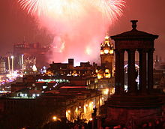

Fireworks over Edinburgh, 2009 by Robbie Shade ¹

Wales

Calennig is a Welsh word which literally translates as “the first day of the month”, although it commonly means “New Year celebration or gift.” The tradition of giving gifts and money on New Year’s Day is an ancient custom that survives even in modern-day Wales. In some parts of Wales, people must visit all their relatives by midday to collect their Calennig. Children would traditionally be given a skewered apple decorated with dried fruit and greenery.
With thanks to https://en.wikipedia.org/wiki/Calennig for information

Portugal and Spain
In Portugal there is a tradition to drink champagne and eat twelve raisins – one for each month of the year, making a wish for each. In Spain it is traditional to eat twelve grapes, one on each chime as the clock strikes midnight on New Year’s Eve. This tradition dates back to at least 1895 but became established in 1909. In December of that year, some vine growers from the Alicante region popularized this custom in the hope of selling huge numbers of grapes from an excellent harvest. According to the tradition, eating the twelve grapes leads to a year of good luck and prosperity. In some areas, it is believed that it wards away witches and general evil but nowadays it’s generally viewed as a cultural tradition to welcome the New Year.
With thanks to https://en.wikipedia.org/wiki/New_Year%27s_Eve#Portugal for information

Saint Silvester’s Day
New Year’s Eve coincides with another very important day for many people in Europe – Saint Silvester’s Day. Saint Silvester served as Pope for 21 years from 314 to 335 and December 31st has been traditionally celebrated as a feast day to mark the anniversary of his death.
In Vienna, the capital of Austria, people walk pigs on this day in the hope of having good luck for the coming year. In Germany many people mark Saint Silvester’s Day by practising a custom known as Bleigiessen in which lead, known as Silvesterblei, is melted over a flame in an old spoon and dropped into a bowl of cold water. One’s fortune for the coming year is determined by the shape of the lead. If the lead forms a ball it is thought that luck will roll one’s way, while the shape of a star signifies happiness.
With thanks to https://en.wikipedia.org/wiki/Saint_Sylvester%27s_Day for information

Fireworks

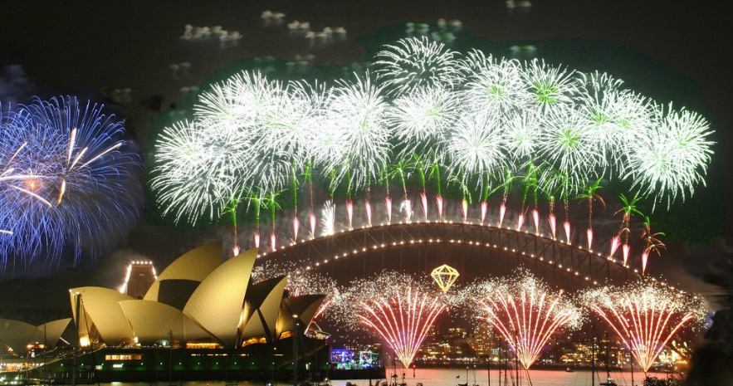
Many towns and cities around the world welcome in the New Year with dramatic firework displays. One of the most famous is in Sydney, Australia. Synchronised to a soundtrack of popular music, the fireworks explode off the arches, catwalk and roadway of the Harbour Bridge, including the Opera House, nearby city buildings and up to eight barges evenly divided on both sides of the bridge. They are regularly viewed by more than one million people watching from around the harbour and globally by one billion people watching on television.
Sydney Fireworks New Year, 2006 – The Opera House and Harbour ²

With thanks to https://en.wikipedia.org/wiki/Sydney_New_Year%27s_Eve for information

New Year resolutions

The tradition of making New Year resolutions dates back thousands of years. Nearly 2000 BC the Babylonians made promises to their gods to return borrowed object and pay their debts and in Roman times people made promisies to their god Janus, from whom the month of January is named.
With thanks to https://en.wikipedia.org/wiki/New_Year%27s_resolution
for information

Have you made any New Year resolutions for this year?
Photographs with thanks to Wikipedia
¹ Fireworks over Edinburgh, 2009 by Robbie Shade https://commons.wikimedia.org/wiki/File:EdinburghNYE.jpg
Robbie Shade / CC BY https://creativecommons.org/licenses/by/2.0

² Sydney Fireworks New Year, 2006 – The Opera House and Harbour
https://commons.wikimedia.org/wiki/File:OperaSydney-Fuegos2006-342289398.jpg
Rob Chandler / CC BY https://creativecommons.org/licenses/by/2.0

New Year Acrostic Poem

In an acrostic poem the first letter of each line spells a word.
Can you write an acrostic poem about New Year? Before you start think about all the words you associate with New Year. Perhaps you can include something from the New Year Traditions sheet.

N

E

W

Y

E

A

R

New Year Word Scramble
Here are twelve words associated with New Year but they
have all been jumbled up. Can you unscramble them?
1. UOSLEROISTN ________________________________
2. NBEIOARSECTL _________________________________
3. AKBN LDHAOYI _______________________________
4. SIARPTE ______________________________________
5. YNGOAMAH ____________________________________
6. IISGGNN ______________________________________
7. GIB ENB ______________________________________
8. ROKISFEWR _______________________________
9. GDTIIHNM ________________________________
10. RFSIT TFGNOIO _______________________________
11. UADL GALN SNEY ___________________________

12. ANNIGDC ___________________________________

New Year Word Scramble Answers

1. UOSLEROISTN Resolutions

2. NBEIOARSECTL Celebrations

3. AKBN LDHAOYI Bank Holiday

4. SIARPTE Parties

5. YNGOAMAH Hogmanay

6. IISGGNN Singing

7. GIB ENB Big Ben

8. ROKISFEWR Fireworks

9. GDTIIHNM Midnight

10. RFSIT TFGNOIO First Footing

11. UADL GALN SNEY Auld Lang Syne

12. ANNIGDC Dancing

