Our Homes

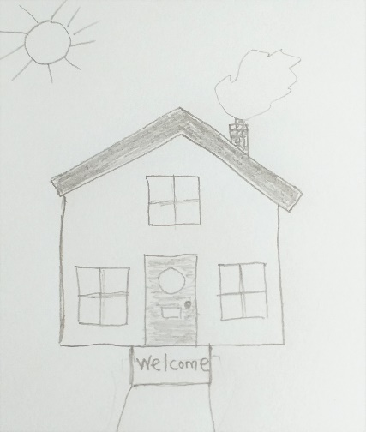
About this topic – The aim of this session is for the children and older people to consider the ways in which homes have changed over the years. The children act as reporters, interviewing the older people about their childhood homes and there is an inventions timeline for everyone to help create. There may be enough material here for two sessions especially if some of the older people are able to bring along photos of their childhood homes.
Resources for this topic
- Suggested session plan
- Our Homes interview sheet
- Inventions Timeline
- Timeline Template
- Our Homes Word Search and Answers
We are happy for you to use the material in this Toolkit exactly as it is or to modify it as required for your purposes. We do however ask that you always acknowledge its source as follows:

“Learning and Sharing Together” Resources (2020)
With thanks to Burnham Health Promotion Trust
Reg. Charity No.1066070 & Reg. Company No.3435602
www.bhpt.org.uk

You may not redistribute, sell or place any part of this Toolkit on any other website or blog without written agreement. Please Contact Us to discuss
Suggested session plan (one and a half hours approx.)
Whilst the plan below has been developed for face to face meetings, all the activities can be modified for use in Virtual meetings too. Instead of working in pairs or small groups the children could take turns to ask each of the adults about their childhood homes. The Inventions Timeline and Our Homes Word Search could be done in break out rooms using the shared screen facility on Zoom.
- Welcome and introductions – Explain that the aim of the session is for the children and older people to think about the ways that homes have changed over the years. For the first part of the session the children will be acting as reporters, interviewing the older people about their childhood homes.
- For this activity it is ideal for one child to work with one adult.
If this is not possible because of uneven numbers, then divide the adults and children into small groups.
- Hand out the Our Homes Interview Sheets (preferably on clipboards) to the children. They will need a separate sheet for each older person that they interview.
- Each child then interviews an older person and writes down their answers to each of the questions. Encourage the children to find out as much as they can from the older person about the home they were living in when they were the same age as the children. If there are more children than older people, then two children can take it in turns to ask the questions and write down the answers. If there are more older people than children, then decide which older person is to be interviewed first – do make sure that everyone gets a chance to be interviewed.
- When the children have completed their interview/interviews ask them to write up a short summary of how homes have changed since the older people were children. Encourage the older people to help them as required.
- Hand out Our Homes Word Search as people finish this activity.
- When all the Our Homes interviews and summaries have been completed divide the children and older people into small groups. Hand out Inventions Timeline. The aim is to correctly match each of the 16 items on Page 1 with date of their invention on Page 2.
- Refreshments and answers to Inventions Timeline

- If there is time, as a whole group activity, create a Timeline from 1876 to the current year (see template for details). Once the inventions and dates have been added you can then add in other dates such as everyone’s year of birth and major events such as World Wars I and II. If there is time some people could do some drawings of the inventions to decorate the timeline.

10. Thankyous and goodbyes - Before the children and older people leave you may wish to say something about the topic or activity you have planned for the next session. This gives everyone the opportunity to be more prepared and, if appropriate, to bring photographs or other memorabilia

Our Homes Interviews

Children – please try to find out as much as you can about the homes the older people lived in when they were about your age. Here are some suggestions for the sorts of questions you can ask
Whereabouts were you living when you were my age?

Who was living there with you?

What sort of home did you live in at that time?
e.g. Was it a house, a bungalow or a flat? How old was it? How many rooms did it have? Did it have a garden?

What sort of heating did you have in your home?

Can you describe what your kitchen was like when you were about my age? What did it have in it?

Did you have your own bedroom or did you share?

What do you think are the main differences between homes when you were a child and homes today?

Inventions Timeline (Page1)
Here are 16 inventions that have all made a big difference to the way people live. How many of these items do you have in your home?
On the next page are 16 dates from 1876 to 1997. Can you match the item with the date when it was invented?

Automatic Washing machine

DVD Player

Electric iron

Black and White Television (first broadcast in Britain)

Colour Television (first broadcast in Britain)

Freezer

Fridge

Fully automatic electric kettle

Internet (World Wide Web)

Mobile phone

Personal Computer

Smart phone

Telephone

Transistor Radio

Upright vacuum cleaner (Hoover)

Video recorder

Inventions Timeline (Page 2)
Write the item next to the year when you think it was invented. Remember this date may be quite a few years before the item became widely available.
Automatic Washing machine, DVD Player, Electric Iron, Dishwasher, Black and White TV (first broadcast in Britain), Colour TV (first broadcast in Britain), Freezer, Fridge, Fully automatic electric kettle, Internet, Mobile Phone, Personal Computer, Smart phone, Telephone, Transistor radio, Upright vacuum cleaner, Video recorder
1876
1882
1923
1926
1928
1937
1940
1954
1955
1967
1973
1974
1991
1992
1997

Inventions Timeline Answers

Year | Invention
1876 | Telephone
1882 | Electric iron
1923 | Fridge
1926 | Upright vacuum cleaner (Hoover)
1928 | Black and White Television (first broadcast in Britain)
1937 | Automatic Washing machine
1940 | Freezer
1954 | Transistor Radio
1955 | Fully automatic electric kettle
1963 | Video recorder
1967 | Colour Television (first broadcast in Britain)
1973 | Mobile phone
1974 | Personal Computer
1991 | Internet (World Wide Web)
1992 | Smart phone
1997 | DVD Player

Timeline Template

You will need a piece of paper or card approximately 60cm wide and at least 20cm deep. Two pieces of A4 paper sellotaped together along the shorter edge will be fine.

Draw a horizontal line about 3 cms from the bottom of the page. Starting at the left hand edge mark on 1875 and after 2cm put 1880. Measure 4 cms and put 1890. Continue adding the next decade every 4 cms up to 2020 which will be near the right hand edge.

Next write in the dates and inventions above the line in the appropriate decade. Alternatively cut out the typed dates and inventions and glue them to the paper or card. You can also add in pictures or other dates such as everyone’s year of birth and major events such as World Wars I and II.

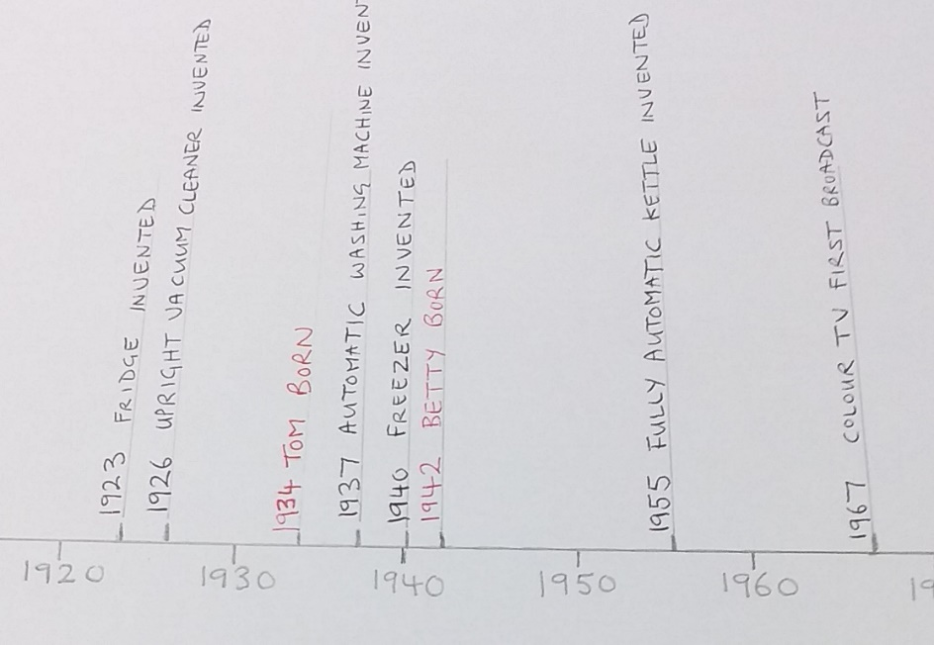

Extract from a Timeline

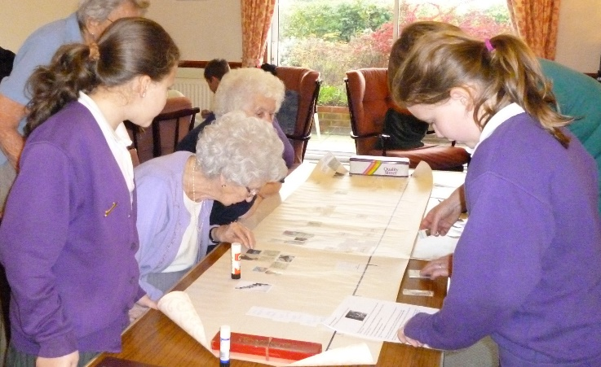

Creating a timeline
Our Homes Word Search
Can you find these 12 words related to “Our Homes” in the grid below?
They may be going forwards or backwards in a horizontal, vertical
or diagonal direction.

Shower Freezer Central Heating Washing machine
Microwave Family Internet Television
Dining room Garden Kitchen Furniture
V | Q | H | U | W | M | L | K | J | J | P | E | E | U | U | R | G
Z | M | O | O | R | G | N | I | N | I | D | O | L | Z | G | N | N
L | E | S | A | W | G | U | O | J | Y | U | T | J | A | I | G | U
U | E | D | J | G | W | Y | I | A | A | L | D | X | T | Q | V | O
X | N | S | C | A | C | T | J | M | G | T | P | A | M | W | V | K
S | L | P | T | R | E | Z | E | E | R | F | E | J | E | F | E | E
F | G | P | K | D | D | R | L | Y | P | H | N | K | B | K | R | D
R | T | K | V | E | I | Y | L | S | L | M | E | S | E | Y | U | X
S | E | V | R | N | T | I | G | A | B | A | H | P | V | I | T | H
Z | L | W | Q | K | M | E | R | P | D | Y | C | C | A | H | I | K
Q | E | D | O | A | S | T | N | X | L | H | T | J | W | P | N | M
Z | V | P | F | H | N | Q | G | R | B | W | I | T | O | M | R | R
R | I | E | W | E | S | V | N | O | E | K | K | U | R | G | U | F
Q | S | A | C | Z | D | D | I | G | O | T | K | G | C | R | F | Z
C | I | N | B | A | V | S | J | N | W | I | N | S | I | S | E | R
E | O | A | W | N | C | G | Y | W | M | B | D | I | M | K | E | C
E | N | I | H | C | A | M | G | N | I | H | S | A | W | C | L | L

Our Homes Word Search Answers
Can you find these 12 words related to “Our Homes” in the grid below?
They may be going forwards or backwards in a horizontal, vertical
or diagonal direction.

Shower Freezer Central Heating Washing machine
Microwave Family Internet Television
Dining room Garden Kitchen Furniture
V | Q | H | U | W | M | L | K | J | J | P | E | E | U | U | R | G
Z | M | O | O | R | G | N | I | N | I | D | O | L | Z | G | N | N
L | E | S | A | W | G | U | O | J | Y | U | T | J | A | I | G | U
U | E | D | J | G | W | Y | I | A | A | L | D | X | T | Q | V | O
X | N | S | C | A | C | T | J | M | G | T | P | A | M | W | V | K
S | L | P | T | R | E | Z | E | E | R | F | E | J | E | F | E | E
F | G | P | K | D | D | R | L | Y | P | H | N | K | B | K | R | D
R | T | K | V | E | I | Y | L | S | L | M | E | S | E | Y | U | X
S | E | V | R | N | T | I | G | A | B | A | H | P | V | I | T | H
Z | L | W | Q | K | M | E | R | P | D | Y | C | C | A | H | I | K
Q | E | D | O | A | S | T | N | X | L | H | T | J | W | P | N | M
Z | V | P | F | H | N | Q | G | R | B | W | I | T | O | M | R | R
R | I | E | W | E | S | V | N | O | E | K | K | U | R | G | U | F
Q | S | A | C | Z | D | D | I | G | O | T | K | G | C | R | F | Z
C | I | N | B | A | V | S | J | N | W | I | N | S | I | S | E | R
E | O | A | W | N | C | G | Y | W | M | B | D | I | M | K | E | C
E | N | I | H | C | A | M | G | N | I | H | S | A | W | C | L | L

