Pancake Day

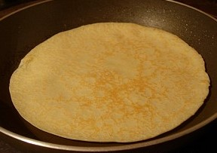
About this topic – Learn some facts and traditions associated with Pancake Day. Test your memory and knowledge with a quiz and have fun with games and pictures
Resources for this topic
- Suggested session plan
- Pancake Day Facts and Traditions
- Pancake Day Quiz and Answers
- Pancake Day Word Game and Answers
- Tossing the Pancake Game
- Mardi Gras Pictures for colouring or drawing

We are happy for you to use the material in this Toolkit exactly as it is or to modify it as required for your purposes. We do however ask that you always acknowledge its source as follows:

“Learning and Sharing Together” Resources (2020)
With thanks to Burnham Health Promotion Trust
Reg. Charity No.1066070 & Reg. Company No.3435602
www.bhpt.org.uk

You may not redistribute, sell or place any part of this Toolkit on any other website or blog without written agreement. Please Contact Us to discuss

Suggested session plan (one and a half hours approx.)
Whilst the plan below has been developed for face to face meetings, all the activities can be used in Virtual meetings too, using the shared screen facility on Zoom for example, and break out rooms for some activities.
- Welcome and introductions
- Working in small groups the children and older people should take turns to read aloud Pancake Day Facts and Traditions. Encourage them to discuss what they have read as there will be a quiz later
- Give out Pancake Day Word Game to groups as they finish 2)
- When all the groups have finished 2) collect in Pancake Day Facts and Traditions and hand out Pancake Day Quiz

- As groups finish the quiz, they should continue with the Pancake Day Word Game.

- Start to play Tossing the Pancake Game as soon as all the groups have finished the Quiz. Alternatively, or as an additional activity, give out Mardi Gras pictures for colouring or drawing
(Before the session you could print off a selection of pictures from https://printablefreecoloring.com/search/?q=mardi+gras)

- Refreshments and Pancake Day Quiz Answers

- Thankyous and goodbyes – Before the children and older people leave you may wish to say something about the topic or activity you have planned for the next session. This gives everyone the opportunity to be more prepared and, if appropriate, to bring photographs or other memorabilia

Pancake Day Facts and Traditions

The origins of Pancake Day
In the Christian Church Shrove Tuesday is the traditional feast day before the start of Lent on Ash Wednesday. Lent is traditionally a time of fasting leading up to Easter so Shrove Tuesday was the last opportunity to use up food like eggs, butter and sugar that would be given up during the Lenten fast. Pancakes were a good way to use these ingredients and it is thought that the British tradition of eating pancakes on Shrove Tuesday developed in the 16th Century.
The name Shrove comes from the old word “Shrive” which means to obtain absolution for one's sins by way of confession and doing penance. Shrove Tuesday was named after the custom of Christians to be "shriven" or forgiven before the start of Lent. The Church bell or “Shriving Bell” would be rung to call people to confession. The bell also served as a reminder for people to start preparing their pancakes. In time it came to be known as the “Pancake Bell” and Shrove Tuesday became known as Pancake Day.
Shrove Tuesday is one of the moveable feasts in the Church calendar and is directly related to the date on which Easter falls. It always falls 47 days before Easter Sunday, so the date varies from year to year between 3rd February and 9th March.
Shrovetide
The last three days before the beginning of Lent are known as Shrovetide and have traditionally been a time of celebration. Shrove Monday was called Collop Monday after the traditional dish of the day which was collops or slices of bacon served with eggs. The collops were also the source of the fat for the next day’s pancakes.
Different parts of the country had different Shrovetide traditions, for example in Cornwall, Shrove Monday night was called “Nickanan Night” and it was a time when boys would run riot in the villages; hiding gates, taking off door knockers and making off with anything that was not locked away!
Pancake Races and other Shrove Tuesday Celebrations
Pancake races have traditionally formed an important part of Shrove Tuesday celebrations in the UK. The object of the race is to get to the finishing line first, carrying a frying pan with a cooked pancake in it and flipping the pancake as you run. The most famous pancake race takes place at Olney in Buckinghamshire. According to tradition, the race was first run in 1445.
No one is completely sure of the origins of the race but one story tells of a woman in Olney hearing the shriving bell while she was making pancakes and so she ran to the church in her apron, still clutching her frying pan.
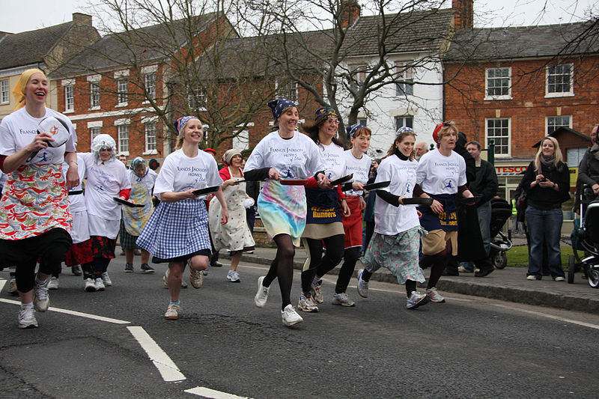
Pancake Race in Olney, Buckinghamshire, 2009 ¹
The Olney pancake race is now world famous. Competitors have to be local women and must wear an apron and a hat or scarf. Each contestant has a frying pan containing a pancake. She must toss it three times during the race which starts at the market square and ends 380 metres away at the Church.
At Westminster School in London, the annual Pancake Grease is held. A verger from Westminster Abbey leads a procession of boys into the playground where the school cook tosses a huge pancake over a five-metre high bar. The boys then race to grab a portion of the pancake and the one who ends up with the largest piece receives money from the Dean.
In Scarborough, Yorkshire, on Shrove Tuesday, everyone assembles on the promenade to skip. Long ropes are stretched across the road and there maybe be ten or more people skipping on one rope. The origins of this custom is not known.
Many towns in England used to hold Shrove Tuesday “mob football” games with large numbers of players. This was a tradition that dated back hundreds of years.
The practice mostly died out with the passing of the 1835 Highways Act which banned the playing of football on public highways.

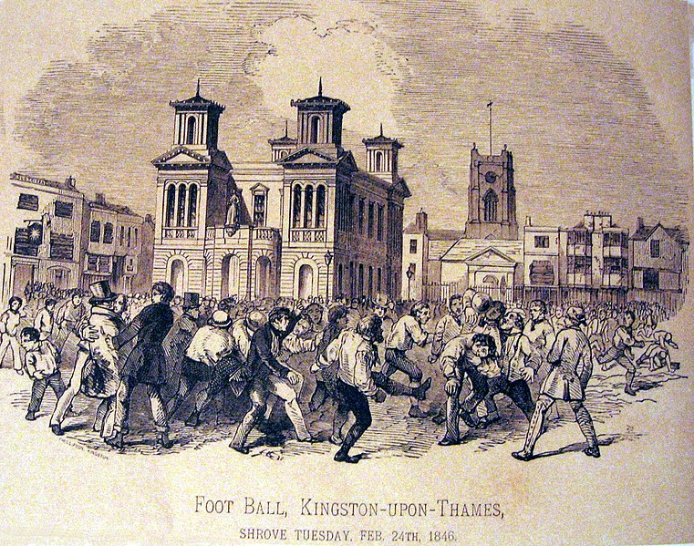

Football match on Shrove Tuesday 1846 - Kingston on Thames, Surrey, England ²
However a number of towns have managed to maintain the tradition to the present day, including Ashbourne in Derbyshire. The Royal Shrovetide Football Match in Ashbourne is played over two eight hour periods over Shrove Tuesday and Ash Wednesday. The goals are three miles apart and there are very few rules. The ball is rarely kicked but instead moves through a giant 'hug'. There is no set pitch: the game is played throughout the entire town, so shops and businesses board up their windows in preparation! The game has been played almost every year since at least 1667, although its exact origins are unknown because records were destroyed in a fire. A specially prepared, hand-sewn leather ball is used. It is larger than a football and filled with cork chippings to help it float in the river. Hundreds of players take part in the game which divides the town and reignites local rivalries. Traditionally your team depends on which side of the Henmore Brook you were born on.
Shrove Tuesday Celebrations around the world
Pancake Day or Shrove Tuesday is celebrated in many parts of the world with all sorts of different traditions that have developed.
In France for example Shrove Tuesday is called Mardi Gras or Fat Tuesday. The name Fat Tuesday comes from the ancient custom of parading a fat ox through Paris on this day. The ox was to remind people that they were not allowed to eat meat during Lent. During the Mardi Gras Carnival people disguise themselves in costumes and masks.
The Brazil Carnival in Rio de Janiero is one of the biggest Mardi Gras celebrations in the world with festivities starting on the Friday before Shrove Tuesday and continuing until midday on Ash Wednesday.
Making pancakes
To make pancakes you will need plain flour, salt, eggs, milk and butter and a frying pan.
Traditional English pancakes are very thin and are sprinkled with caster sugar and freshly squeezed lemon juice and served rolled.

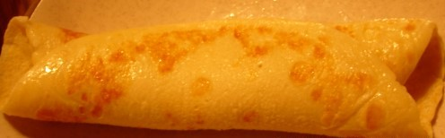
All sorts of other pancake fillings and toppings are now popular including jam, golden syrup, bananas and chocolate sauce, ice cream and toffee sauce.
What do you like best?
With thanks to Mandy Barrow for permission to include information and photos from Project Britain website
https://www.projectbritain.com/pancakeday/index.htm
https://www.projectbritain.com/pancakeday/world.htm

and to Wikipedia for additional information
https://en.wikipedia.org/wiki/Shrove_Tuesday
and photos
¹ Pancake Race in Olney, Buckinghamshire, 2009 https://commons.wikimedia.org/wiki/File:EnglishPancakeRace.jpg
Lestalorm / CC BY-SA https://creativecommons.org/licenses/by-sa/3.0
² Football match on Shrove Tuesday 1846 in Kingston on Thames, Surrey, England https://commons.wikimedia.org/wiki/File:Foot_Ball,_Kingston-upon-Thames,_Shrove_Tuesday,_Feb._24th,_1846.jpg
Photograph in public domain (Unknown author)
Pancake Day Quiz - 25 points
1. What begins the day after Shrove Tuesday? 1 point

2. What is the latest date in March that Shrove Tuesday can occur? 1 point

3. How many days before Easter Sunday does Shrove Tuesday occur? 1 point

4.Why did people traditionally go to Church on Shrove Tuesday? 1 point

5 In which English county does the most famous pancake race take place? 1 point

6 Who is allowed to take part and what must they wear? 3 points

7 How many metres is the course? 1 point

8 How do boys at Westminster School celebrate Pancake Day? 2 points

9 What unusual ways do people celebrate Pancake Day in
a) Scarborough - 1 point

b) Ashbourne in Derbyshire - 1 point

11 Traditionally what food was served the day before Pancake Day? 1 point

12 What bad things did boys do on the night before Pancake Day in Cornwall?
3 possible points

13 What ingredients do you need to make pancakes? 5 possible points

14. What is the French name for Shrove Tuesday? 1 point

15. What traditionally happened in Paris on Shrove Tuesday and why? 2 points

Pancake Day Quiz Answers – 25 points
1. What begins the day after Shrove Tuesday? 1 point
Lent
2. What is the latest date in March that Shrove Tuesday can occur? 1 point
March 9th
3. How many days before Easter Sunday does Shrove Tuesday occur? 1 point
47
4.Why did people traditionally go to Church on Shrove Tuesday? 1 point
For confession (or to be absolved or forgiven from their sins)
5 In which English county does the most famous pancake race take place? 1 point
Buckinghamshire
6 Who is allowed to take part and what must they wear? 3 points
Local women and they must wear an apron and a hat or scarf
7 How many metres is the course? 1 point
380 metres
8 How do boys at Westminster School celebrate Pancake Day? 2 points
They have to race to try and get the largest piece of a huge pancake which the school cook has tossed over a five metre high bar

9 What unusual ways do people celebrate Pancake Day in
a) Scarborough – 1 point
Skipping on the promenade. Long ropes stretched across the road with ten or more people skipping on one rope
b) Ashbourne in Derbyshire – 1 point
a huge two day football match with goals three miles apart and hundreds of players

11 Traditionally what food was served the day before Pancake Day? 1 point
Collops (slices) of bacon and eggs
12 What bad things did boys do on the night before Pancake Day in Cornwall?
3 possible points
hide gates , take off door knockers , run off with anything that people had forgotten to lock away
13 What ingredients do you need to make pancakes? 5 possible points
Plain flour, eggs, milk, butter, salt
14. What is the French name for Shrove Tuesday? 1 point
Mardi Gras
15. What traditionally happened in Paris on Shrove Tuesday and why? 2 points
An ox is taken through the streets to remind people they must not eat meat during Lent

Pancake Word Game
How many words of 3 letters or more can you make out of the word PANCAKE?
You should not include any words that begin with a capital letter e.g. names or places

Pancake Word Game Answers
Here are 20 words. Can you find any more?
ace
acne
ape
cake
can
cane
cap
cape
ken
nap
nape
neck
pace
pack
pan
pane
pea
peak
peck
pen

“Tossing the Pancake” Game
We have had so much fun playing this game!
All you need is a lightweight frying pan and a couple of packets of tortillas from a supermarket.
Take it in turns to toss the “pancake” up in the air and catch it in the pan.
Have a competition to see how many times people can “toss the pancake” without dropping it. Everyone can get involved, either by having a go themselves or by helping to keep score and encouraging one another.
N.B. Do make sure people sit down for this activity if they are likely to be at all unsteady on their feet.
For virtual projects the children could play this game under the supervision of the teaching assistant and the adults could be the supporters, watching and keeping score. The adults and children could be divided into teams to encourage some good natured competition!

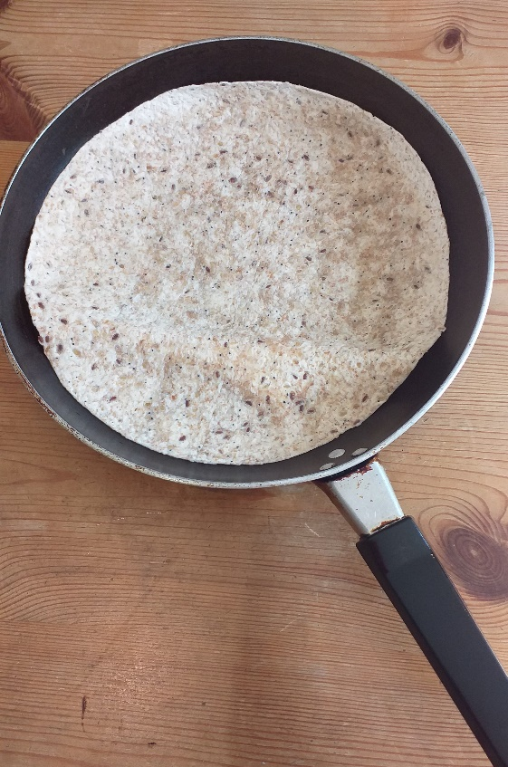

Mardi Gras Pictures to draw or colour in

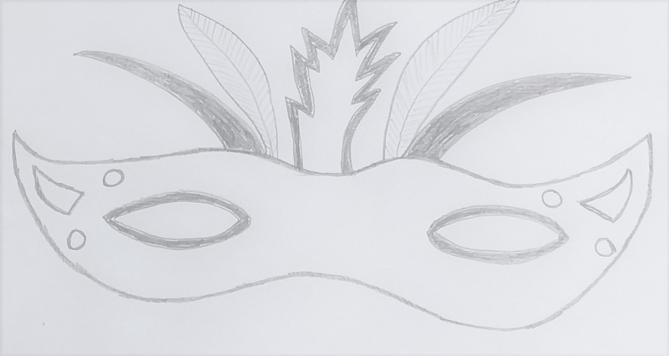
You will find a good selection of Mardi Gras pictures for drawing or colouring in on this website https://printablefreecoloring.com/search/?q=mardi+gras

