Spring

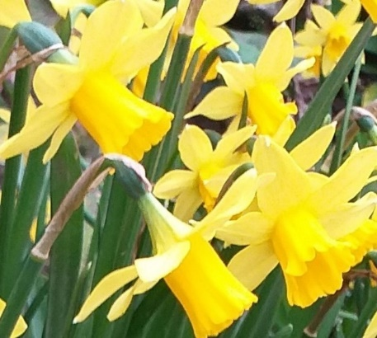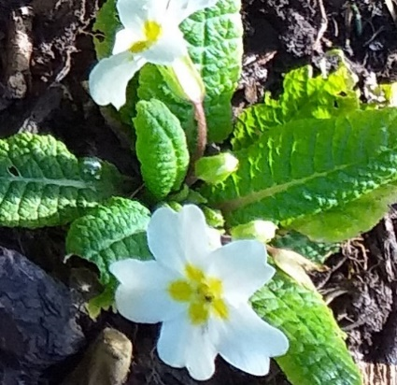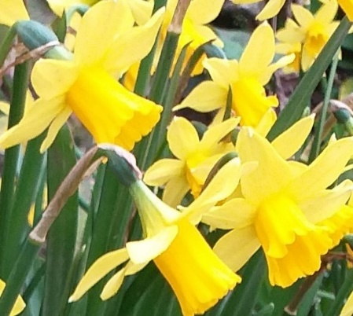
About this topic – Learn some Spring facts and traditions from around the world and test your memory with a quiz. Find out how many Spring flowers you can identify and play a word game.
You may find there is enough material here for two sessions.
Resources for this topic
- Suggested session plan
- Spring Facts and Traditions
- Spring Quiz and Answers
- Spring Flowers Picture Quiz, Answer Sheet and Answers
- Spring Flowers Word Search and Answers
- Spring Word Game

We are happy for you to use the material in this Toolkit exactly as it is or to modify it as required for your purposes. We do however ask that you always acknowledge its source as follows:

“Learning and Sharing Together” Resources (2020)
With thanks to Burnham Health Promotion Trust
Reg. Charity No.1066070 & Reg. Company No.3435602
www.bhpt.org.uk

You may not redistribute, sell or place any part of this Toolkit on any other website or blog without written agreement. Please Contact Us to discuss

Suggested session plan (one and a half hours approx.)
Whilst the plan below has been developed for face to face meetings, all the activities can be used in Virtual meetings too, using the shared screen facility on Zoom for example, and break out rooms for some activities.
- Welcome and introductions – you could start by playing a short piece of Spring music. On Zoom we enjoyed a Spring music video from You Tube.
- Working in small groups the children and older people should take turns to read aloud Spring Facts and Traditions. Encourage them to discuss what they have read as there will be a quiz later
- Give out Spring Flowers Picture Quiz to groups as they finish 2)
- When all the groups have finished 2) collect in Spring Facts and Traditions and hand out Spring Quiz
- As groups finish the Quiz they should continue with the Spring Flowers Picture Quiz. Hand out Spring Flowers Word Search to groups when they have finished the Quiz and the Spring Flowers Picture Quiz
- Go through the Spring Quiz Answers when all the groups have finished the Quiz
- Refreshments and Answers to Spring Flowers Picture Quiz. Continue with Spring Flowers Word Search. If there is time give out the Spring Word Game

- Thankyous and goodbyes - Before the children and older people leave you may wish to say something about the topic or activity you have planned for the next session. This gives everyone the opportunity to be more prepared and, if appropriate, to bring photographs or other memorabilia
Spring facts and traditions
In Spring, the Earth’s axis is tilted toward the sun, increasing the number of hours of daylight and bringing warmer weather.
When it is Spring in the Northern Hemisphere, it will be Autumn in the Southern Hemisphere. In the Northern Hemisphere Spring lasts from the Vernal (Spring) Equinox, which falls between the 19th and 21st March until the Summer Solstice which is around 21st June. The reason the equinoxes and solstices don’t always fall on exactly the same day each year is that the Earth doesn’t circle the sun in exactly 365 days.
A solstice is when the Sun reaches the most southerly or northerly point in the sky, while an equinox is when the Sun passes over the Earth’s equator. The word equinox comes from the Latin equi (meaning equal) and nox (meaning night).
At the Vernal equinox the sun passes the equator moving from the southern to the northern hemisphere and the North Pole begins to tilt towards the sun. At this point day and night are of roughly equal length. After the Vernal equinox the days become increasingly longer and the temperatures become warmer, until the Autumn equinox six months later when the pattern is reversed.
On the first day of Spring, a person at the North Pole would see the sun moving across the horizon, beginning six months of continual daylight. By comparison at the South Pole six months of darkness would be beginning.
Hundreds of years ago the season we now call Spring was called Lent in Old English. Around the 14th century, it was called “springing time” which was a reference to plants “springing” from the ground. During the 15th century this got shortened to “spring-time,” and then further shortened in the 16th century to just “spring.”
Many trees, flowers, plants and bulbs begin to grow during the Spring because of the availability of water, light, warmth and good soil conditions.
As it stays light for longer in spring, birds know it is time to find a mate. They do this by singing to each other.
Many herbivores (plant eating animals) have their young in early Spring because of the good food supplies in spring and summer which give them the best chance of growing large and strong and putting on some fat before winter.
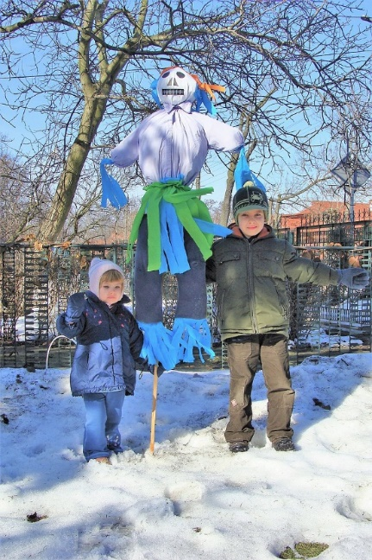
There are many Spring celebrations around the world some of which date back thousands of years to ancient and pagan rituals that marked the Spring Equinox. Spring was seen as a sign of renewal, rebirth and fertility. For agricultural communities it was the time for planting crops.
Here are some examples of Springtime traditions from around the world:
Poland - In a tradition dating backs hundreds of years many Polish people celebrate the first day of Spring by drowning dolls called Marzannas.
These dolls are generally made of straw. The dolls are paraded through the streets accompanied by crowds of men, women and children all making their way to a river, lake or pond or other stretch of water. The dolls are then thrown into the water to symbolize the end of winter.
Two Polish children with their Marzanna ¹

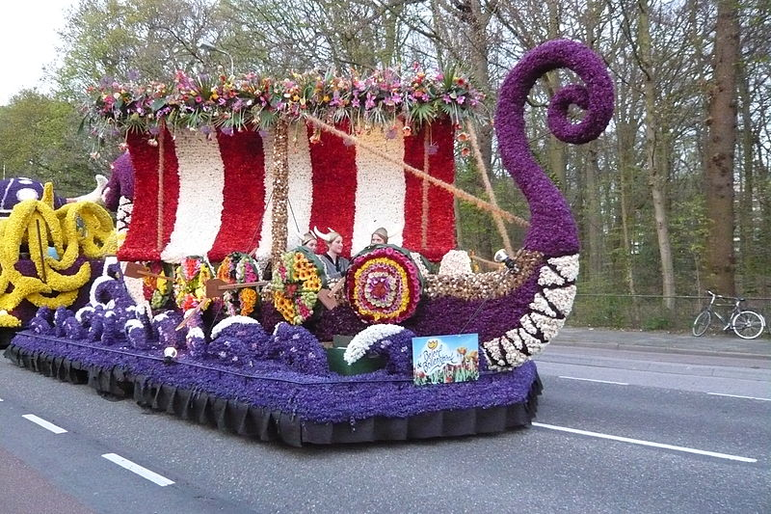
The Netherlands – “Bloemencorso” is a Dutch word which means flower parade. Many towns and regions in the Netherlands and Belgium hold parades every year. Each parade has its own character and theme.
One of the largest and most famous is the Bloemencorso Bollenstreek which takes place every April in the southern part of the Netherlands. The parade sets off from Noordwijk and ends 12 hours later and about 25 miles away in the city of Haarlem. Hundreds of thousands of people line the route to admire the floats and cars with their beautiful displays which include many of the Spring bulb flowers like hyacinths, tulips and daffodils for which the region is so famous.
Switzerland – In Zurich in Switzerland there is a tradition known as “The Böögg” which dates back to the 16th Century. On the 3rd Monday of April, to celebrate the end of the dark winter days, a snowman is burned on a stake. The head of the snowman is stuffed with explosives and it is said that if the head explodes quickly it is an indication of a warm, sunny summer ahead whilst a longer burning time suggests a cold and rainy one.
Bloemencorso Bollenstreek, 2010 ²
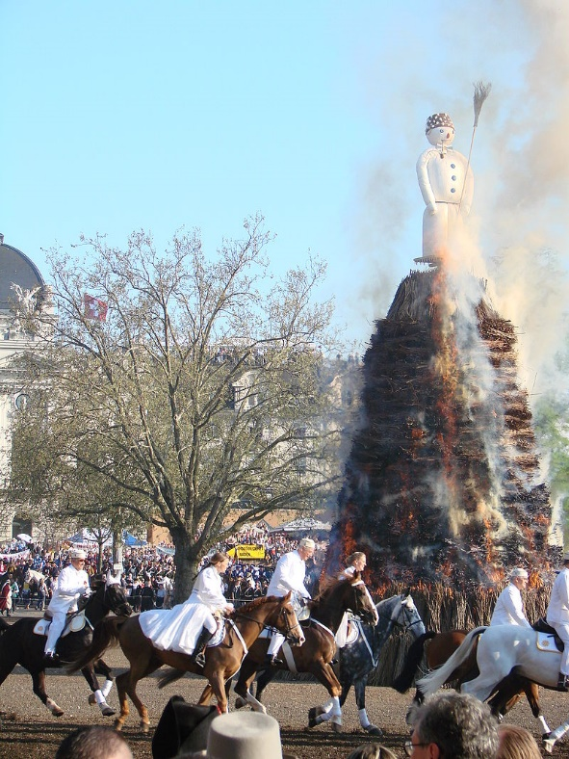
The origins of the festival are believed to go back to medieval times when the first day of summer working hours was celebrated across the city. The length of the working day was strictly regulated at that time. During the winter people worked as long as there was daylight but on the Monday following the Spring Equinox the law stated that work must cease when the church bells tolled at six o'clock. Changing to summer working hours traditionally was a joyous occasion because it marked the beginning of the season where people had some non-working daylight hours.
Böögg burning, Zurich, 2007 ³

Bosnia - Every March as Spring begins, thousands of people congregate in Zenica, Bosnia, to celebrate the start of the new season at Cimburijada or the "Festival of Scrambled Eggs". The egg symbolises new life and huge quantities of scrambled eggs are cooked in huge pans in a tradition dating back hundreds of years.
Scotland - In Lanark in Scotland, as the church bell rings 6pm on the 1st of March, local children run three laps around the church in a clockwise direction , swinging balls of crumpled paper around their heads. This is called "Whuppity Scoorie" and dates back at least to the early 19th Century.

One explanation for this tradition is that it originated to rid the town of evil spirits before the spring season started.
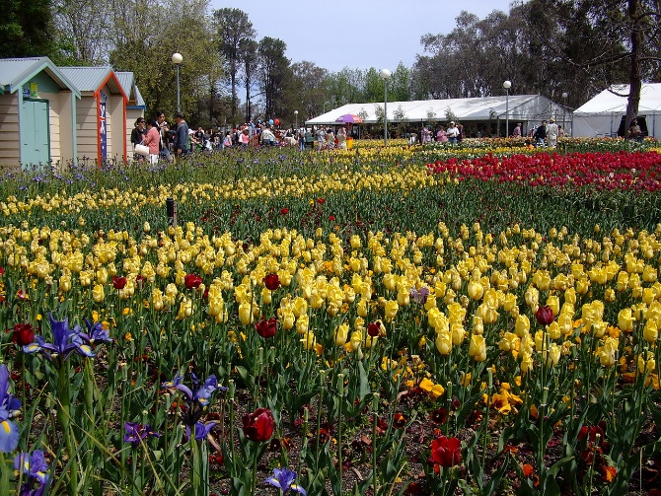
Australia - In a relatively new tradition in Australia's capital, Canberra, thousands of people visit the huge flower festival or Floriade which is held each September when the Spring season begins in the Southern Hemisphere.
As well as the wonderful displays of flowers in the Commonwealth Park the festival includes art displays, concerts
and all sorts of other entertainment.
Spring flowers in Floriade, Canberra ⁴

Japan - Cherry blossom is the national flower of Japan. In Japanese it is known as “sakura” and it is seen as a symbol of renewal and hope each year as it heralds the arrival of spring. During cherry blossom season which generally lasts for about 14 days between late March to mid-April there is a tradition called “hanami”, or “flower viewing”. It’s a custom that dates back many centuries. Many people enjoy parties and picnics underneath the cherry trees.
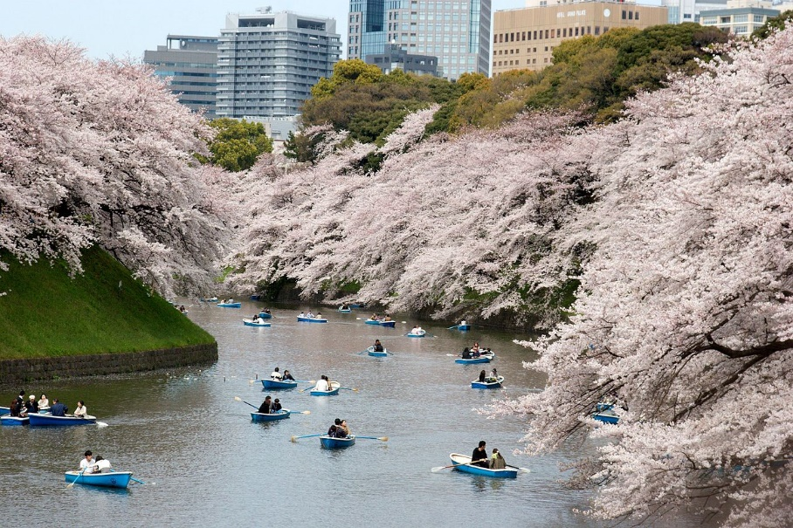
Enjoying the cherry blossoms along the Imperial Palace moat in Tokyo, Japan ⁵

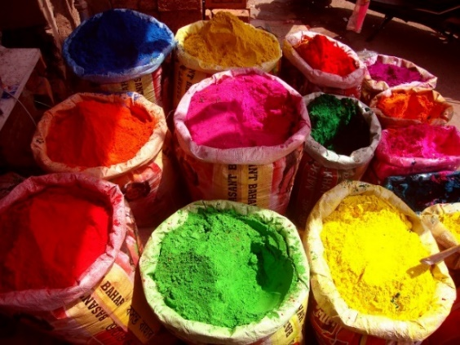
India - Holi is a popular ancient Hindu Spring festival which originated in India. It is now also celebrated in many other part of Asia as well as in many other places around the world .
Holi is also known as the "festival of colours" or the "festival of love". The festival symbolises the victory of good over evil and the end of winter and the arrival of spring.
Colours for Holi on sale at a market in Mysore, India ⁶
For many people it is a festive day to meet others, play and laugh, forget and forgive, and repair broken relationships. It is also celebrated as a thanksgiving for a good harvest. To welcome the Spring season, people celebrate the night before Holi with bonfires and parties. The next day, people meet on the streets for a giant colour fight, throwing dyed powder onto each other. The relaxed and carefree atmosphere offers people a chance to connect with one another and let go of past difficulties.
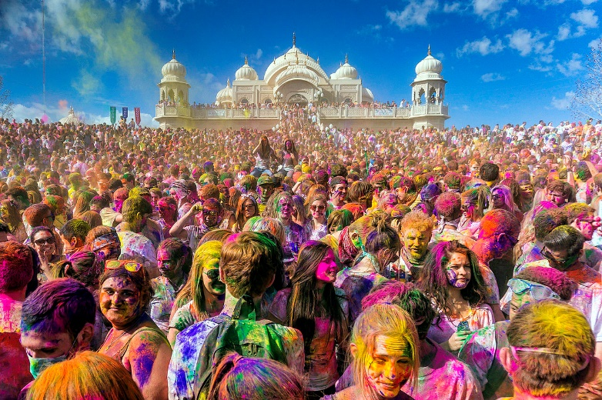
Holi celebrations at Sri Radha Krishna Temple in Utah, USA in 2013 ⁶

Photographs with thanks to Wikipedia
¹ Two Polish children with their Marzanna
https://commons.wikimedia.org/wiki/File:Morana.jpg
Ratomir Wilkowski, www.RKP.org.pl / CC BY https://creativecommons.org/licenses/by/3.0
² Bloemencorso Bollenstreek, 2010 ²
https://commons.wikimedia.org/wiki/File:Bloemencorso_2010_Herenweg,_
Heemstede_13.JPG
Jane023 / CC0 Creative Commons CC0 1.0 Universal Public Domain Dedication
³ Böögg burning, Zurich City, April 2007
https://commons.wikimedia.org/wiki/File:Sechselauten_2007_Boegg_Burning.JPG
Guérin Nicolas (messages) / CC BY-SA
https://creativecommons.org/licenses/by-sa/3.0

⁴ Spring flowers in Floriade, Canberra
https://commons.wikimedia.org/wiki/File:Floriade07.jpg
Dfrg.msc / CC BY https://creativecommons.org/licenses/by/3.0

⁵ Enjoying the cherry blossoms along the Imperial Palace moat in Tokyo, Japan https://commons.wikimedia.org/wiki/File:Chidorigafuchi_(3451082281).jpg
KimonBerlin / CC BY-SA https://creativecommons.org/licenses/by-sa/2.0

⁶ Colours for Holi on sale at a market in Mysore, India
https://commons.wikimedia.org/wiki/File:Holi_shop.jpg
Kamalakanta777 / CC BY-SA (https://creativecommons.org/licenses/by-sa/3.0
⁷ 2013 Holi celebrated at Utah's Sri Radha Krishna Temple, Utah, USA
https://commons.wikimedia.org/wiki/File:Holi_Festival_of_Colors_Utah,_
United_States_2013.jpg
Steven Gerner / CC BY-SA (https://creativecommons.org/licenses/by-sa/2.0)
Springs Facts and Traditions Quiz (25 points)
1. In which country do people celebrate Spring by eating scrambled eggs? (1 point)

2. How do children in Lanark celebrate on March 1st? (Up to 2 points)

3. i) What is the name (in English and Japanese) of the flower associated with Spring in Japan (2 points) and ii) what is the name (in English and Japanese) of the Spring celebration in Japan (2 points)?
i)
ii)
4. Approximately how long is the Bollenstreek flower parade in Holland in hours and what distance is the route in miles? (2 points)

5. Name three flowers that you could expect to see on this parade – (3 points)

6. In which park and in which Australian city could you see a Spring flower festival in September? (2 points)

7. What is the name of the famous Hindu Festival celebrated in Spring and what other 2 names is it known by? (3 points)

8. How do people celebrate Spring in Switzerland and what is this tradition called?
(2 points)

9. Why would people be pleased if the main event finished quickly? (1 point)

10. In which country would you see a Marzanna and what would it probably be made of? (2 points)

11. What is the meaning in English of the Latin words "vernal equinox"? (2 points)

12. What was the old English word for Spring? (1 point)

Springs Facts and Traditions Quiz Answers (25 points)
1. In which country do people celebrate Spring by eating scrambled eggs? (1 point)
Bosnia
2. How do children in Lanark celebrate on March 1st? (Up to 2 points)
Run 3 laps around the church swinging balls of crumpled paper over their heads
3. What is the name (in English and Japanese) of the flower associated with Spring in Japan (2 points) i) Cherry blossom, Sakura
and what is the name (in English and Japanese) of the Spring celebration in Japan (2 points)? ii) Flower viewing, hanami
4. Approximately how long is the Bollenstreek flower parade in Holland in hours and what distance is the route in miles? (2 points)
12 hours, 25 miles
5. Name three flowers that you could expect to see on this parade – (3 points)
Daffodil, tulip, hyacinth
6. In which park and in which Australian city could you see a Spring flower festival in September? (2 points)
Commonwealth Park in Canberra
7. What is the name of the famous Hindu Festival celebrated in Spring and what other 2 names is it known by? (3 points)
Holi, Festival of Colour, Festival of Love
8. How do people celebrate Spring in Switzerland and what is this tradition called?
(2 points)
By burning a snowman on a stake. Böögg
9. Why would people be pleased if the main event finished quickly? (1 point)
If the snowman’s head burns quickly it indicates a long warn summer ahead
10. In which country would you see a Marzanna and what would it probably be made of? (2 points)
Poland, Straw
11. What is the meaning in English of the Latin words "vernal equinox"? ( 2 points)
Vernal = Spring Equinox = Equal night
12. What was the old English word for Spring? (1 point)
Lent

Spring Flowers
Can you name these 12 Spring Flowers?
Write your answers on the separate answer sheet
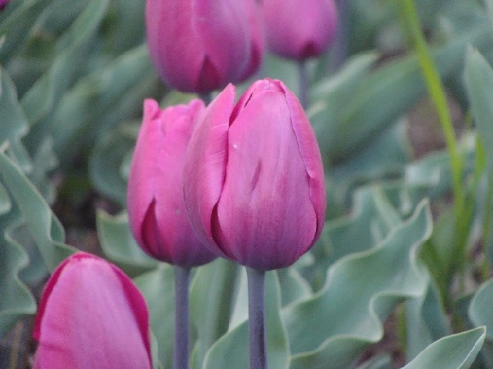 | 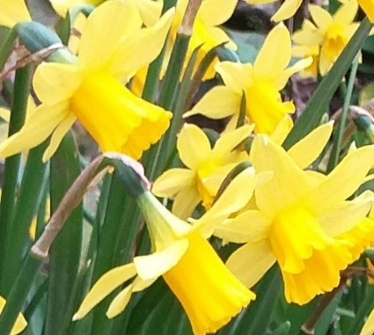
1 | 2
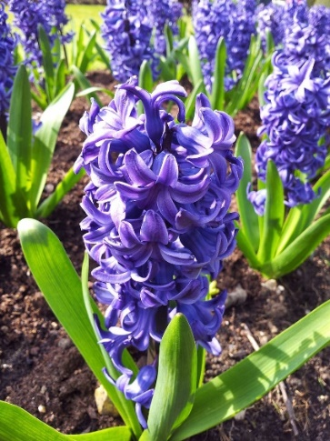 | 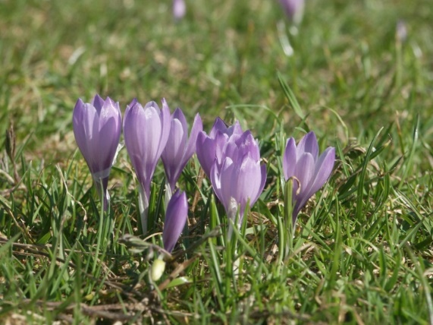
3 | 4
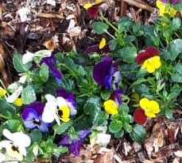 | 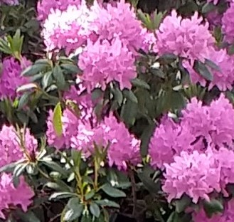
5 | 6
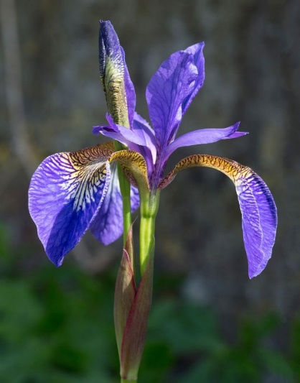 | 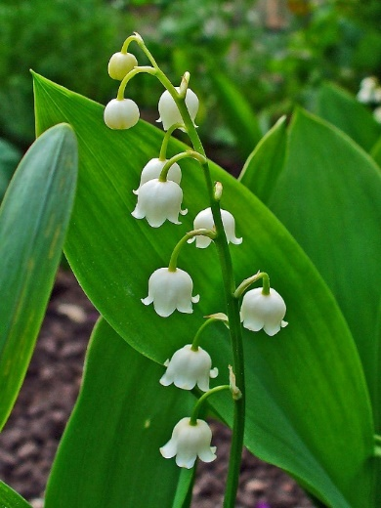
7 | 8
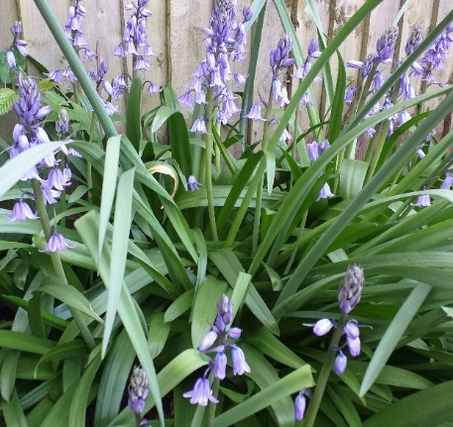 | 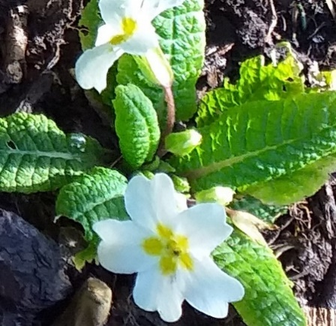
9 | 10
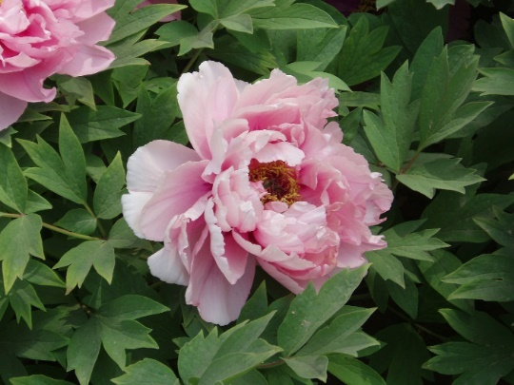 | 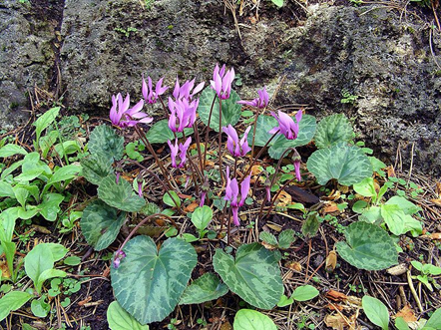
11 | 12

With thanks to Wikipedia for images 1,3,4,7,8,11 and 12 – see Answer sheet for references
Name the Spring Flower Answer sheet
1

2

3

4

5

6

7

8

9

10

11

12

Name the Spring Flower Answers
* With thanks to Wikipedia for photos 1,3, 4, 7, 8, 11,12 – see details below
1 Tulip *
2 Daffodil
3 Hyacinth *
4 Crocus *
5 Pansy
6 Rhododendron
7 Iris *
8 Lily of the Valley *
9 Bluebell
10 Primrose or primula
11 Peony*
12 Cyclamen*
1 Tulip https://upload.wikimedia.org/wikipedia/en/a/ac/Cultivated_Tulip_in_Tulip_
Garden%2C_Srinagar.jpg
licensed under the Creative Commons Attribution-ShareAlike 3.0 License.
3 Hyacinth https://upload.wikimedia.org/wikipedia/commons/7/7e/Hyacinth_-
_Anglesey_Abbey.jpg
The wub / CC BY-SA (https://creativecommons.org/licenses/by-sa/3.0

4 Crocus https://upload.wikimedia.org/wikipedia/commons/3/32/Crocus_vernus_group1.jpg
Bernd Haynold / CC BY-SA http://creativecommons.org/licenses/by-sa/3.0/
7 Iris https://en.wikipedia.org/wiki/Iris_(plant)#/media/File:Iris_germanica_
(Purple_bearded_Iris),_Wakehurst_Place,_UK_-_Diliff.jpg
Diliff / CC BY-SA https://creativecommons.org/licenses/by-sa/3.0
8 Lily of the Valley
https://en.wikipedia.org/wiki/Lily_of_the_valley#/media/File:Convallaria_majalis_0002.JPG
H. Zell / CC BY-SA https://creativecommons.org/licenses/by-sa/3.0
11 Peony https://upload.wikimedia.org/wikipedia/commons/f/fd/PaeoniaSuffruticosa7.jpg
Taken by Fanghong / CC BY-SA http://creativecommons.org/licenses/by-sa/3.0/
12 Cyclamen https://commons.wikimedia.org/wiki/File:Cyclamen_purpurascens_Orchi_01.jpg
Orchi / CC BY-SA (http://creativecommons.org/licenses/by-sa/3.0/)
Spring Flowers Word Search
Now try and find the names of the 12 Spring Flowers in this Word Search. They may be going forwards or backwards in a horizontal, vertical or diagonal direction.

D | U | T | C | D | H | J | T | K | U | I | O | B | G | W | T | L
K | P | H | V | J | Q | N | S | X | Y | G | U | S | U | D | P | I
E | W | R | U | U | N | B | A | P | I | L | U | T | D | L | Q | M
G | V | B | G | H | V | V | P | A | C | E | E | Y | P | I | W | U
U | P | W | H | L | J | W | P | Y | Z | P | A | A | P | L | U | I
B | G | F | L | V | B | R | C | B | J | G | N | N | F | Y | M | G
P | L | W | E | Y | I | L | L | S | D | S | F | O | E | O | M | H
B | E | J | D | M | A | E | S | P | Y | F | C | R | E | F | C | R
P | D | O | R | M | Y | T | R | S | P | Y | R | D | S | T | P | B
I | N | O | E | M | P | X | H | I | P | C | O | N | Y | H | H | J
O | S | N | T | J | F | R | Z | R | A | I | C | E | N | E | S | R
E | E | F | M | V | I | S | V | I | S | G | U | D | O | V | J | Y
K | H | W | R | V | Y | O | E | O | L | Q | S | O | E | A | U | X
Y | Q | C | B | L | O | Q | M | W | W | M | J | D | P | L | H | L
G | L | L | E | B | E | U | L | B | X | S | X | O | C | L | T | A
P | L | A | V | H | T | N | I | C | A | Y | H | H | E | E | E | I
R | A | G | R | D | A | F | F | O | D | I | L | R | F | Y | J | L

Spring Flowers Word Search Answers

D | U | T | C | D | H | J | T | K | U | I | O | B | G | W | T | L
K | P | H | V | J | Q | N | S | X | Y | G | U | S | U | D | P | I
E | W | R | U | U | N | B | A | P | I | L | U | T | D | L | Q | M
G | V | B | G | H | V | V | P | A | C | E | E | Y | P | I | W | U
U | P | W | H | L | J | W | P | Y | Z | P | A | A | P | L | U | I
B | G | F | L | V | B | R | C | B | J | G | N | N | F | Y | M | G
P | L | W | E | Y | I | L | L | S | D | S | F | O | E | O | M | H
B | E | J | D | M | A | E | S | P | Y | F | C | R | E | F | C | R
P | D | O | R | M | Y | T | R | S | P | Y | R | D | S | T | P | B
I | N | O | E | M | P | X | H | I | P | C | O | N | Y | H | H | J
O | S | N | T | J | F | R | Z | R | A | I | C | E | N | E | S | R
E | E | F | M | V | I | S | V | I | S | G | U | D | O | V | J | Y
K | H | W | R | V | Y | O | E | O | L | Q | S | O | E | A | U | X
Y | Q | C | B | L | O | Q | M | W | W | M | J | D | P | L | H | L
G | L | L | E | B | E | U | L | B | X | S | X | O | C | L | T | A
P | L | A | V | H | T | N | I | C | A | Y | H | H | E | E | E | I
R | A | G | R | D | A | F | F | O | D | I | L | R | F | Y | J | L

Spring Word Game
How many words of three letters or more can you make out of the word SPRING? (excluding plurals and words that begin with a capital letter e.g. names or places)

Spring Word Game Answers
How many words of three letters or more can you make out of the word SPRING? (excluding plurals and words that begin with a capital letter e.g. names or places)
Here are 14 – can you find more?
Gin
Grin
Grip
Nip
Pig
Ping
Pin
Rig
Ring
Sin
Sing
Sip
Spin
Sprig

