St David’s Day

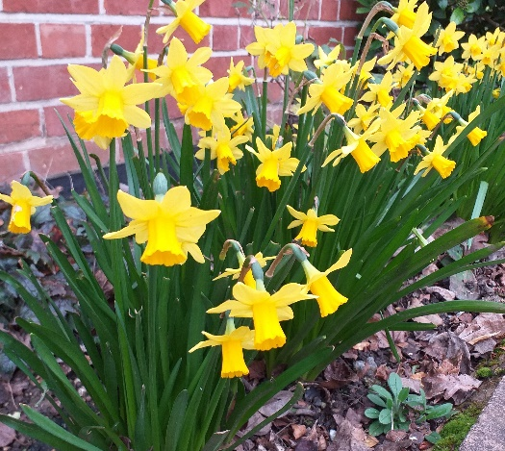
About this topic – Learn about St David and some of the traditions associated with St David’s Day. Find out about different types of daffodils, read a famous poem and draw some daffodils.
Resources for this topic
- Suggested session plan
- St David’s Day Facts
- St David’s Day Quiz and Answers
- Daffodils Facts
- Daffodils Poem
- A pot or vase of daffodils (not provided here!)
We are happy for you to use the material in this Toolkit exactly as it is or to modify it as required for your purposes. We do however ask that you always acknowledge its source as follows:

“Learning and Sharing Together” Resources (2020)
With thanks to Burnham Health Promotion Trust
Reg. Charity No.1066070 & Reg. Company No.3435602
www.bhpt.org.uk

You may not redistribute, sell or place any part of this Toolkit on any other website or blog without written agreement. Please Contact Us to discuss

Suggested session plan (one and a half hours approx.)
Whilst the plan below has been developed for face to face meetings, all the activities can be used in Virtual meetings too, using the shared screen facility on Zoom for example, and break out rooms for some activities.
For this session we suggest you bring a pot or vase of daffodils
- Welcome and introductions
- Working in small groups the children and older people should take turns to read aloud St David’s Day Facts. Encourage them to discuss what they have read as there will be a quiz later
- Give out Daffodils Facts and Daffodils Poem for groups to read and discuss as they finish 2)
- When all the groups have finished 2) collect in St David’s Day Facts and hand out St David’s Day Quiz

- As groups finish the quiz, they should continue reading and discussing the Daffodils Facts and Daffodils Poem

- Go through the St David’s Day Quiz Answers when all the groups have finished the quiz

- Give out paper for children and older people to draw the pot or vase of daffodils

- Refreshments – continue with Daffodils drawings

- Thankyous and goodbyes - Before the children and older people leave you may wish to say something about the topic or activity you have planned for the next session. This gives everyone the opportunity to be more prepared and perhaps to bring photographs or other memorabilia
St David’s Day
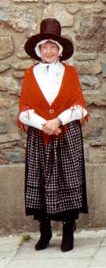
St David’s Day takes place on 1st March each year. It is the feast of St David, the Patron Saint of Wales.
It commemorates the anniversary of his death in 589 and was declared the Welsh National Day in the 18th century.
Two national emblems, the daffodil and the leek, are traditionally worn on St David's Day. Some women and girls also dress up in traditional Welsh costume which consists of a long woolen skirt, white blouse, woolen shawl and a distinctive Welsh hat.
The Flag of Saint David is flown from most public buildings as well as from many private premises. Many Welsh people take part in eisteddfods of singing, dancing and recitals. Celebrations take place not only in Wales but also in many places around the world where Welsh people live.

Saint David - St David, who is known in Welsh as Dewi Sant, was born around about 500 AD. He was the son of a member of the Royal Family of Wales. David became a well-known teacher and preacher, rising to the position of Bishop and establishing monasteries and churches in Brittany, Cornwall and Wales at a time when many areas of the British Isles were still mostly pagan. He also went on pilgrimages to Jerusalem and Rome.

David led an austere life and expected his monks to do the same. They were allowed no personal possessions. They lived on a diet of bread with salt and herbs, washed down with water, and worked hard on the land, pulling the plough themselves instead of using draft animals. When they were not working, they devoted their time to prayer, meditation, reading and writing.

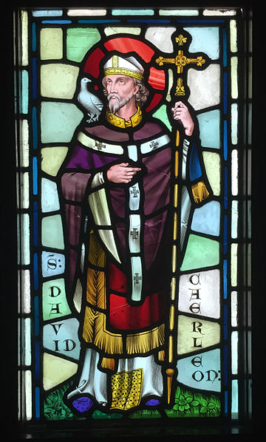
David performed several miracles. The best known is said to have taken place when those at the back of a crowd to which he was preaching complained they could not see or hear him. It is said that the ground beneath his feet rose to lift him and a white dove appeared on his shoulder. This was seen as a sign of God’s grace and blessing. David died on 1st March 589 and was buried at St David’s Cathedral which stands on the site of a monastery he founded in the valley of Glyn Rhosyn in Pembrokeshire. His shrine became a popular pilgrimage destination in the Middle Ages.

Stained glass depiction of St David, designed by William Burgess, Castell Coch, Cardiff ¹
The Welsh National Flag
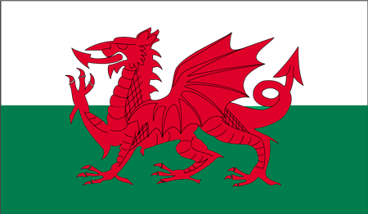The Welsh National Flag was granted official status in 1959, but the red dragon itself has been associated with Wales for centuries. The origin of the adoption of the dragon symbol is now lost in history but one possible explanation is that the Romans brought the emblem to what is now Wales during their occupation of Britain. The green and white stripes of the flag were added by the House of Tudor, the Welsh dynasty that held the English throne from 1485 to 1603. Green and white are also the colours of the leek, another national emblem of Wales.
The Welsh Flag is the only flag of the four countries of the UK not to be incorporated into the Union Flag, the national flag of the United Kingdom. Wales had no explicit recognition in the flag because Wales had been annexed by Edward I of England in 1282 and was still considered a part of the Kingdom of England when the flag of Great Britain was designed in 1606.
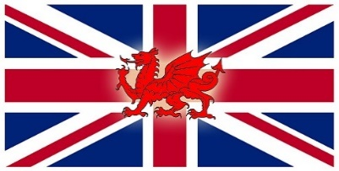
Over the years there have been proposals to include the Dragon or the flag of Saint David on the Union Flag, but these have not met with much support. This is what a new flag might look like.
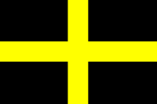Apart from the national Flag of Wales, the flag most associated with the country of Wales is the Flag of Saint David. Although not as well known as the Red Dragon, the Flag of St David has grown in recognition from the late 20th century to the early 21st century. The Flag of St David, a yellow cross on a black background, is flown throughout Wales during St. David's Day, and in recent times the flag has been adopted as a symbol of Welsh nationalism.
With thanks to Mandy Barrow for permission to include images from Project Britain website http://projectbritain.com/nationaldays/wales.html
With thanks to Wikipedia for
¹ Stained Glass depiction of St David, designed by William Burgess, Castell Coch, Cardiff
https://commons.wikimedia.org/wiki/File:Castell_Coch_stained_glass_panel_2.JPG
Hchc2009 / CC BY-SA (https://creativecommons.org/licenses/by-sa/4.0)

St David’s Day Quiz (20 possible points)

- Why was March 1st chosen as the date for St David’s Day? 1 point

- Which two national emblems do Welsh people traditionally wear on St David’s Day? 2 points

- What is the traditional Welsh costume worn by women and girls? Up to 4 points

- What sort of family was David born into? 1 point

- Which two places did David go to on pilgrimages? 2 points

- What sort of diet did David’s monks have? 2 points

- What was unusual about the way they farmed the land? 1 point

8. What miracle is said to have happened when David was preaching to a
very large crowd? 2 points

- What are the colours and design of the flag that is traditionally flown on St David’s Day? 2 points

- What is unusual about the Welsh National flag? 1 point

Can you draw it? Up to 2 points

St David’s Day Quiz Answers

- March 1st was date of St David’s death in 589 (1 point)
- Daffodil and leek (2 points)
- Long woollen skirt, white blouse, woollen shawl and tall black Welsh hat
(4 points)
- He was the son of a member of the Welsh Royal family (1 point)
- Jerusalem and Rome (2 points)
- Bread with salt and herbs, water to drink (2 points)
- Pulled plough by hand (1 point)
- Ground rose up so that people at back could see him and a white dove appeared on his shoulder (2 points)
- Yellow cross on a black background (2 points)

- Only flag of a UK country not in the Union Jack (1 point)

2 points for correct drawing
Some Facts about Daffodils
Botanically speaking, daffodils are known as narcissus, but most people refer to these popular spring flowers as daffodils. Depending on who you talk to, there are currently between 40 and 200 different species of daffodil and over 32,000 registered varieties. All parts of the daffodil are toxic and can cause nausea, sickness and an upset stomach if eaten. For horticultural purposes, daffodils are split into 13 divisions according to the size and shape of their cups in relation to their petals. Here are six examples:
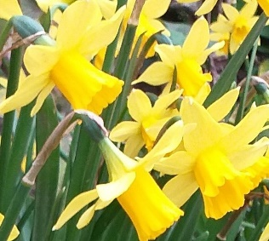
Trumpet – these have large blooms and only one flower
to a stem, with trumpets that are as long or longer than their petals.

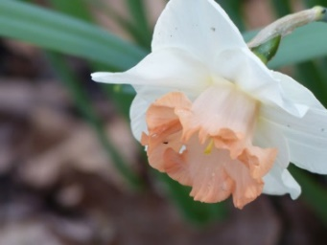
Large Cupped - these have cups that are more than one third, but less than equal to the length of their petals. Each stem bears a single flower.
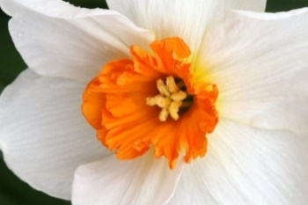
Small cupped - these daffodils have cups that are not more than one third the length of their petals. Each stem carries one medium-sized flower
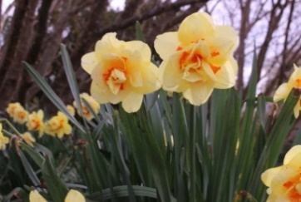
Doubles - these have frilly rows of petals that resemble carnations. Each produces one or more blooms to a stem.

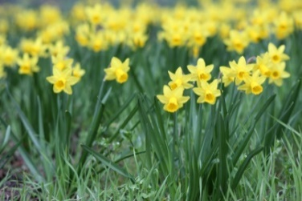
Jonquils - these have dark green, tube-shaped leaves instead of the flat leaves found in most daffodils. They have a strong fragrance and three or more small flowers to a stem.

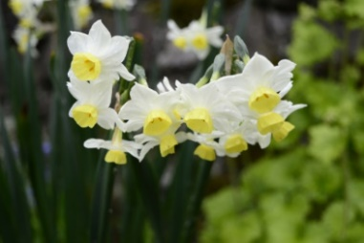
Tazettas – these fragrant daffodils can produce up to twenty short cupped flowers to a stem
Daffodils

I wandered lonely as a cloud
That floats on high o'er vales and hills,
When all at once I saw a crowd,
A host, of golden daffodils;
Beside the lake, beneath the trees,
Fluttering and dancing in the breeze.

Continuous as the stars that shine
And twinkle on the milky way,
They stretched in never-ending line
Along the margin of a bay:
Ten thousand saw I at a glance,
Tossing their heads in sprightly dance.

The waves beside them danced; but they
Out-did the sparkling waves in glee:
A poet could not but be gay,
In such a jocund company:
I gazed—and gazed—but little thought
What wealth the show to me had brought:

For oft, when on my couch I lie
In vacant or in pensive mood,
They flash upon that inward eye
Which is the bliss of solitude;
And then my heart with pleasure fills,
And dances with the daffodils.

William Wordsworth

William Wordsworth was an English poet who was born in the Lake District. It is thought that he composed this famous poem in 1804, two years after he saw the daffodils while walking along the shore of Lake Ullswater on a stormy day with his sister, Dorothy.

