Autumn

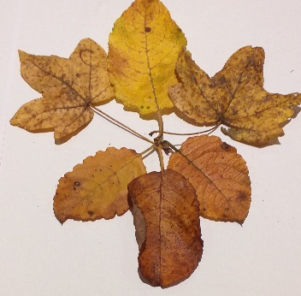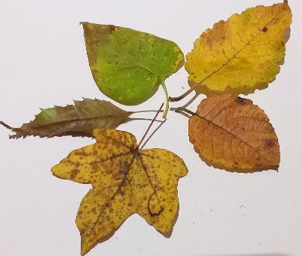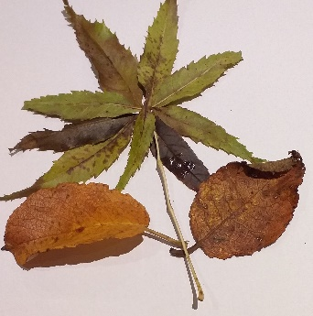
About this topic – Learn about the changes associated with this time of year and test your memory and knowledge with a quiz and games
Resources for this topic
- Suggested session plan
- Autumn Facts
- Autumn Quiz and Answers
- Tree Picture Quiz and Answers
- Autumn Word Search and Answers
- Tree Word Scramble and Answers
- Additional Activities for Autumn

We are happy for you to use the material in this Toolkit exactly as it is or to modify it as required for your purposes. We do however ask that you always acknowledge its source as follows:

“Learning and Sharing Together” Resources (2020)
With thanks to Burnham Health Promotion Trust
Reg. Charity No.1066070 & Reg. Company No.3435602
www.bhpt.org.uk

You may not redistribute, sell or place any part of this Toolkit on any other website or blog without written agreement. Please Contact Us to discuss

Suggested session plan (one and a half hours approx.)
Whilst the plan below has been developed for face to face meetings, all the activities can be used in Virtual meetings too, using the shared screen facility on Zoom for example, and break out rooms for some activities.
- Welcome and introductions
- Working in small groups the children and older people should take turns to read aloud Autumn Facts. Encourage them to discuss what they have read as there will be a quiz later
- Give out Tree Picture Quiz to groups as they finish 2)
- When all the groups have finished 2) collect in Autumn Facts and hand out Autumn Quiz

- As groups finish the quiz, they should continue with the Tree Picture Quiz. Hand out Autumn Word Search to groups when they have finished the Quiz and Tree Picture Quiz

- Go through the Autumn Quiz Answers when all the groups have finished the quiz

- Refreshments and Answers to Tree Picture Quiz.

- Additional activity if required - Tree Word Scramble

- Thankyous and goodbyes - Before the children and older people leave you may wish to say something about the topic or activity you have planned for the next session. This gives everyone the opportunity to be more prepared and, if appropriate, to bring photographs or other memorabilia

Autumn Facts

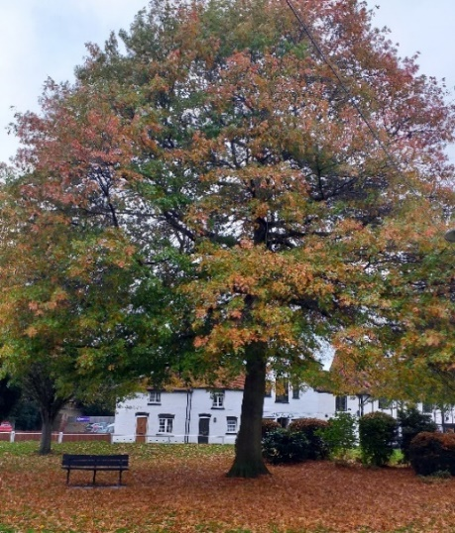
Autumn and Fall
We generally think of the word 'Fall' as the North American version of the word 'Autumn'.
However fall was originally a shortening of the phrase fall of the leaf and was in common use in England in the 17th century.
The word Autumn originates from the French word automne and didn't become widely used in England until the 18th century.

When does Autumn begin?
There are two different dates when Autumn could be said to begin. For the purposes of recording climate data, it is important to have set dates that can be compared from one year to the next. Meteorologists therefore split the year into four equal periods or seasons of three months each. The meteorological seasons are Spring (March 1st to May 31st), Summer (June 1st to August 31st), Autumn (September 1st to November 30th) and Winter (December 1st to February 28th or 29th in a Leap Year)
However astronomers base their seasons on the position of the Sun in relation to the Earth. The start of each season is marked by either a solstice (for winter and summer) or an equinox (for spring and autumn). A solstice is when the Sun reaches the most southerly or northerly point in the sky, while an equinox is when the Sun passes over the Earth’s equator. The word equinox comes from the Latin equi (meaning equal) and nox (meaning night).
On the Autumn equinox, day and night are of roughly equal length. It is the point at which the sun passes the equator moving from the northern to the southern hemisphere and the North Pole moves away from the sun. After the Autumn equinox the nights become increasingly longer than the days and the temperatures become cooler, until the Spring equinox six months later when the pattern is reversed.
The Autumn equinox generally falls on the 22nd or 23rd of September.

Signs of Autumn
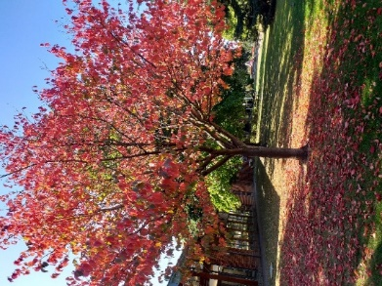
One of the most stunning signs of Autumn is the changing colour of leaves from green to many shades of amber, red and yellow.
Chlorophyll is the chemical which makes tree leaves green. It also plays an important part in photosynthesis which is the process by which trees create their own food from sunlight, water and carbon dioxide. In Autumn as the days start to shorten, there is less light for photosynthesis so the trees start to close down their food production system and reduce the amount of chlorophyll in their leaves. As chlorophyll declines other chemicals become more prominent in the leaves. These chemicals are responsible for the vibrant colours of autumn. Some of these chemicals are the same ones that give carrots and egg yolks their colours.
Bird migration
Migration is the regular seasonal movement undertaken by many species of birds often in response to changes in food availability, habitat or the weather.
Birds migrate to survive so some parts of the world have a much higher proportion of migrants than others. For example in far northern regions, such as Canada or Scandinavia, most species migrate south to escape winter. In more temperate regions, such as the UK, about half the species migrate, in particular insect-eaters that are unable to find enough food during the winter. In tropical regions, such as the Amazon rainforest, fewer species migrate because the weather and food supply there are more reliable all year round.
The timing of migration seems to be controlled primarily by changes in day length. Migrating birds navigate using celestial cues from the sun and stars, the earth's magnetic field, and mental maps.
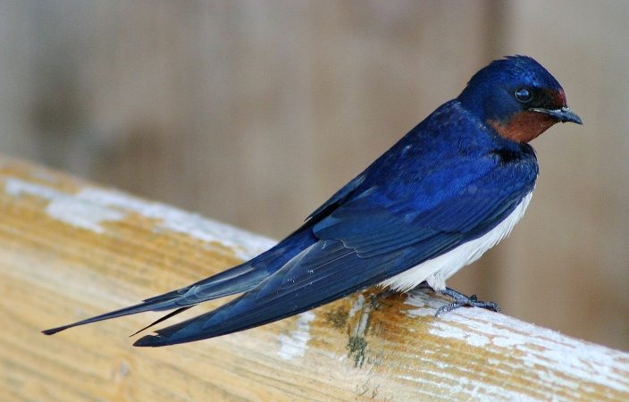
Different species of bird migrate in different ways. The most famous are long distance migrants, such as swallows, which breed in Europe and spend the winter in Africa. Warblers, redstarts, swifts and cuckoos are just some of the other examples of long distant migrants which may spend the summer in Britain before flying south with their young in the Autumn.
Barn Swallow ¹
Many species of seabirds also arrive on British shores to breed in the Spring after spending the winter at sea. These include puffins, gannets and terns.
As well as summer visitors there are many other species which arrive in the UK in the Autumn. These winter visitors include fieldfares and redwings and many kinds of ducks and geese. They come to the UK from the north or east where winters are harsher and food harder to find and then return to their breeding grounds in the Spring.

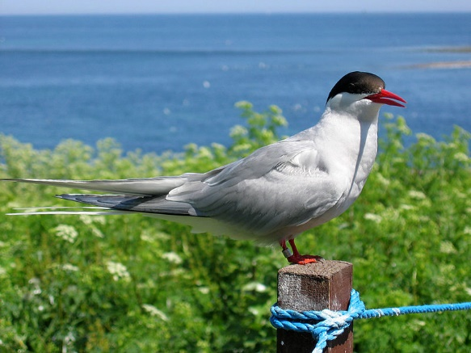
Whilst many birds stay in the UK for several months there are some species that just use it as a stopping off point for a few weeks during their long journey north or south. These are known as passage migrants and include birds such as wood sandpipers and black terns.
The Arctic tern holds the long-distance migration record for birds, travelling many thousands of miles from their Arctic
breeding grounds to the Antarctic and back again each year.
Arctic Tern on Farne Islands, Northumberland ²
Hibernation
The only mammals that truly hibernate in the UK are hedgehogs, dormice and all our British bat species. During hibernation, the body temperature lowers and the breathing rate and heart rate both slow down.
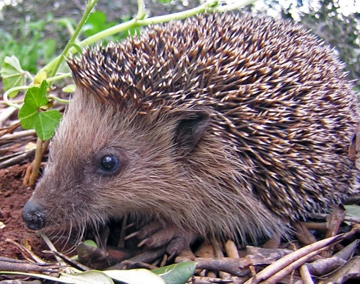
To prepare for hibernation, hedgehogs eat as much as they can during early Autumn to build up their fat reserves. They will then seek out a quiet spot to rest for the winter months. For example this could be under piles of dead leaves or stacks of logs, in compost heaps or under garden sheds. If you think hedgehogs are visiting your garden you can help them prepare for hibernation by putting out water and food such as tinned cat food or dog food or crushed cat or dog biscuits.
Hedgehogs usually hibernate from October or November through to March or April depending on the severity of the weather. However research has shown that each hedgehog is likely to move nesting sites at least once during this period and so they can sometimes be seen out and about during the winter months.
A young hedgehog ³
During mild winters hedgehogs can remain active well into November and December.
The hibernation period for dormice begins in October or November and may last for six months or more until April or May. Sometimes they wake briefly from hibernation to eat food they had stored nearby. During the summer, they accumulate fat in their bodies to nourish them through the hibernation period.
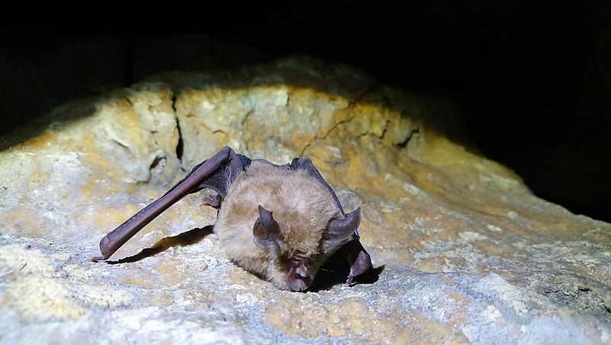
During the Autumn bats start to prepare for hibernation, building up their fat reserves and searching for a suitable place to spend the winter months. This may be an old tree, disused building, cave or bat box. They may roost on their own or in small groups. They usually hibernate from November or December to April.
Greater horseshoe bat found in a hibernation site in Gloucestershire, England ⁴
With thanks to Wikipedia for photographs of birds and animals
¹ Barn Swallow, Denmark 2004
https://en.wikipedia.org/wiki/Barn_swallow#/media/File:Landsvale.jpg
I, Malene / CC BY-SA http://creativecommons.org/licenses/by-sa/3.0/
² Arctic Tern on Farne Islands
https://commons.wikimedia.org/wiki/File:2009_07_02_-_Arctic_tern_on_
Farne_Islands_-_The_blue_rope_demarcates_the_visitors%27_path.JPG
Jamumiwa / CC BY-SA https://creativecommons.org/licenses/by-sa/4.0

³ A young hedgehog https://commons.wikimedia.org/wiki/File:Igel.JPG
Gibe / CC BY-SA http://creativecommons.org/licenses/by-sa/3.0/
⁴ Greater Horseshoe Bat, Gloucestershire https://commons.wikimedia.org/wiki/File:Greater_Horseshoe_Bat_
(Rhinolophus_ferrumequinum),_Gloucestershire,_UK.jpg
Rhinolophusferrumequinum / CC BY-SA https://creativecommons.org/licenses/by-sa/4.0
Autumn Quiz (15 possible points)
- When did the word Autumn start to be commonly used in England? 1 point
- The Autumn Equinox usually falls on 21st/22nd September TRUE/FALSE
1 point

- What does the word Equinox mean? 1 point

- Where is the sun at the time of the Autumn Equinox? I point
- What happens to the length of nights after the Autumn Equinox? 1 point
- What is the chemical that gives leaves their green colour? 1 point

- Where do swallows spend the winter? 1 point

- Can you name two types of bird that spend the winter in the UK? 2 points

- Can you give an example of a passage migrant? 1 point
- Which bird migrates the furthest distance? 1 point

- How could you help a hedgehog prepare for hibernation? 1 point
- Name three changes that happen to animals during hibernation - 3 points
Autumn Quiz Answers (15 possible points)
- When did the word Autumn start to be commonly used in England? 1 point
18th Century
- The Autumn Equinox usually falls on 21st/22nd September TRUE/FALSE
1 point
FALSE - September 22nd or 23rd

- What does the word Equinox mean? 1 point
Equal (Equi) night (nox)

- Where is the sun at the time of the Autumn Equinox? I point
Over the equator
- What happens to the length of nights after the Autumn Equinox? 1 point
They get longer
- What is the chemical that gives leaves their green colour? 1 point
Chlorophyll

- Where do swallows spend the winter? 1 point
Africa
- Can you name two types of bird that spend the winter in the UK? 2 points
Fieldfares and redwings

- Can you give an example of a passage migrant? 1 point
Sandpiper or black tern
- Which bird migrates the furthest distance? 1 point
Arctic Tern
- How could you help a hedgehog prepare for hibernation? 1 point
Put out some water and food
- Name three changes that happen to animals during hibernation? Up to 3 points
Heart rate slows, breathing slows, body temperature lowers
Tree Quiz – Below are the names of 10 trees.
8 appear in the pictures below. Can you match them?
Ash, Crab apple, Hornbeam, Lime, Oak, Horse chestnut, Maple, Beech, Silver Birch, Fig
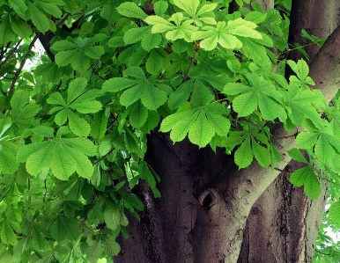 | 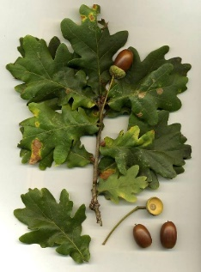
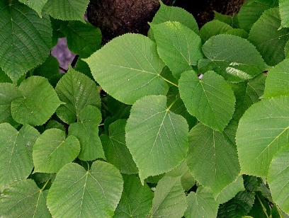 | 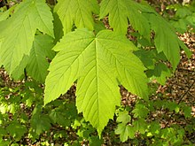
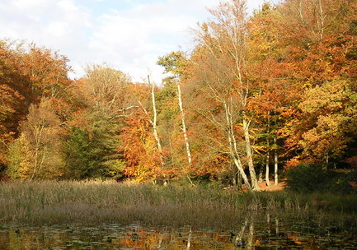 | 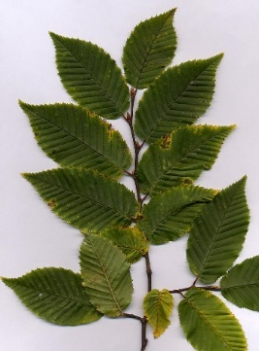
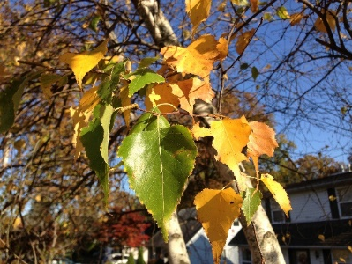 | 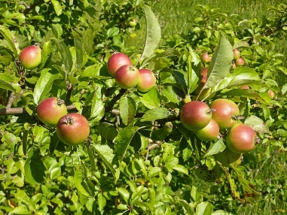
Ash, Crab apple, Hornbeam, Lime, Oak, Horse chestnut, Maple, Beech, Silver Birch, Fig

Tree Quiz – Can you identify 8 trees from these pictures?
Answers
- Horse chestnut
- Oak
- Lime
- Maple
- Beech
- Hornbeam
- Silver Birch
- Crab apple

With thanks to Wikipedia for the Tree Quiz photographs
- Horse chestnut https://en.wikipedia.org/wiki/Aesculus_hippocastanum#/media/File:Aesculus_hippocastanum-1.jpg
Alvesgaspar / CC BY-SA http://creativecommons.org/licenses/by-sa/3.0/

- Oak
https://en.wikipedia.org/wiki/Oak#/media/File:Quercus_robur.jpg GNU Free Documentation License
- Lime
https://commons.wikimedia.org/wiki/File:Tilia_x_europea-2.JPG
Alvesgaspar / CC BY-SA http://creativecommons.org/licenses/by-sa/3.0/

- Maple
https://en.wikipedia.org/wiki/Maple#/media/File:Acer_pseudoplatanus_002.jpg
https://creativecommons.org/licenses/by-sa/2.5
- Beech https://en.wikipedia.org/wiki/Burnham_Beeches#/media/File:Middle_Pond_-_geograph.org.uk_-_600952.jpg
Mark Percy/Middle Pond Creative Commons Attribution-Share Alike 2.0 Generic
License
- Hornbeam
https://commons.wikimedia.org/wiki/File:Carpinus_foliage.jpg
MPF / CC BY-SA http://creativecommons.org/licenses/by-sa/3.0/

- Silver Birch
https://en.wikipedia.org/wiki/Betula_pendula#/media/File:2014-10-30_09_58_18_Birch_foliage_during_autumn_along_Terrace_Boulevard_in_Ewing,_New_Jersey.jpg
Famartin / CC BY-SA https://creativecommons.org/licenses/by-sa/4.0

- Crab apple
https://en.wikipedia.org/wiki/Malus#/media/File:Crabapples.jpg
Wehha / CC BY-SA https://creativecommons.org/licenses/by-sa/3.0

An Autumn Word Search
Can you find these 15 words related to Autumn in the grid below. They may be going forwards or backwards in a horizontal, vertical or diagonal direction.
Apples | Pumpkins | Bonfires | Acorns Conkers
November | October | Dormouse | Migrate Leaves
Hedgehogs | September | Equinox | Hibernation Fall
W | H | V | O | L | Y | O | W | A | J | I | L | C | A | W | A | C
L | X | S | R | E | K | N | O | C | V | G | U | H | F | R | B | O
D | U | R | S | N | R | O | C | A | D | Q | P | F | K | M | X | N
A | T | P | R | H | X | O | N | I | U | Q | E | J | Y | Y | O | L
E | Z | R | E | I | N | N | Q | L | B | L | O | R | O | Y | X | B
S | Q | S | B | B | P | U | M | P | K | I | N | S | E | K | N | O
U | V | G | M | E | S | D | F | B | O | N | F | I | R | E | S | F
O | H | O | E | R | C | L | J | A | Q | L | E | X | Z | N | E | E
M | O | H | V | N | B | S | C | A | I | A | E | Z | N | L | I | T
R | R | E | O | A | L | G | O | P | A | P | L | A | W | H | N | A
O | K | G | N | T | Q | C | S | P | G | B | B | M | V | H | D | R
D | R | D | W | I | T | K | Z | L | O | F | I | O | S | E | X | G
X | N | E | O | O | G | N | I | E | L | M | K | L | U | Y | S | I
A | C | H | B | N | E | C | G | S | T | H | N | Y | P | A | H | M
W | I | E | N | N | V | R | E | B | M | E | T | P | E | S | S | Z
Q | R | O | T | Y | R | F | O | A | R | C | Q | W | S | A | N | R
A | Q | M | A | N | U | J | M | K | E | R | R | X | F | A | L | L

An Autumn Word Search Answers

W | H | V | O | L | Y | O | W | A | J | I | L | C | A | W | A | C
L | X | S | R | E | K | N | O | C | V | G | U | H | F | R | B | O
D | U | R | S | N | R | O | C | A | D | Q | P | F | K | M | X | N
A | T | P | R | H | X | O | N | I | U | Q | E | J | Y | Y | O | L
E | Z | R | E | I | N | N | Q | L | B | L | O | R | O | Y | X | B
S | Q | S | B | B | P | U | M | P | K | I | N | S | E | K | N | O
U | V | G | M | E | S | D | F | B | O | N | F | I | R | E | S | F
O | H | O | E | R | C | L | J | A | Q | L | E | X | Z | N | E | E
M | O | H | V | N | B | S | C | A | I | A | E | Z | N | L | I | T
R | R | E | O | A | L | G | O | P | A | P | L | A | W | H | N | A
O | K | G | N | T | Q | C | S | P | G | B | B | M | V | H | D | R
D | R | D | W | I | T | K | Z | L | O | F | I | O | S | E | X | G
X | N | E | O | O | G | N | I | E | L | M | K | L | U | Y | S | I
A | C | H | B | N | E | C | G | S | T | H | N | Y | P | A | H | M
W | I | E | N | N | V | R | E | B | M | E | T | P | E | S | S | Z
Q | R | O | T | Y | R | F | O | A | R | C | Q | W | S | A | N | R
A | Q | M | A | N | U | J | M | K | E | R | R | X | F | A | L | L

Tree Word Scramble
Here are the jumbled up names of 10 trees
Can you unscramble them?
1. EHROS TUTNECHS ___________________________________
2. YMROSAEC __________________________________________
3. RVESIL CBHRI ______________________________________
4. HBOMAENR __________________________________________
5. WNPEEGI LOWWIL ____________________________________
6. ELIGNSH KAO _______________________________________
7. EPRCOP HBEEC ______________________________________
8. SCUEPR ____________________________________________
9. ARPOLP ____________________________________________
10. RCAED _____________________________________________

Tree Word Scramble Answers
1. EHROS TUTNECHS __Horse Chestnut __________________
2. YMROSAEC __Sycamore________________________________
3. RVESIL CBHRI __Silver Birch________________________
4. HBOMAENR __Hornbeam________________________________
5. WNPEEGI LOWWIL __Weeping Willow____________________
6. ELIGNSH KAO __English Oak__________________________
7. EPRCOP HBEEC __Copper Beech________________________
8. SCUEPR __Spruce____________________________________
9. ARPOLP __Poplar____________________________________
10. RCAED __Cedar______________________________________

Additional Activities for Autumn

Look out for and collect Autumn leaves – how many different shapes and colours can you find in your garden or in the street or in the Park?
Can you identify them?
The Woodland Trust website has lots of information and activity sheets to help you identify different leaves and trees https://naturedetectives.woodlandtrust.org.uk/
Many parks now have tree trails which are a great way to get to know more about the trees in your local area.

Make an Autumn collage using the leaves you have collected
