January

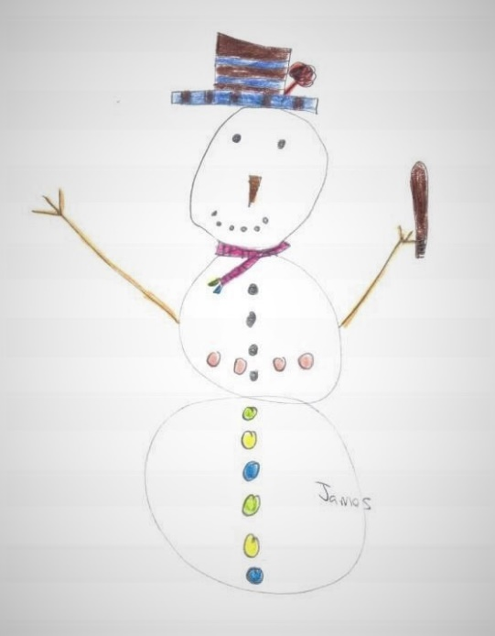
About this topic – Find out all sorts of things about the month of January and test your knowledge and memory with games and a quiz.
Resources for this topic
- Suggested session plan
- Some January Facts
- January Quiz and Answers
- January Events Matching Game and Answers
- Ham the Chimp Report
- January Word Scramble and Answers

We are happy for you to use the material in this Toolkit exactly as it is or to modify it as required for your purposes. We do however ask that you always acknowledge its source as follows:

“Learning and Sharing Together” Resources (2020)
With thanks to Burnham Health Promotion Trust
Reg. Charity No.1066070 & Reg. Company No.3435602
www.bhpt.org.uk

You may not redistribute, sell or place any part of this Toolkit on any other website or blog without written agreement. Please Contact Us to discuss
Suggested session plan (one and a half hours approx.)
Whilst the plan below has been developed for face to face meetings, all the activities can be used in Virtual meetings too, using the shared screen facility on Zoom for example, and break out rooms for some activities.
- Welcome and introductions
- Working in small groups the children and older people should take turns to read aloud Some January Facts. Encourage them to discuss what they have read as there will be a quiz later.

- Give out January Events Matching Game to groups as they
finish 2)
- When all the groups have finished 2) collect in January Facts and hand out January Quiz

- As groups finish the Quiz, they should continue with the January Events Matching Game. Hand out Ham the Chimp Report for groups to read aloud and discuss when they have finished the Quiz and the January Events Matching Game

- Go through the January Facts Quiz Answers when all the groups have finished the quiz

- Refreshments and Answers to January Events Matching Game and discussion about Ham the Chimp.

- Additional activity if required: January Word Scramble

- Thankyous and goodbyes – Before the children and older people leave you may wish to say something about the topic or activity you have planned for the next session. This gives everyone the opportunity to be more prepared and perhaps to bring photographs or other memorabilia
Some facts about January
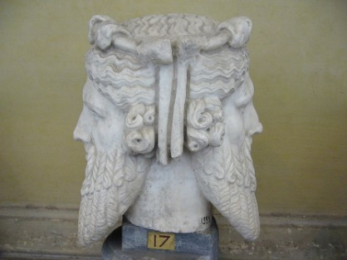
It was in 46 B.C. that the Roman emperor Julius Caesar made January 1st the first day of the year, partly to honour the month’s namesake Janus who was the Roman god of beginnings. Janus is also known as the god of gateways. Janus is usually represented as a head with two faces allowing him to look back into the past and forward into the future. Romans celebrated the new year by offering sacrifices to Janus, exchanging gifts with one another, decorating their homes with laurel branches and attending lively parties.
Statue of head of Janus, Vatican Museum, Rome ¹
New Year continues to be a time of year when people tend to reflect on events of the previous year and often resolve to alter some aspect of their lives in the future by making New Year resolutions. The ancient Babylonians are said to have been the first people to make New Year's resolutions, some 4,000 years ago. They often resolved to get out of debt. They were also the first to hold recorded celebrations in honour of the new year though for them the year began in mid-March, when the crops were planted. At this time the months of January and February did not exist. They were not added to the calendar until about 700 B.C.
The Anglo-Saxons called January “Wulfmonath” as it was the month when hungry wolves came into towns and villages looking for food.
In the northern hemisphere, January is generally the coldest month of the year. In the southern half of the world, January is usually the warmest month of the year. The full moon that occurs in January is called the “wolf moon.”
In leap years January always begins on the same day of the week as April and July. In the horoscope, the month of January shares two Zodiac signs: Capricorn, which lasts from December 22nd to January 19th, and Aquarius, which lasts from January 20th until February 18th. The birthstone for January is the garnet which represents constancy and the flower is the carnation.

With thanks to Mandy Barrow for permission to include material from Project Britain website http://www.projectbritain.com/year/january.htm
With thanks to https://en.wikipedia.org/wiki/January for additional information and image of Head of Janus ¹ https://commons.wikimedia.org/wiki/File:Janus1.JPG
Loudon dodd / CC BY-SA https://creativecommons.org/licenses/by-sa/3.0
January Quiz (15 possible points)
- Who are thought to have been the first people to make New Year resolutions? (1 point)
- When did January 1st start to be celebrated as the beginning of the New Year? (1 point)
- Who introduced this change? (1 point)
- From which god does the month of January get its name? (1 point)

- What was unusual about Janus's appearance? (1 point)

- How did the Romans celebrate New Year? (up to 4 points)

- In Anglo Saxon times what was the name for the month of January and why did it have this name? (2 points)

- Which flower is associated with January? (1 point)

- What is the sign of the Zodiac for people whose birthday is today?
(1 point)

- In a leap year, if January 1st falls on a Sunday which other two months will also start on a Sunday? (2 points)
January Quiz with answers (15 possible points)
- Who are thought to have been the first people to make New Year resolutions? 1 point Ancient Babylonians

- When did January 1st start to be celebrated as the beginning of the New Year? 1 point 46BC
- Who introduced this change? 1 point Julius Caesar
- From which god does the month of January get its name? 1 point
Janus, Roman god of beginnings

- What was unusual about Janus's appearance? I point
Two faces one pointing forwards and one back

- How did the Romans celebrate New Year? Up to 4 points
Sacrifices to Janus, exchanging gifts, decorating houses with laurel branches and lively parties
- In Anglo Saxon times what was the name for the month of January and why did it have this name? 2 points
Wulfmonath because hungry wolves would come into towns and villages looking for food
- Which flower is associated with January? 1 point Carnation
- What is the sign of the Zodiac for people whose birthday is today?
1 point Capricorn (up to an including Jan 19th) or Aquarius from January 20th to February 18th
- In a leap year, if January 1st falls on a Sunday which other two months will also start on a Sunday? 2 points April and July

January Events Matching Game
Below are 10 events that happened during the month of January between 1773 and 1984. Match each event with one of the dates in the box below.
Fill in your answers on the January Events Answer sheet
- Ham the Chimp travelled into outer space
- The first Apple Macintosh computer went on sale
- The first commercial jet plane (BOAC's Comet) was put into service
- The Scrabble board game was first sold in the UK
- Captain Cook became the first explorer to cross the Antarctic Circle
- First X Ray machine demonstrated
- Thomas Edison received a patent for the electric light bulb
- John F Kennedy was inaugurated as the 35th President of the United States
- First public television broadcast was demonstrated in London
- President Nixon announced that a peace accord had been reached in Vietnam
Dates
17th January 1773 | 19th January 1955
27th January 1880 | 20th January 1961
18th January 1896 | 31st January 1961
27th January 1926 | 23rd January 1973
22nd January 1952 | 24th January 1984

January Events Matching Game Answer Sheet
17th January 1773
18th January 1896
19th January 1955
20th January 1961
22nd January 1952
23rd January 1973
24th January 1984
31st January 1961
27th January 1926
27th January 1880

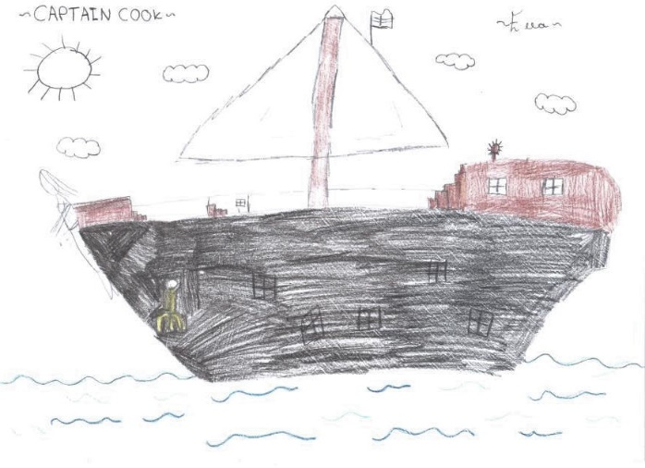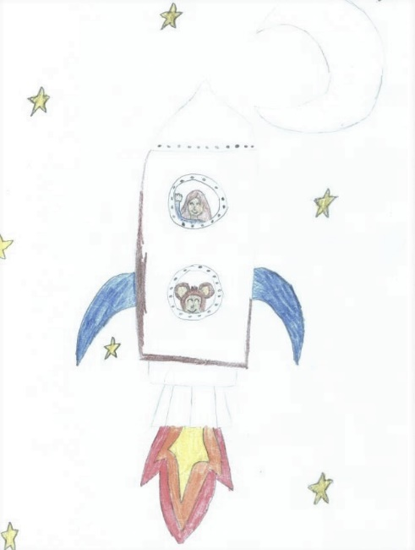
January Events Matching Game Answers

17th January 1773 | Captain Cook became the first explorer to cross the Antarctic Circle
27th January 1880 | Thomas Edison received a patent for the electric light bulb
18th January 1896 | First X Ray machine demonstrated
27th January 1926 | First public television broadcast was demonstrated in London
22nd January 1952 | The first commercial jet plane (BOAC's Comet) was put into service
19th January 1955 | The Scrabble board game was first sold in the UK
20th January 1961 | John F Kennedy was inaugurated as the 35th President of the United States
31st January 1961 | Ham the Chimp travelled into outer space
23rd January 1973 | President Nixon announced that a peace accord has been reached in Vietnam
24th January 1984 | The first Apple Macintosh computer went on sale

Ham the chimp goes into space
Ham was the first chimpanzee to go into Space as part of the American space programme. The test flight was one of many planned to ensure that a human being could survive space flight, think clearly and perform useful functions outside the Earth's atmosphere. Chimpanzees were chosen for these tests because of their similarity to humans. Ham was just 3 ½ years old at the time of the space flight. In the wild he would still have been very dependent on his mother.
Ham, who was named after the Holloman Aerospace Medical Centre, was originally from Cameroon, Africa. He was chosen from six "astrochimps" who underwent intensive training in Florida. Ham's training included being trained to pull levers in response to flashing lights during flight.
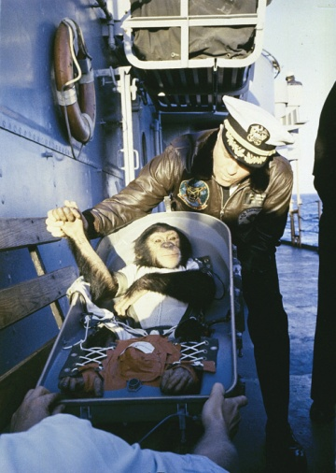
On the day of the test flight Ham was dressed in a nappy, waterproof pants and a spacesuit and was fitted with sensors to monitor his heart rate, breathing and body temperature. He was then sealed into the capsule of a 25-metre-long spacecraft. During Ham's 16-minute ordeal, he experienced some crushing forces on take-off and re-entry and weightlessness for more than six minutes. Despite this he performed all his in-flight tasks perfectly. After the flight, Ham’s space capsule splashed down 130 miles from its target and began taking on water. Some reports suggest it was several hours before he was rescued. There are different reports as to how Ham reacted to this whole experience. For example, when he was finally released his face bore a huge grin. This was interpreted by many people as a happy smile but by others as a sign of extreme fear and anxiety.
Afterwards Ham was retired to the United States National Zoo in Washington DC. Some reports say he was treated like a celebrity but others suggest that his life there was very lonely. After 17 years he was transferred to the North Carolina Zoo where he had the company of other chimps for the last years of his life. He died aged about 26.
Ham’s success paved the way for the successful launch of America’s first human astronaut a few months later.
A “hand shake” welcome. After his flight on a Mercury-Redstone rocket, chimpanzee Ham is greeted by the commander of the recovery ship ¹
¹ https://commons.wikimedia.org/wiki/File:Ham_Retreival_GPN-2000-001004.jpg NASA on The Commons, Public domain

What do you think about sending an animal into Space?
January Word Scramble
1. RASIAUUQ __________________________________________
2. CICRPORNA _________________________________________
3. NETRGA ____________________________________________
4. NJUSA _____________________________________________
5. UUIJSL SRECAA _____________________________________
6. IWENRT ____________________________________________
7. EUOILSTSRON ______________________________________
8. SOWNNAM ___________________________________________
9. UOWFANTMHL _________________________________________
10. ANRCONITA _________________________________________
January Word Scramble Answers
- Aquarius
- Capricorn
- Garnet
- Janus
- Julius Caesar
- Winter
- Resolutions
- Snowman
- Wulfmonath
- Carnation

