June

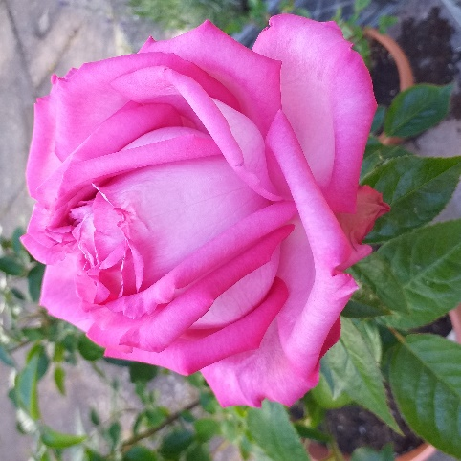
About this topic – Learn some facts and traditions associated with the month of June and test your knowledge of summer flowers
Resources for this topic
- Suggested session plan
- Some Facts about the month of June
- June Quiz and Answers
- Name the Summer Flowers Picture sheet and Answer Sheet
- Name the Summer Flowers Answers
- Summer Flowers for colouring or drawing
We are happy for you to use the material in this Toolkit exactly as it is or to modify it as required for your purposes. We do however ask that you always acknowledge its source as follows:

“Learning and Sharing Together” Resources (2020)
With thanks to Burnham Health Promotion Trust
Reg. Charity No.1066070 & Reg. Company No.3435602
www.bhpt.org.uk

You may not redistribute, sell or place any part of this Toolkit on any other website or blog without written agreement. Please Contact Us to discuss

Suggested session plan (one and a half hours approx.)
Whilst the plan below has been developed for face to face meetings, all the activities can be used in Virtual meetings too, using the shared screen facility on Zoom for example, and break out rooms for some activities.
- Welcome and introductions
- Working in small groups the children and older people should take turns to read aloud Some Facts about the month of June. Encourage them to discuss what they have read as there will be a quiz later.
- Give out Name the Summer Flower picture sheet and Answer sheet to groups as they finish 2)
- When all the groups have finished 2) collect in Some Facts about the month of June and hand out June Quiz

- As groups finish the Quiz, they should continue with the Name the Summer Flowers picture sheet.

- As groups finish the Quiz and Summer Flowers picture sheet hand out flower pictures for copying or colouring
(Before the session you could print off a selection of pictures from https://printablefreecoloring.com/search/?q=flowers&p=16)

- Go through the June Quiz Answers when all the groups have finished the Quiz
- Refreshments and Name the Summer Flower Answers. If time, continue colouring/drawing flower pictures.

- Thankyous and goodbyes – Before the children and older people leave you may wish to say something about the topic or activity you have planned for the next session. This gives everyone the opportunity to be more prepared and, if appropriate, to bring photographs or other memorabilia
Some facts about the month of June
June is the sixth month of the year and takes its name from the Roman goddess Juno, the goddess of marriage. For this reason, June has traditionally been considered to be the best month in which to marry:
Married in the month of roses - June
Life will be one long honeymoon.
Trooping the Colour
Each June, usually on the second Saturday, the Sovereign and other members of the Royal Family attend the Trooping the Colour ceremony on Horse Guards Parade, Whitehall in London. Since 1748 the celebration of the official birthday of the Sovereign has been combined with the Trooping of the Colour ceremony.
The Sovereign attends the ceremony to take the salute from thousands of guardsmen who parade the Colour (their regiment's flag). The Trooping the Colour is a tradition going back to the days when the Colour was trooped in front of soldiers to make sure everyone could recognise their regiment’s flag in battle.
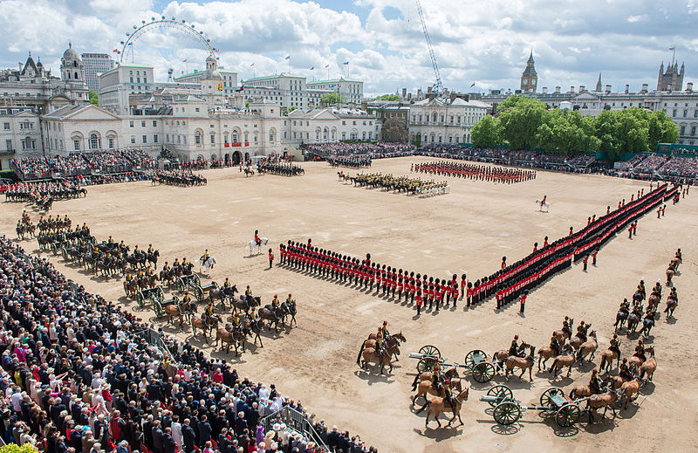
The parade route goes from Buckingham Palace along The Mall to Horse Guards Parade, Whitehall and back again. Precisely as the clock on the Horse Guards Building strikes eleven, the Royal Procession arrives at Horse Guards Parade and The Sovereign takes the Royal Salute. The parade begins with the Inspection, with the Sovereign moving slowly down the ranks of all eight Guards and then past the Household Cavalry. After the event the Royal Family gathers on the balcony of Buckingham Palace to watch an RAF fly past at 1pm.

Trooping the Colour, Horse Guards Parade, London June 2013 ¹

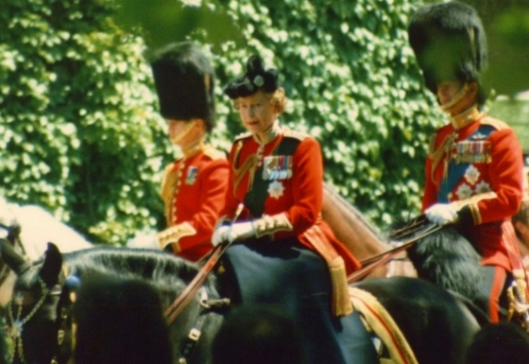
For many years of her reign,
Queen Elizabeth II attended the event on horseback. From 1969 to 1986 she rode her black horse “Burmese” , a gift from the Royal Canadian Mounted Police. Burmese retired in 1986 and in future years the Queen travelled to the ceremony by carriage.
Queen Elizabeth II on Burmese in 1986 with Prince Charles on the white horse to her right and Prince Philip on the bay horse behind her. ²
The Order of the Garter Ceremony
The Garter Day ceremony takes place in June each year at Windsor Castle, usually on the Monday before the start of Royal Ascot.
The Most Noble Order of the Garter is the senior and oldest British Order of Chivalry. It was founded in 1348 by King Edward III. It is the only actual honour that the Sovereign can decide to award to anyone. All other awards like CBE's and OBE's are political awards and, although given by the Sovereign, they are decided upon by politicians. The Order of the Garter is strictly decided upon by the Sovereign.
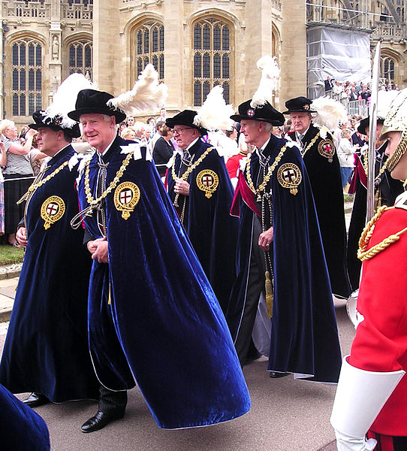
Every June on Garter Day, the Knights of the Garter gather at Windsor Castle, where new knights take the oath and are invested with the special Garter insignia. A lunch is given in the Waterloo Chamber, after which the Sovereign and other members of the Royal party proceed with the Knights to a service in St George's Chapel. All wear the Garter's traditional flowing blue velvet robes, hoods of red velvet worn over the right shoulder, and black velvet hats with white feathers. The badge of the Order is worn on the left shoulder of the robe. A fanfare of trumpets announces the arrival on foot of the main procession, led by the Constable and Governor of Windsor Castle and the Military Knights of Windsor.
Knights Companion of the Most Noble Order of the Garter, in procession to St George’s Chapel, Windsor for the annual service of the Order of the Garter ³
Bands of the Household Division play as the procession passes dismounted squadrons of the Household Cavalry, lining the route in their scarlet ceremonial uniforms. After the chapel service, which is relayed via loudspeakers to the crowds, there is an open-carriage procession back up the hill.
The summer Solstice
Solstices occur when the sun is at its greatest distance from the equator. Solstices occur twice a year, once in the summer and once in the winter. The summer solstice is the time when the sun reaches its northernmost latitude. The North Pole leans more directly toward the sun than it does on any other day of the year. At this time we have the longest day. For people in the northern hemisphere the date is on or near 21st June.
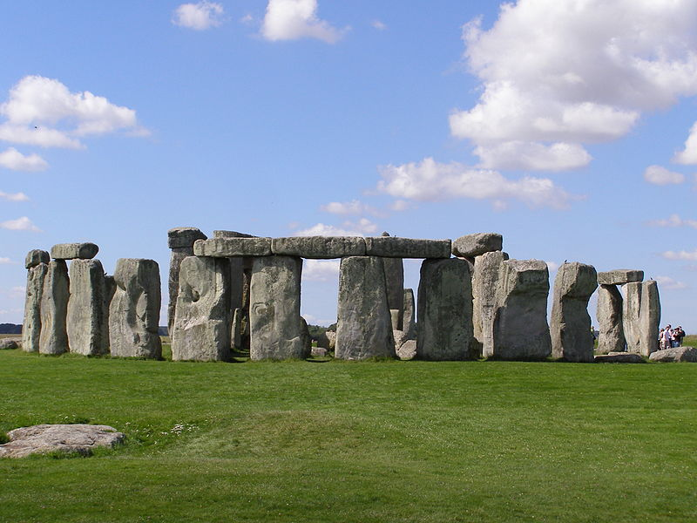
At Stonehenge in Wiltshire, there is a circle of huge stones and hundreds of people go there to watch the sun rise on 21st June. A lot of the stones are ten or twelve metres high. The earliest part of Stonehenge is nearly 5,000 years old. It is thought that the Druids used Stonehenge for a calendar. The Druids were the priests in Britain over 2,000 years ago.
Stonehenge, a Neolithic stone monument constructed from 3000 BC to 2000 BC ⁴

Midsummer's Day
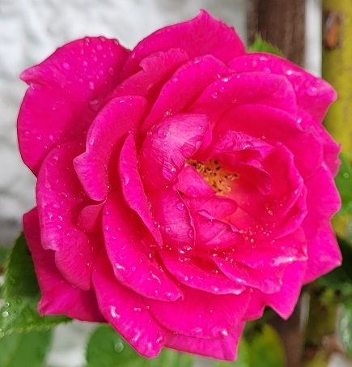
Midsummer's Day, the middle of summer, falls on the 24th of June. Traditionally Midsummer's Day is a time associated with witches, magic, fairies and dancing.
On the eve of Midsummer's Day, many bonfires used to be lit all over the country. This was in praise of the sun, for the days were getting shorter and the sun appeared to be getting weaker, so people would light fires to try and strengthen the sun.
Roses are of special importance on Midsummer's Eve.
It is said that any rose picked on Midsummer's Eve, or Midsummer's Day will keep fresh until Christmas.
With thanks to Mandy Barrow for permission to include information from Project Britain website http://www.projectbritain.com/year/june.htm and http://www.projectbritain.com/midsummer.htm
With thanks to Wikipedia for photos
¹ Trooping the Colour, Horse Guards Parade, London June 2013
https://commons.wikimedia.org/wiki/File:Trooping_the_Colour_MOD_45155754.jpg
Photo: Corporal Paul Shaw/MOD / OGL v1.0 http://NationalArchives.gov.uk/doc/open-government-licence/version/1/
² Queen Elizabeth II on Burmese in 1986 with Prince Charles on the white horse to her right and Prince Philip on the bay horse behind her. ²
Photo: Sandpiper, Public domain, via Wikimedia Commons
³Knights Companion of the Most Noble Order of the Garter, in procession to St George’s Chapel, Windsor for the annual service of the Order of the Garter
https://commons.wikimedia.org/wiki/File:Knights_Companion_of_the_Garter
.JPG
Philip Allfrey, 2006 / CC BY-SA https://creativecommons.org/licenses/by-sa/2.5
⁴ Stonehenge, a Neolithic stone monument constructed from 3000 BC to 2000 BC
https://commons.wikimedia.org/wiki/File:Stonehenge2007_07_30.jpg
Gareth Wiscombe, 2007 / CC BY https://creativecommons.org/licenses/by/2.0

June Quiz (15 points)

- Who does the month of June get its name from? 1 point

- When does the Trooping of the Colour ceremony usually take place? 1 point

- What is meant by a Colour? 1 point

- Where does the Sovereign take the Royal Salute? 1 point

- Where and when does the Order of the Garter ceremony take place? 2 points

- What colour are the robes worn by the Knights of the Garter and what material are they made of? 2 points

- What colour hats do they wear and how are the hats decorated? 2 points

- What is the summer solstice? 1 point

- When is the summer solstice for people in the northern hemisphere? 1 point

- When is Midsummers Day? 1 point

- What is said to be special about a rose picked on Midsummers Day? 1 point

- Why did people traditionally light bonfires on Midsummers Day? 1 point

June Quiz with answers (15 points)
- Who does the month of June get its name from? 1 point
Roman goddess Juno, Goddess of marriage
- When does the Trooping of the Colour ceremony usually take place? 1 point
Second Saturday in June
- What is meant by a Colour? 1 point
Regimental flag
- Where does the Sovereign take the Royal Salute? 1 point
Horseguards Parade, Whitehall

- Where and when does the Order of the Garter ceremony take place?
2 points
Windsor Castle, Monday before start of Royal Ascot
- What colour are the robes worn by the Knights of the Garter and what material are they made of? 2 points
Blue with red hood
Velvet material
- What colour hats do they wear and how are the hats decorated? 2 points
Black hat with white feathers
- What is the summer solstice? 1 point
The time when the sun reaches its most northern latitude so we have the longest day
- When is the summer solstice for people in the northern hemisphere?
1 point
On or near 21st June
- When is Midsummers Day? 1 point
June 24th
- What is said to be special about a rose picked on Midsummers Day? 1 point
Will keep fresh until Christmas

- Why did people traditionally light bonfires on Midsummers Day? 1 point
In praise of the sun, to strengthen the sun as it appeared to be getting weaker
Summer Flowers
Can you name these 12 Summer Flowers?
Write your answers on the separate answer sheet
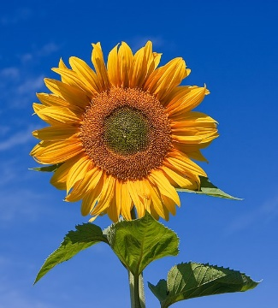 | 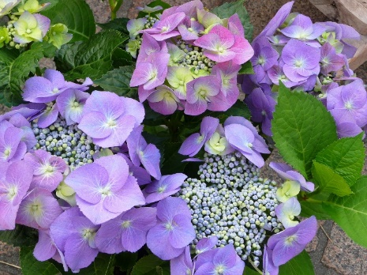
1 | 2
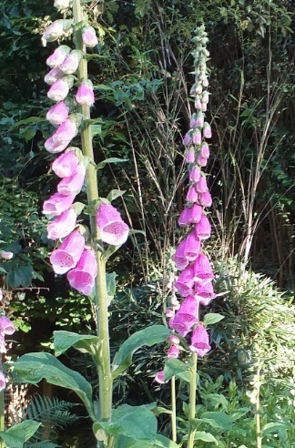 | 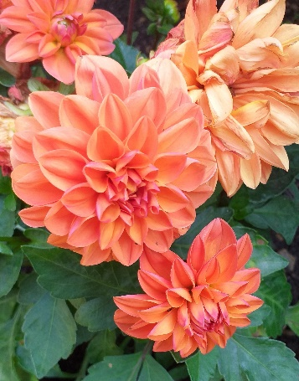
3 | 4
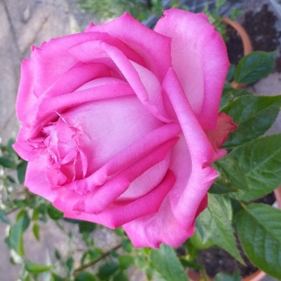 | 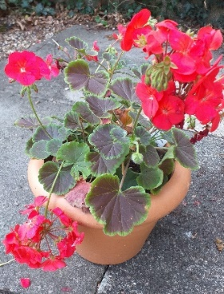
5 | 6

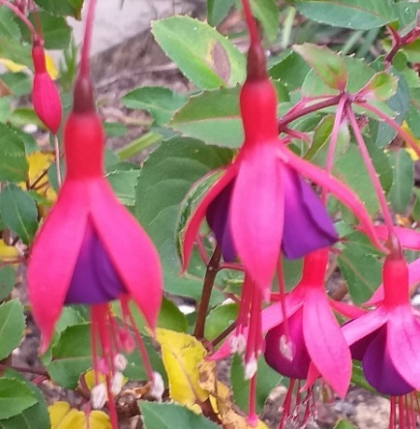 | 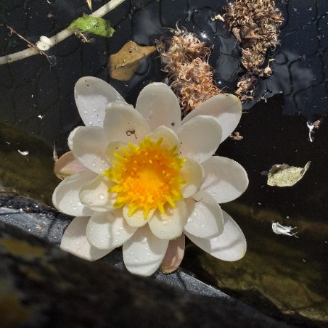
7 | 8
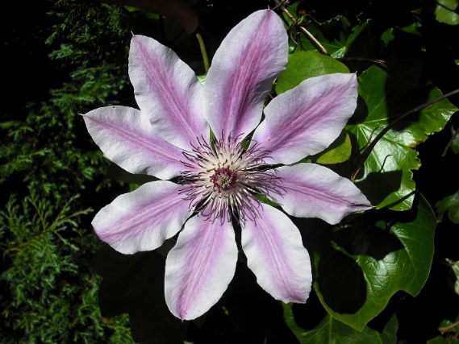 | 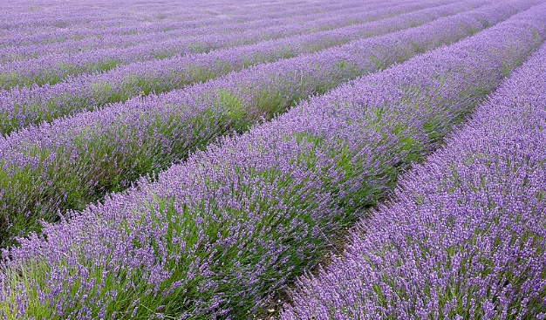
9 | 10
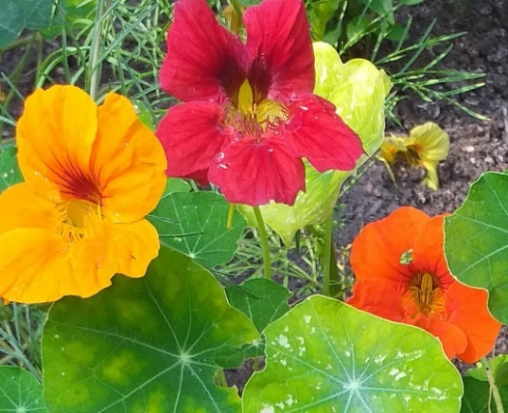 | 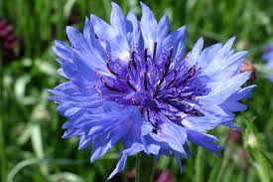
11 | 12

With thanks to Wikipedia for images 1,2,9 and 10 – see Answer sheet for references
Name the Summer Flower Answer sheet
1

2

3

4

5

6

7

8

9

10

11

12

Name the Summer Flower Answers
*With thanks to Wikipedia for images 1,2,9 and 10 - see below for references
1 Sunflower*
2 Hydrangea*
3 Foxglove
4 Dahlia
5 Rose
6 Geranium
7 Fuchsia
8 Water lily
9 Clematis Nelly Moser*
10 Lavender*
11 Nasturtium
12 Cornflower

1 Sunflower https://upload.wikimedia.org/wikipedia/commons/4/40/Sunflower_sky_backdrop.jpg
Fir0002 / GFDL 1.2 http://www.gnu.org/licenses/old-licenses/fdl-1.2.html

2 Hydrangea https://upload.wikimedia.org/wikipedia/commons/0/0d/Bauernhortensie_Wochenmarkt.jpg
3268zauber / CC BY-SA https://creativecommons.org/licenses/by-sa/3.0
9 Clematis Nelly Moser
https://en.wikipedia.org/wiki/Clematis#/media/File:Clematis_'Nelly_Moser'.JPG
Jolly Janner / Public domain

10 Lavender
https://upload.wikimedia.org/wikipedia/commons/4/43/Hitchin_lavender_fields.jpg
DeFacto / CC BY-SA https://creativecommons.org/licenses/by-sa/4.0

Summer flowers pictures to draw or colour in

You will find a large selection of pictures of flowers for drawing or colouring in on this website https://printablefreecoloring.com/search/?q=flowers&p=16
Alternatively you could take a vase or pot of flowers for people to draw
