May


About this topic – Learn about special celebrations, traditions and superstitions associated with the month of May and test your memory and knowledge with a quiz and games.
Resources for this topic
- Suggested session plan
- May Facts – Celebrations, Superstitions and Anniversaries
- May Facts Quiz and Answers
- May Anniversaries Matching Game
- May Word Search and Answers
- May Word Games
We are happy for you to use the material in this Toolkit exactly as it is or to modify it as required for your purposes. We do however ask that you always acknowledge its source as follows:

“Learning and Sharing Together” Resources (2020)
With thanks to Burnham Health Promotion Trust
Reg. Charity No.1066070 & Reg. Company No.3435602
www.bhpt.org.uk

You may not redistribute, sell or place any part of this Toolkit on any other website or blog without written agreement. Please Contact Us to discuss

Suggested session plan (one and a half hours approx.)
Whilst the plan below has been developed for face to face meetings, all the activities can be used in Virtual meetings too, using the shared screen facility on Zoom for example, and break out rooms for some activities.
- Welcome and introductions
- Working in small groups take turns to read aloud May Facts – Celebrations, Traditions and Superstitions. There will be a quiz later so encourage the children and older people to discuss what they have read.
- Give out May Anniversaries Matching Game to groups as they finish 2). The aim is to match 10 events with the date that they occurred.
- When all the groups have finished 2) collect in May Facts and hand out May Quiz
- As groups finish the quiz, they should continue with the May Anniversaries Matching Game. Hand out May Word Scramble to groups when they have finished the Quiz and the May Anniversaries Matching Game
- Go through the May Quiz Answers and the May Anniversaries Matching Game Answers when all the groups have finished both
- Refreshments and finish May Word Scramble
- Additional Activity if time – May Word Games

- Thankyous and goodbyes - Before the children and older people leave you may wish to say something about the topic or activity you have planned for the next session. This gives everyone the opportunity to be more prepared and, if appropriate, to bring photographs or other memorabilia

May Day Celebrations, Traditions and Superstitions

May is named after the Greek goddess Maia. Traditionally May was a time of great celebration in the northern hemisphere as the weather got warmer, many flowers started to emerge and crops began to grow.
The Anglo-Saxon name for May was Tri-Milchi, in recognition of the fact that with the lush new grass cows could be milked three times a day.
Although summer does not officially begin until June, the 1st of May has traditionally marked its beginning and May Day has been celebrated all over Europe for over 2000 years. The celebrations have their origins in the Roman festival of Flora, goddess of fruit and flowers, which was held annually from April 28th to May 3rd
For our ancestors, largely in rural areas, it was a major annual festival and was celebrated throughout the country, especially on the first of May with music, dancing and games. There are a lot of traditions associated with May Day.
Washing in the early morning dew
On May morning girls would make a special point of washing their faces in the early morning dew. There is an old tale that says that May dew has magic properties that could remove spots and freckles and it was thought that anyone who had washed their face in it would have a beautiful complexion all through the year.
Garland Day
In some parts of England May 1st was known as Garland Day. Traditionally children would parade with garlands of flowers, sometimes fastened to sticks or in the shape of a cross or fixed to hoops. This was done in the hope of collecting money. Sometimes this was known as May Dolling because often a small doll was placed in the centre of the garland to represent the goddess of Spring.
There are still garland ceremonies today. For example, at Charlton-on-Otmoor, a village in Oxfordshire, a May Day festival is held involving all the children from the Primary School. It starts with a special May Day song followed by a procession to the Church. The children carry a long rope strung with garlands, as well as posies and small crosses decorated with flowers. In the Church, the flowers are displayed below the Rood Screen, above which stands a large wooden cross wrapped in yew and box leaves.
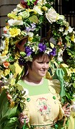
May Queen
Traditionally on May Day there was dancing on the village green, an archery contest and exhibitions of strength.
The highlight of the day was the crowning of the May Queen, the human replica of Flora. By tradition she took no part in the games or dancing but sat like a queen in a flower-decked chair to watch her 'subjects'.

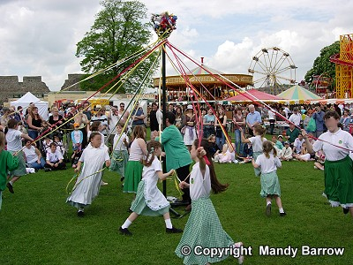Dancing - May day celebrations traditionally included Maypole dancing and Morris dancing.
Maypole dancing - On May Day, people used to cut down young trees and stick them in the ground in the village to mark the arrival of summer. People danced around the tree poles in celebration of the end of winter and the start of the fine weather that would allow planting to begin. Maypoles were once common all over England and were kept from one year to the next. School children would practise skipping round the pole for weeks before the final show on the village greens. Many schools today have continued this tradition of Maypole dancing
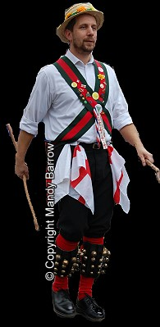The tallest maypole is said to have been erected in London on the Strand in 1661; it stood over 143 feet high. It was felled in 1717, when it was used by Isaac Newton to support Huygen's new reflecting telescope.
Another traditional dance seen throughout the month of May is Morris Dancing. It is a traditional English form of folk dancing, performed by groups of men or women. Morris Dancing has been danced for hundreds of years and passed down through the generations in the villages of rural England.
Morris dancers wear different clothes depending on the part of the country in which they dance. They are often dressed in white with coloured belts known as baldrics across their chests.
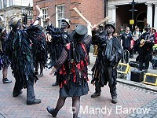
Other celebrations that still take place today include:
Rochester's annual Sweeps Festival in Kent celebrates the traditional holiday that chimney sweeps used to enjoy on 1st May. It was the one time of the year when the sweeps could put away their tools and have some fun.
The Sweeps Festival is a colourful mix of music, dancing and entertainment and is an opportunity to see some of the traditional dances and hear the songs which have been passed down from generation to generation.
The oldest May Day celebration still taking place today, is the Padstow 'Obby 'Oss celebration in Cornwall. Its origins date back to the 14th century. Every May Day thousands of people come to see the two famous Hobby Horses, the Old Oss and the Blue Ribbon Oss. Celebrations in Padstow officially start the night before at midnight, when a group of 'mayers' meet outside the Golden Lion Inn to serenade the owner with their special Night Song.
On May Day the whole town is ablaze with bluebells, forget-me-nots, cowslips, and sycamore twigs and dancing and other celebrations take place all day.
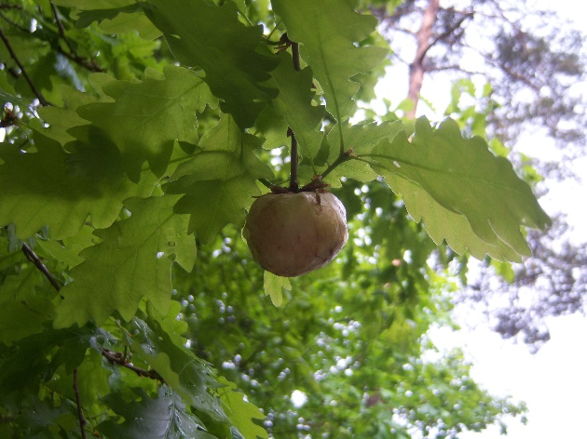
May 29th Oak Apple Day (Pinch-Bum Day)
This is the date when people traditionally pinned oak apples or oak leaves to their clothes to remember the day that King Charles II returned triumphantly to London after the restoration of the monarchy in 1660. Oak apples or oak leaves were chosen because the King had narrowly escaped capture by Cromwell's soldiers by hiding in an oak tree. Until well into the twentieth century, anyone caught not wearing an oak leaf or oak apple on 29th May could be pinched or kicked. Or another favourite punishment was whipping with nettles, hence the name 'Nettle Day' in some areas. Oak Apple Day continues to be celebrated in some parts of England.
Oak Leaf and Oak Apple ¹
Some Superstitions about the month of May
The month of May was considered an unlucky month particularly for getting married.
'Marry in May and you'll rue the day'
Being born in May was thought to produce a sickly child.
Washing blankets in May was also thought to be extremely unlucky
Wash a blanket in May.
Wash a dear one away.
Cats born in May were thought not to be good rodent catchers and even worse, would bring snakes into the home.
There are also some myths about oak leaves’ connection with rainfall which have survived from ancient times. It is said if the leaves of the ash tree open before those of the oak tree, we will be in for a wet summer but if the other way round, then it will be dry.
From Ireland
If the oak before the ash, then we’ll only have a splash.
If the ash before the oak, then we’ll surely have a soak!
And from Hampshire:
Ash before oak, we’re in for a soak;
Oak before ash, naught but a splash.
With thanks to Mandy Barrow for permission to include much of the information above and photos from the Project Britain website http://projectbritain.com/mayday.htm
Additional photograph - With thanks to Wikipedia
¹ Oak Leaf and Oak Apple - EapClochydd / CC BY-SA https://commons.wikimedia.org/w/index.php?curid=32739186
https://creativecommons.org/licenses/by-sa/3.0
May Celebrations, Traditions and Superstitions Quiz
(20 possible points)

- Who does the month of May get its name from? 1 point
- What was the Anglo Saxon name for May? 1 point

- Why did it have this name? 1 point
- What did girls think might happen if they washed their face in the early morning dew on May Day morning? 2 points

- Which Roman goddess is remembered with the crowning of a May Queen and what was she the goddess of? 2

- How tall was the tallest maypole? 1 point

- Where was it? 1 point

- What happened to it when it was cut down? 1 point

- What is the name given to the coloured belts that Morris dancers traditionally wear across their chests? 1 point

- What happens in Rochester on May Day? 1 point

- What do people still go to see in Padstow every May Day? 1 point

- What was said to be the matter with cats that were born in May? 2 points

- Why did people wear oak apples or oak leaves on May 29th? 1 point

- Name three punishments which you might receive for not wearing an oak apple or leaf? 3 points

15. What sort of summer is expected if the leaves of the ash tree open before those of the oak? 1 point

May Celebrations, Traditions and Superstitions Quiz Answers
- Who does the month of May get its name from? 1 point Greek goddess Maia
- What was the Anglo Saxon name for May? 1 point Tri Milchi
- Why did it have this name? 1 point
In May cows could be milked three times a day because of lush new grass
- What did girls think might happen if they washed their face in the early morning dew on May Day morning? 2 points Spots and freckles would disappear and they would have a beautiful complexion in the year ahead
- Which Roman goddess is remembered with the crowning of a May Queen and what was she goddess of? 2 points Flora, goddess of fruit and flowers
- How tall was the tallest maypole? 1 point 143 feet
- Where was it? 1 point The Strand, London
- What happened to it when it was cut down? 1 point
Used to support Huygen’s new telescope
- What is the name given to the coloured belts that Morris dancers traditionally wear across their chests? 1 point Baldrics
- What happens in Rochester on May Day? 1 point Annual Sweeps’ festival
- What do people still go to see in Padstow every May Day? 1 point
Padstow Obby Orse celebration
- What was said to be the matter with cats that were born in May? 2 points Not good rodent catchers and would bring snakes into house
- Why did people wear oak apples or oak leaves on May 29th? 1 point
To remember King Charles II returning to London in 1660 after restoration of monarchy. Charles was believed to have hidden in an oak tree to escape capture by Cromwell’s soldiers
- Name three punishments which you might receive for not wearing an oak apple or leaf? 3 points Could be pinched, kicked or whipped with nettles
15. What sort of summer is expected if the leaves of the ash tree open before those of the oak? 1 point A wet one (Ash before oak, in for a soak)
May Anniversaries Matching Game
Here are 10 dates and 10 events that all happened in the month of May but the order has been muddled up. Can you match the date with the correct event? Write the correct date for the event in the column on the right
9th May 1671 |  | VE (Victory in Europe) Day
12th May 1820 |  | Amy Johnson was the first woman to fly solo from England to Australia
6th May 1840 |  | Edmund Hillary and Tenzing Norgay reached the summit of Mt Everest
28th May 1908 |  | The world's first postage stamp, the 'Penny Black' stamp, became valid for use in the UK
5th May 1930 |  | Helen Sharman became the first British woman in space
8th May 1945 |  | Captain Blood attempted to steal the Crown Jewels
29th May 1953 |  | Roger Bannister ran a mile in less than four minutes
6th May 1954 |  | Nelson Mandela became the President of South Africa
18th May 1991 |  | Florence Nightingale was born
10th May 1994 |  | Ian Fleming, author of the James Bond books, was born

May Anniversaries Matching Game Answers
9th May 1671 Captain Blood attempted to steal the crown jewels
12th May 1820 Florence Nightingale was born
6th May 1840 The world's first postage stamp, the 'Penny Black' stamp, became
valid for use in the UK
28th May 1908 Ian Fleming, author of the James Bond books, was born
5th May 1930 Amy Johnson was the first woman to fly solo from England to
Australia
8th May 1945 VE (Victory in Europe) Day
29th May 1953 Edmund Hillary and Tenzing Norgay reached the summit of Mt
Everest
6th May 1954 Roger Bannister ran a mile in less than four minutes
18th May 1991 Helen Sharman became the first British woman in space
10th May 1994 Nelson Mandela became the President of South Africa

May Word Scramble
1. EANSLRIBEOCT ______________________________________
2. MIOSRR RACSEDN ____________________________________
3. NLSRDAAG __________________________________________
4. LORFA _____________________________________________
5. MYA QNEUE _________________________________________
6. PIITGRESNM ________________________________________
7. OYAPEML ___________________________________________
8. SOEWLRF ___________________________________________
9. RNDITOASIT ________________________________________
10. WEESPS FATSELIV ___________________________________

May Word Scramble Answers
1. CELEBRATIONS
2. MORRIS DANCING
3. GARLANDS
4. FLORA
5. MAY QUEEN
6. SPRINGTIME
7. MAYPOLE
8. FLOWERS
9. TRADITIONS
10. SWEEPS FESTIVAL

May Word Games

How many words of one syllable can you think of that rhyme with MAY?

How many words of 4 letters or more can you make out of the word MAYPOLE?

May Word Games Answers

Here are 20 words that rhyme with May. Can you find any more?
Bay
Bray
Clay
Day
Drey
Gay
Grey
Hay
Jay
Lay
Neigh
Pay
Play
Prey
Pray
Ray
Say
Sleigh
Way
Weigh

Here are 20 words from the word Maypole. Can you find any more?
Ample
Lame
Lamp
Leap
Loam
Lope
Male
Maple
Meal
Mole
Mope
Pale
Palm
Peal
Play
Plea
Ploy
Pole
Poem
Yelp

