October

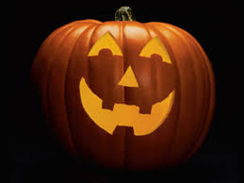
About this topic – Find out about all sorts of events with an October connection, test your memory with a crossword and play a word game
Resources for this topic
- Suggested session plan
- Special Dates in October Matching Game
- October Word Game
- October Crossword and Answers

We are happy for you to use the material in this Toolkit exactly as it is or to modify it as required for your purposes. We do however ask that you always acknowledge its source as follows:

“Learning and Sharing Together” Resources (2020)
With thanks to Burnham Health Promotion Trust
Reg. Charity No.1066070 & Reg. Company No.3435602
www.bhpt.org.uk

You may not redistribute, sell or place any part of this Toolkit on any other website or blog without written agreement. Please Contact Us to discuss

Suggested session plan (one and a half hours approx.)
Whilst the plan below has been developed for face to face meetings, it should be possible to modify the activities to use in Virtual meetings too. For example for the first activity, instead of matching the dates, pictures and events the children and older people could take turns to read and discuss them using the shared screen facility on Zoom and break out rooms. As an extra activity the children and adults could do a drawing of one or two of the events that particularly interest them.
For face to face meetings prepare the “Special Dates in October Matching Game” before the session.
- Welcome and introductions
- Children and older people should work in small groups for this activity. Give each group an envelope containing the Special Dates in October Matching Game. Explain that the envelopes contain 15 dates, 15 pictures and 15 descriptions of an event. Some dates are of something important that happened a long time ago in October, others may be a date when something is, or used to be, celebrated each year. Encourage the children and older people to take turns to read out loud one of the descriptions and then to try to correctly match it to the appropriate picture and date. They should then be arranged in order by day of the month.
- As groups finish the Special Dates in October Matching Game hand out the October Word Game
- When all the groups have finished the Matching Game go through the correct order of dates. You might like to create an October timeline to keep as a record of this activity with each of the groups being responsible for sticking some of the dates, events and pictures onto a large piece of paper. Once this is finished clear the tables and hand out Crossword

- Refreshments - Go through answers to Word Game and Crossword
- Thankyous and goodbyes - Before the children and older people leave you may wish to say something about the topic or activity you have planned for the next session. This gives everyone the opportunity to be prepared and, if appropriate, to bring photographs or other memorabilia
Special Dates in October Matching Game
Before the session - Cut out the dates, descriptions and pictures on the next 5 pages and put them in an envelope. You will need an envelope for each group.
At the session- Each group is given an envelope containing the 15 dates, pictures and descriptions. The aim is to correctly match the descriptions with the pictures and the dates. They should then be arranged in order by day of the month (see below). Some of the dates are of something important that happened a long time ago, others may be a date when something is, or used to be, celebrated each year.
With thanks to Mandy Barrow for permission to use information and images from Project Britain website http://www.projectbritain.com/calendar/october.html
2nd October 1869 | Gandhi born in western India
3rd October 1906 | SOS International distress signal established
Around 3rd October (every year) | National Poetry Day
5th October 1936 | 200 unemployed workers marched to London from Jarrow
5th October 1952 | Tea Rationing ended
5th October (every year) | World Teacher’s Day
8th October 1965 | Post Office tower (BT Tower) officially opened
14th October 1066 | Battle of Hastings
15th October 1783 | First tethered manned balloon flight
16th October (every year) | World Food Day
18th October (used to be every year) | Whip Dog Day
20th October 1632 | Sir Christopher Wren born
21st October 1805 | Battle of Trafalgar
24th October 2003 | Concorde’s last flight
31st October (every year) | Halloween
2nd October 1869 | 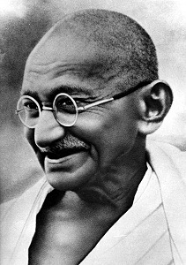 | Mohandas Karamchand Gandhi was born in Porbander in western India. Gandhi was an Indian political and spiritual leader.  Gandhi is famous for working to achieve freedom and equality for all, in India and in Africa. He is remembered particularly for his non-violent approach and for his belief that everyone should have equal rights.
3rd October 1906 |  | This signal was established as an International Distress Signal by an agreement made between the British Marconi Society and the German Telefunk organisation at the Berlin Radio Conference.
Around 3rd October  (every year) | 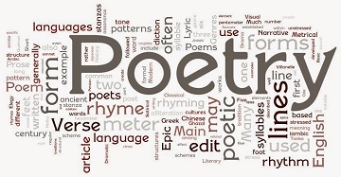 | National Poetry Day is celebrated on or around this date each year. It is the annual celebration of poetry and all things poetical with many different events taking place across the country. National Poetry day was founded in 1994 by William Sieghart and has engaged millions of people across the country reading, writing and listening to poetry.
5th October 1936 | 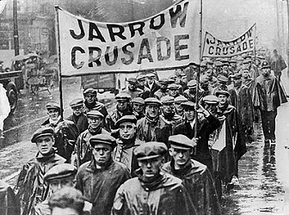 | A group of 200 British unemployed workers staged a hunger march as a way of bringing public attention to the plight of the unemployed in depressed areas of the country.  The march began in the ship-building town of Jarrow in north east England, where two thirds of the working population were jobless, and ended in London, a distance of almost 300 miles (480 km).
5th October 1952 | 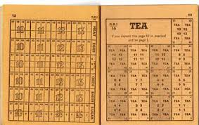 | Tea rationing ended on this day. During the second world war all sorts of food items were rationed as well as petrol, clothes and furniture. The year after tea was freed from rationing a host of other items including sweets, eggs, butter and sugar were made freely available again. Rationing of foodstuffs finally ended the following year when meat was taken off the ration books.
5th October  (every year) |  | World Teachers' Day is held annually on this day to celebrate teacher organizations worldwide. Its aim is to mobilize support for teachers and to ensure that the needs of future generations will continue to be met by teachers.
8th October 1965 |  | The Post Office Tower, now known as the BT Tower, was officially opened by the then Prime Minister, Harold Wilson. Costing £2 million to construct, the 189m cylindrical tower was, at the time of opening, the tallest building in London. Its purpose was to support the microwave aerials used to carry telecommunications traffic from London to the rest of the country. Today the tower is a telecommunications centre designed to relay broadcast, Internet and telephone information around the world.
14th October 1066 | 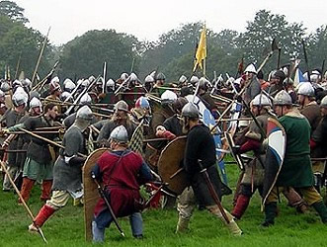 | The Battle of Hastings took place on this day. It was one of the bloodiest and most important battles fought on British soil and heralded the beginning of the Norman Conquest. The Battle of Hastings was fought to win/keep the English throne. Harold, the King of England tried his best to keep hold of the throne. His opposition was William of Normandy, leader of the Normans. The two armies met near Hastings. The Normans won.
15th October 1783 | 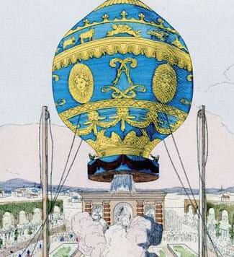 | The first tethered manned balloon flight took place on this day.  Jean Francois Pilatre de Rozier and Francois Laurent, Marquis d'Arlandes, were the first people to fly when they ascended in a Montgolfier hot-air balloon in Paris, France.  The first free flight with human passengers took place the following month.
16th October every year |  | World Food Day is celebrated every year to commemorate the founding of the Food and Agriculture Organization of the United Nations in 1945. The aim of World Food Day is to heighten public awareness of the plight of the world's hungry and malnourished and to encourage people worldwide to take action against hunger.
18th October  (used to be celebrated every year in Yorkshire) | 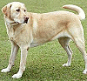 | Whip-Dog Day was a Yorkshire custom which took place on this day. The custom is said to have originated when a dog swallowed the consecrated wafer during a service in York Minster. In past times it was the job of Dog-Whippers to keep stray dogs out of churches.
20th October 1632 | 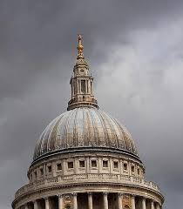 | Sir Christopher Wren was born on this day. He was the architect who designed St Paul’s Cathedral in London. He was also responsible for rebuilding 51 other churches in the City of London after the Great Fire in 1666.
21st October 1805 | 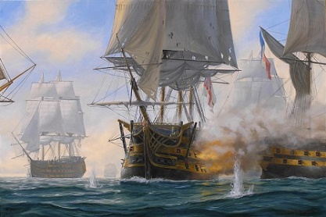 | The Battle of Trafalgar was fought between the combined fleets of Spain and France led by Napoleon and the British Royal Navy led by Nelson. 27 British ships defeated 33 French and Spanish ships in the Atlantic Ocean off the southwest coast of Spain, just west of Cape Trafalgar. The Franco-Spanish fleet lost 22 ships, without a single British vessel being lost. This decisive battle conclusively ended French plans to invade England but Nelson was shot during the battle and died shortly afterwards, becoming one of Britain's greatest war heroes.
24th October 2003 | 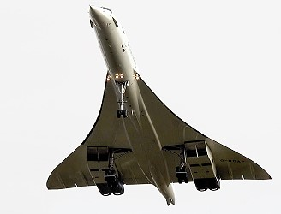 | The supersonic jet Concorde took its last flight ending three decades of supersonic travel. The last transatlantic flight carried 100 celebrities from New York and touched down on this day at 16.05 BST at London Heathrow airport.
31st October (every year) |  | Halloween is said to have its roots in Samhain, an ancient Celtic celebration which marked the end of summer. People at the time were frightened of evil spirits and would dress up and make noises to try and make the spirits go away. When the Catholic Church came to the Celtic land, it brought with it the celebration of All Saints Day or All Hallows Day on November 1st. The night before was All Hallows Eve. Many of the traditions from the two holidays merged and in time, All Hallows Eve was shortened to Halloween.
October Word Game
How many words of three or more letters can you make out of the word October?
OCTOBER

October Word Game Answers
Here are 20 words. Can you find any more?
Bet
Boo
Boot
Bore
Cob
Coo
Coot
Core
Cot
Oboe
Orb
Rob
Robe
Robot
Roe
Root
Rot
Too
Tor
Tore

October Events Crossword
 |  |  |  | 1
 |  |  |  |  |  |  |  |  |  |  |  | 2
 |  |  |  | 3
 |  |  |  |  |  |  | 4 |  |  | 5
 |  |  | 6
7 | 8 |  |  |  |  |  |  |  |  |  |  |  |  | 9
 |  |  |  |  |  |  |  |  |  | 10
 |  |  |  |  |  |  | 11
 |  |  |  |  |  | 12
Across  1. Leader of the Norman army in 1066 (7)  6. Sir Christopher Wren's profession (9)  7. Leader of Royal Navy at Battle of Trafalgar (6)  10. Famous Indian political and spiritual leader (6)  12. County that celebrated Whip-Dog Day (9) |  |  |  |  |  |  |  | Down  2. Where Concorde landed for last time(8)  3. A famous march began here (6)  4. Prime Minister’s surname in October 1965 (6)  5. Profession celebrated on 5th October (8)  8. Became freely available again in 1953 (4)  9. Founder of National Poetry Day (8)  11. International Distress Signal (3)

October Events Crossword Answers
 |  |  |  | ¹W | I | L | L |  | I | A | M
 |  |  |  |  |  |  |  |  |  |  |  | ²H
 |  |  |  | ³J |  |  |  |  |  |  |  | E
 |  |  |  | A |  |  | ⁴W |  |  | ⁵ T |  | A
 |  |  | ⁶ A | R | C | H | I |  | T | E | C | T
 |  |  |  | R |  |  | L |  |  | A |  | H
⁷N | ⁸E | L | S | O | N |  | S |  |  | C |  | R |  | ⁹ S
 | G |  |  | W |  |  | O |  |  | H |  | O |  | I
 | G |  |  |  |  |  | N |  |  | I |  | W |  | E
 | S |  |  |  |  |  |  |  |  | N |  |  |  | G
 |  |  |  |  |  |  |  |  |  | ¹⁰G | A | N | D | H | I
 |  |  |  |  |  |  | ¹¹S |  |  |  |  |  |  | A
 |  |  |  |  |  | ¹²Y | O |  | R | K | S | H | I | R | E
 |  |  |  |  |  |  | S |  |  |  |  |  |  | T
Across  1. Leader of the Norman army in 1066  6. Sir Christopher Wren's profession  7. Leader of Royal Navy at Battle of Trafalgar  10. Famous Indian political and spiritual leader  12. County that celebrated Whip-Dog Day |  |  |  |  |  |  |  | Down  2. Where Concorde landed for last time  3. A famous march began here  4. Prime Minister’ in October 1965  5. Profession celebrated on 5th October  8. Became freely available again in 1953  9. Founder of National Poetry Day  11. International Distress Signal

