Remembrance
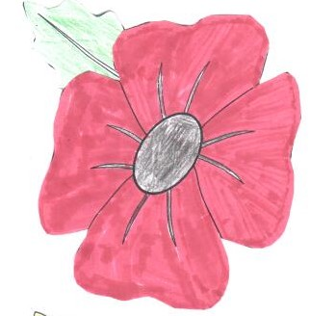

About this topic – Learn about the history and traditions of Remembrance Day and Remembrance Sunday. Test your memory and knowledge with a quiz and crossword and draw or colour in a poppy as a keepsake

Resources for this topic

- Suggested session plan
- Remembrance Day and Remembrance Sunday Facts
- Remembrance Quiz and Answers
- Remembrance Crossword and Answers
- Poppies for drawing or colouring in
We are happy for you to use the material in this Toolkit exactly as it is or to modify it as required for your purposes. We do however ask that you always acknowledge its source as follows:

“Learning and Sharing Together” Resources (2020)
With thanks to Burnham Health Promotion Trust
Reg. Charity No.1066070 & Reg. Company No.3435602
www.bhpt.org.uk

You may not redistribute, sell or place any part of this Toolkit on any other website or blog without written agreement. Please Contact Us to discuss
Suggested session plan (one and a half hours approx.)

Whilst the plan below has been developed for face to face meetings, all the activities can be used in Virtual meetings too, using the shared screen facility on Zoom for example, and break out rooms for some activities.

- Welcome and introductions
- Working in small groups the children and older people should take turns to read aloud Remembrance Day and Remembrance Sunday Facts. Encourage them to discuss what they have read as there will be a quiz later
- Give out Remembrance Crossword to groups as they finish 2)
- When all the groups have finished 2) collect in Remembrance Facts and hand out Remembrance Quiz
- As groups finish the quiz, they should continue with the Remembrance Crossword. If any group finishes both the quiz and the crossword hand out paper for drawing Poppies or Poppies Drawing/Colouring Sheets. You could print some off before the session from https://printablefreecoloring.com/search/?q=poppy
- Go through Quiz Answers when all the groups have finished Quiz

- Refreshments – this is a good time to ask if anyone will be attending Remembrance Day Parades or Services

- Continue drawing or colouring in poppies
As an alternative or additional activity you could write Remembrance poems – these could be acrostic poems using the letters of the word Remember or Poppies or Peace for example

- Thankyous and goodbyes – Before the children and older people leave you may wish to say something about the topic or activity you have planned for the next session. This gives everyone the opportunity to be more prepared and, if appropriate, to bring photographs or other memorabilia
Remembrance Day and Remembrance Sunday Facts
The eleventh hour of the eleventh day of the eleventh month marks the signing of the Armistice, on 11 November 1918, to signal the end of the First World War. At 11 am on 11 November 1918 the guns of the Western Front fell silent after more than four years of continuous warfare.
Remembrance Day is on 11 November. It is a special day set aside to remember all those men and women who were killed during the two World Wars and all subsequent wars and conflicts.
At one time the day was known as Armistice Day and was renamed Remembrance Day after the Second World War.
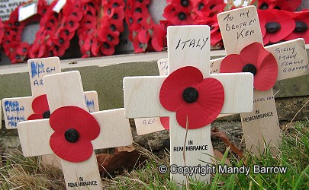
Remembrance Sunday is held on the second Sunday in November, which is usually the Sunday nearest to 11 November. Special services are held at war memorials and churches all over Britain. Wreaths are laid beside war memorials by local companies, clubs and societies. People also leave small wooden crosses by the memorials in remembrance of a family member who died in war.
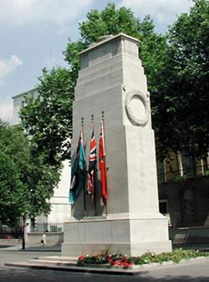
A national ceremony takes place at the Cenotaph in Whitehall, London. The Sovereign lays the first wreath at the foot of the Cenotaph and bows, followed one by one, by other adult members of the immediate Royal Family, who bow if in civilian dress, or salute if in military uniform. The next to lay their wreaths are The Prime Minister, the leader of the Opposition and leaders of other political parties. They are followed by other people laying wreaths. The ceremony ends with a march past of war veterans; a poignant gesture of respect for their fallen comrades. Literally meaning 'Empty Tomb' in Greek, The Cenotaph was designed by Edward Lutyens and was created from Portland stone, the inscription simply reads "The Glorious Dead".
There are only two cenotaphs in Britain. There is the one in Whitehall, London and the other one is in Aberdare, Wales. All other war monuments in Britain are war memorials.

Two minute silence - At 11am on each Remembrance Sunday a two minute silence is observed at war memorials and other public spaces across the UK.

The 'Last Post' - The "Last Post" is traditionally played to introduce the two minute silence in Remembrance Day ceremonies. It is usually ' played on a bugle. (In military life, 'The Last Post' marks the end of the day and the final farewell.)
The sounding of "Reveille" (or, more commonly "The Rouse") ends the two minute silence, followed by the recitation of the "Ode of Remembrance."

"They shall grow not old, as we that are left grow old:
Age shall not weary them, nor the years condemn.
At the going down of the sun and in the morning
We will remember them."

The First Two Minute Silence -
This is how the first Two Minute Silence held in London on 11th November 1919 was reported in the Manchester Guardian newspaper the following day.

'The first stroke of eleven produced a magical effect.
The tram cars glided into stillness, motors ceased to cough and fume, and stopped dead, and the mighty-limbed dray horses hunched back upon their loads and stopped also, seeming to do it of their own volition.
Someone took off his hat, and with a nervous hesitancy the rest of the men bowed their heads also. Here and there an old soldier could be detected slipping unconsciously into the posture of 'attention'. An elderly woman, not far away, wiped her eyes, and the man beside her looked white and stern. Everyone stood very still ... The hush deepened. It had spread over the whole city and become so pronounced as to impress one with a sense of audibility. It was a silence which was almost pain ... And the spirit of memory brooded over it all.'

Why are poppies associated with Remembrance Day?
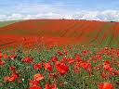
The poppies are worn because in World War One the Western Front contained in the soil thousands of poppy seeds, all lying dormant. They would have lain there for years more, but the battles being fought there churned up the soil so much that the poppies bloomed like never before. The most famous bloom of poppies in the war was in Ypres, a town in Flanders, Belgium, which was crucial to the Allied defence. The poppies inspired the Canadian soldier, Major John McCrae, to write his most famous poem.
In Flanders Fields
In Flanders fields the poppies blow
Between the crosses, row on row
That mark our place; and in the sky
The larks, still bravely singing, fly
Scarce heard amid the guns below.
We are the Dead. Short days ago
We lived, felt dawn, saw sunset glow,
Loved and were loved, and now we lie
In Flanders fields.
Take up our quarrel with the foe:
To you from failing hands we throw
The torch; be yours to hold it high.
If ye break faith with us who die
We shall not sleep, though poppies grow
In Flanders fields.
John McCrae (1872 - 1918)
The American Moina Michael from Georgia, was the first person to wear a poppy in remembrance. In reply to McCrae's poem, she wrote a poem entitled 'We shall keep the faith' which includes the lines:
And now the Torch and Poppy Red
We wear in honour of our dead.
She bought some silk poppies, wore one, and sold the others, raising money for ex-servicemen. She campaigned successfully for the poppy to be adopted as a national memorial symbol in America and her idea was soon taken up by a French woman, Anna Guerin, who particularly wanted to raise money for orphaned children. She in turn campaigned for other countries to adopt the poppy as a symbol of remembrance and the idea quickly caught on. In November 1921, the Royal British Legion sold poppies for the first time and have continued to do so ever since. The money raised is used to help war veterans.
With thanks to Mandy Barrow for permission to include above information and photographs from the Project Britain website http://projectbritain.com/remembrance/poppy.htm

Remembrance Quiz
(I point for each correct answer)

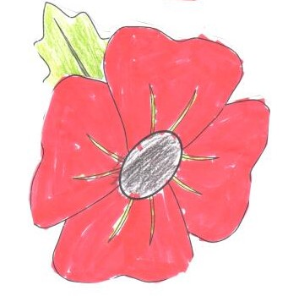
1.What happened on the 11th of November 1918?

2. What did Remembrance Day used to be called?

3. When was it renamed?

4. When is Remembrance Sunday held?

5. Where is the national Remembrance ceremony held in England?

6. Who lays the first wreath?

7. What does the word Cenotaph mean?

8. Where is the second Cenotaph in Britain?

9. When was the first two minute silence held?

10. Which piece of music is traditionally played to introduce the two minute silence?

11. What poem is recited at the end of the two minute silence?

12. Why are poppies associated with Remembrance Day?

13. When did the British Legion start selling poppies for the first time?

14. Who wrote the poem In Flanders Fields?

15. What is the second line of the poem?

Remembrance Quiz Answers (15 points possible)

1. What happened on the 11th of November 1918? End of World War One

2. What did Remembrance Day used to be called? Armistice Day
3. When was it renamed? After Second World War
4. When is Remembrance Sunday held? 2nd Sunday in November
5. Where is the national Remembrance ceremony held in England?
Cenotaph, Whitehall, London
6. Who lays the first wreath? The Sovereign
7. What does the word Cenotaph mean? Empty tomb
8. Where is the other Cenotaph in Britain? Aberdare, Wales
9. When was the first two minute silence held? 11th November 1919
10. Which piece of music is traditionally played to introduce the two minute silence? The Last Post
11. What poem is recited at the end of the two minute silence?
Ode of Remembrance
12. Why are poppies associated with Remembrance Day? Because so many poppies bloomed in the battlefields of the First World War because the soil had been so churned up

13. When did the British Legion start selling poppies for the first time? 1921

14. Who wrote the poem In Flanders Fields? John McCrae
15. What is the second line of the poem? Between the crosses, row on row
Remembrance Crossword
 | 1 |  |  |  |  |  | 2
 |  |  | 3 |  | 4
 |  |  |  |  |  |  |  |  |  |  |  |  |  | 5
6
 |  |  |  |  |  |  |  |  |  | 7
 |  | 8
 |  |  |  |  |  |  | 9
 | 10
Across  6. Inscription on the Cenotaph in London (3,8,4)  8. Who wrote the poem In Flanders Fields? (4,6)  9. What type of stone is the London  Cenotaph made from? (8)  10. Who lays the first wreath in London after the members of the Royal Family (5,8) |  |  |  |  |  |  |  |  | Down  1. Surname of first person to wear a poppy in remembrance (7)  2. Official name of Remembrance Day (9)  3. What instrument is "The Last Post" traditionally played on? (5)  4. Number of minutes of silence (3)  5. Who benefits from the money raised by the Royal British Legion each year? (3,8)  7. Town in Belgium famous for poppies (5)

Remembrance Crossword Answers
 | 1  M |  |  |  |  |  | 2  A
 | I |  | 3  B |  | 4  T |  | R
 | C |  | U |  | W |  | M |  |  |  |  |  | 5  W
6  T | H | E | G | L | O | R | I | O | U | S | D | E | A | D
 | A |  | L |  |  |  | S |  |  |  |  |  | R
 | E |  | E |  |  |  | T |  | 7  Y |  |  |  | V
 | L |  |  |  |  |  | I |  | P |  |  |  | E
 |  | 8  J | O | H | N | M | C | C | R | A | E |  | T
 |  |  |  |  |  |  | E |  | E |  |  |  | E
 |  |  |  |  |  |  |  |  | S |  |  |  | R
 |  |  |  |  |  |  |  |  |  |  |  |  | A
 |  |  |  |  |  |  | 9  P | O | R | T | L | A | N | D
 |  |  |  |  |  |  |  |  |  |  |  |  | S
 | 10  P | R | I | M | E | M | I | N | I | S | T | E | R

Poppies for drawing or colouring in
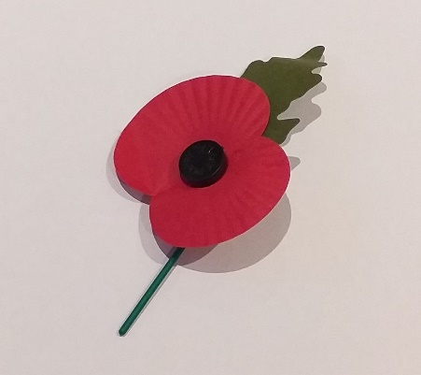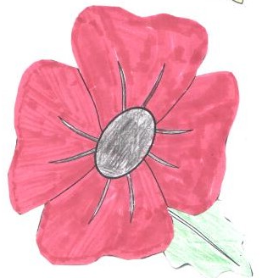
You will find a very good selection of poppy pictures for drawing or colouring-in on this website https://printablefreecoloring.com/search/?q=poppy
You could suggest that people dedicate their poppy to someone who is special to them.

