St Andrew’s Day

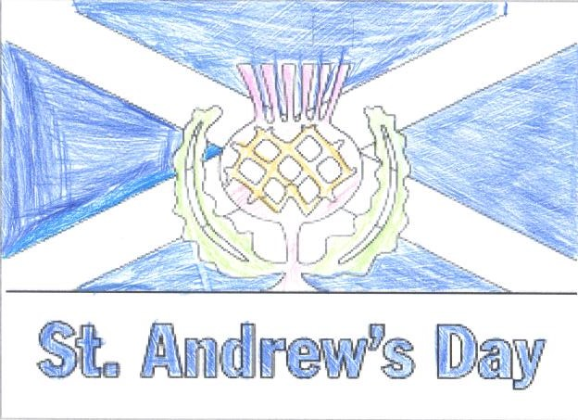
About this topic – Learn about St Andrew, Patron Saint of Scotland and discover some interesting Scottish facts. Test your memory and knowledge with a quiz and games
Resources for this topic
- Suggested session plan
- St Andrew’s Day and Scottish Facts
- St Andrew’s Day and Scottish Facts Quiz and Answers
- Scottish Inventors Puzzle
- St Andrew’s Day Word Search and Answers

We are happy for you to use the material in this Toolkit exactly as it is or to modify it as required for your purposes. We do however ask that you always acknowledge its source as follows:

“Learning and Sharing Together” Resources (2020)
With thanks to Burnham Health Promotion Trust
Reg. Charity No.1066070 & Reg. Company No.3435602
www.bhpt.org.uk

You may not redistribute, sell or place any part of this Toolkit on any other website or blog without written agreement. Please Contact Us to discuss

Suggested session plan (one and a half hours approx.)
Whilst the plan below has been developed for face to face meetings, all the activities can be used in Virtual meetings too, using the shared screen facility on Zoom for example, and break out rooms for some activities.
- Welcome and introductions
- Working in small groups the children and older people should take turns to read aloud St Andrew’s Day and Scottish Facts. Encourage them to discuss what they have read as there will be a quiz later
- Give out Scottish Inventors Puzzle to groups as they finish 2)
- When all the groups have finished 2) collect in St Andrew’s Day and Scottish Facts and hand out St Andrew’s Day and Scottish Facts Quiz

- As groups finish the quiz, they should continue with the Scottish Inventors Puzzle
- Go through the St Andrew’s Day and Scottish Facts Quiz
Answers when all the groups have finished the quiz

- Refreshments and answers to Scottish Inventors Puzzle
- Additional activity if required: St Andrew’s Day Word Search

9. Thankyous and goodbyes - Before the children and older people leave you may wish to say something about the topic or activity you have planned for the next session. This gives everyone the opportunity to be more prepared and perhaps to bring photographs or other memorabilia
St Andrew’s Day and Scottish facts
St Andrew’s Day is celebrated each year in Scotland on 30th November in honour of St Andrew who is believed to have died on that day in 60 AD. According to Christian teaching Andrew and his brother Simon Peter were fishermen in Galilee when they met Jesus and became his first disciples.
Like Jesus, Andrew was ultimately martyred for his beliefs, but Andrew is said to have refused a T-shaped cross, considering himself unworthy to be crucified in the same manner as Jesus. Instead, it is believed that he was bound to an X-shaped cross on 30 November 60AD in Greece. As a result, the diagonal cross which is known as a saltire was adopted as St Andrew’s symbol and the last day in November was designated as his saint day.
Some of Andrew’s bones are said to have been brought to a place on the north east coast of Scotland during the 4th Century, where the town of St Andrew’s is today. St Andrew was made the Patron Saint of Scotland over 1000 years ago. Since medieval times the saltire has been the Scottish national symbol and the flag of Scotland which is a white diagonal cross on a blue background is generally known as the Saltire.
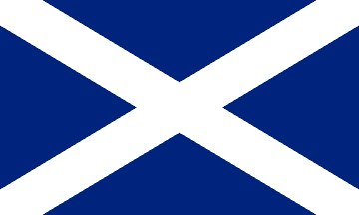
It wasn’t until the 18th century that Saint Andrew’s Day began to be celebrated as an annual event. It became a public holiday in Scotland in 2007.
In Scotland, and in many countries with Scottish connections, the day is marked with a celebration of Scottish culture with traditional Scottish food and music. In Scotland the day is also seen as the start of a season of Scottish winter festivals encompassing Saint Andrew's Day, Hogmanay and Burns Night. There are week-long celebrations in the town of St Andrews and in some other Scottish cities.
As well as being the patron saint of Scotland, St Andrew is the patron saint of fishermen and singers and of Romania, Russia, Ukraine and Patras in Greece.
Some other Scottish facts
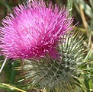
For centuries the Scottish national emblem has been the thistle, a prickly leaved purple flower which is commonly seen throughout the highlands, islands and lowlands of Scotland.
There are several different legends that tell how the thistle became Scotland’s emblem, but most date from the reign of Alexander III and in particular the events surrounding the Battle of Largs in 1263. According to one legend a sleeping party of Scottish warriors were saved from ambush by an invading Norse army when one of the enemies trod on the spiky plant. His shrieks woke the Scottish warriors who defeated the Norsemen at the Battle of Largs, thus saving Scotland from invasion. The important role that the thistle had played was recognised and so it was chosen as Scotland’s national emblem.
The Order of the Thistle is the greatest order of chivalry in Scotland and is awarded by the Queen to Scottish men and women who have held public office or who have contributed in a particular way to national life.
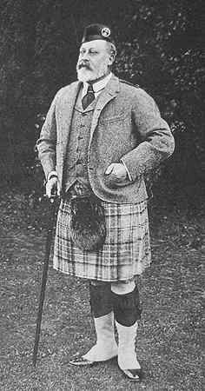
The national dress of Scotland is the kilt. Traditionally for a man this is worn with a shirt, tie, waistcoat and tweed jacket, socks with garter flashes, brogue shoes and a sporran.
Since the traditional kilt does not have pockets, the sporran serves as a wallet and container for any other necessary personal items.
The photo to the left shows King Edward VII at Balmoral in 1904. He is wearing a tweed Argyll jacket, kilt and a woollen cap known as a Glengarry.
Traditionally, women and girls do not wear kilts but may wear ankle-length tartan skirts, along with a colour-co-ordinated blouse. A tartan sash or shawl may also be worn, usually pinned with a brooch or clan badge.
King Edward VII at Balmoral, 1904 ¹
Scottish kilts almost always have tartan patterns. Tartan is made with alternating bands of coloured (pre-dyed) threads woven as both warp and weft at right angles to each other. The weft is woven in a simple twill, two over—two under the warp, advancing one thread at each pass. This forms visible diagonal lines where different colours cross, which give the appearance of new colours blended from the original ones. The resulting blocks of colour repeat vertically and horizontally in a distinctive pattern of squares and lines known as a sett.
Depending upon how "different tartan" is defined, it has been estimated that there are about 3,500 to 7,000 different tartans, with around 150 new designs being created every year.
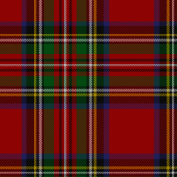
It is generally stated that one of the most popular tartans today is the Royal Stewart tartan. This is the personal tartan of Queen Elizabeth II. In addition to its use in clothing, such as skirts and scarves, Royal Stewart tartan has also appeared on biscuit tins for Scottish shortbread.
Royal Stewart ²
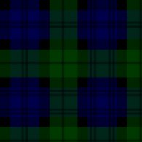
Another popular tartan is the Black Watch (also known as Old Campbell, Grant Hunting, Universal, Government). This tartan was used and is still used by several military units in the British Army and other Commonwealth forces.
Black Watch ³
With thanks to: https://en.wikipedia.org/wiki/Andrew_the_Apostle
and https://en.wikipedia.org/wiki/Tartan for information

With thanks to Wikipedia for images
¹ King Edward VII at Balmoral, 1904 by Lord Redesdalesm – Public domain https://commons.wikimedia.org/wiki/File:EdwardVIIby_LordRedesdalesm.jpg
² Royal Stewart Tartan https://commons.wikimedia.org/wiki/File:Royal_Stewart_tartan.png
MyNikki / CC BY-SA https://creativecommons.org/licenses/by-sa/4.0

³ Black Watch Tartan https://commons.wikimedia.org/wiki/File:Black_Watch_or_Campbell_tartan.svg
lack_Watch_or_Campbell_tartan.png: Celtusderivative work: Wgabrie / CC BY https://creativecommons.org/licenses/by/2.5

St Andrew’s Day Quiz (15 possible points)
- What was the name of Andrew’s brother and what was their occupation?
(2 points)

- When and where is St Andrew believed to have died? (2 points)

- What shape is the St Andrew’s symbol and what is it called? (2 points)

- When did Andrew become patron saint of Scotland? (1 point)

- When did the Battle of Largs take place? (1 point)
- Who was defeated at this battle? (1 point)
- What part did the thistle play in their defeat? (1 point)

- What is the name of the personal tartan of the Queen? (I point)

- Apart from on clothing where else might you see this tartan? (1 point)

10. What is the name of the pattern of squares and lines in tartan? (1 point)
11. What is a sporran used for? (1 point)
12. Approximately how many new tartan designs are created each year?
(1 point)
St Andrew’s Day Quiz with answers (15 possible points)
- What was the name of Andrew’s brother and what was their occupation?
Simon Peter, Fishermen (2 points)
- When and where is St Andrew believed to have died? 30th November 60AD in Greece (2 points)
- What shape is the St Andrew’s symbol and what is it called?
Diagonal cross / Saltire (2 points)
- Approximately how many years ago did Andrew become patron saint of Scotland? Over 1000 years ago (1 point)

- When did the Battle of Largs take place? 1263 (1 point)
- Who was defeated at this battle? Norse army (1 point)
- What part did the thistle play in their defeat?
a Norseman trod on a thistle and shrieked out alerting the sleeping Scottish warriors who then beat the Norseman (1 point)
- What is the name of the personal tartan of the Queen? Royal Stewart
(1 point)
- Apart from on clothing where else might you see this tartan? Biscuit tins
(1 point)
- What is the name of the pattern of squares and lines in tartan?
A sett (1 point)
- What is a sporran used for? Wallet, container for personal items (1 point)
- Approx. how many new tartan designs are created each year? 150 (1 point)
Scottish Inventors Puzzle
Below are the names of 10 Scottish Inventors, 10 inventions and 10 dates but the lists have all got muddled up.
Can you work out the date of each invention and which invention is accredited to which inventor. Fill in your answers on the Scottish Inventors Puzzle Answer sheet

Penicillin | 1893 | Alexander Graham Bell
Television | 1875 | Sir James Dewar
Pneumatic tyres | 1892 | Kirkpatrick MacMillan
Telephone | 1888 | University of Aberdeen  Researchers
Vacuum flask/Thermos flask | 1839 | James Watt
Bicycle | 1776 | Sir Alexander Fleming
Toaster | 1926 | John Logie Baird
MRI Scanner | 1928 | Alan MacMaster
Fingerprinting of criminals | 1880 | John Boyd Dunlop
Improved steam engine | 1980 | Henry Faults

Scottish Inventors Puzzle Answer sheet

Year | Invention | Inventor
1776
1839
1875
1880
1888
1892
1893
1926
1928
1980

Scottish Inventors Puzzle Answers
Year | Invention | Inventor
1776 | Improved steam engine | James Watts
1839 | Bicycle | Kirkpatrick MacMillan
1875 | Telephone | Alexander Graham Bell
1880 | Fingerprinting of criminals | Henry Faults
1888 | Commercial pneumatic tyres | John Boyd Dunlop
1892 | Vacuum flask/Thermos flask | Sir James Dewar
1893 | Toaster | Alan MacMaster
1926 | Television | John Logie Baird
1928 | Penicillin | Sir Alexander Fleming
1980 | MRI Scanner | University of Aberdeen  Researchers

St Andrews Day Wordsearch
Can you find these 15 words related to St Andrew’s Day in the grid below. They may be going forwards or backwards in a horizontal, vertical or diagonal direction
Legends Emblem Haggis Whisky Tartan Kilt Sporran
Tweed Thistle Saltire Martyr Fisherman
I | S | W | Q | N | J | E | J | D | R | B | A | X | H | A | K | X
L | D | L | E | A | C | I | I | B | U | W | S | C | Y | K | Z | Y
Y | N | S | L | M | M | A | E | Z | Y | X | D | I | E | F | I | M
E | E | Z | T | R | A | F | M | H | T | D | N | R | G | P | O | Z
T | G | F | S | E | R | X | B | X | P | S | T | O | G | G | X | R
R | E | I | I | H | T | N | L | L | F | W | T | E | R | C | A | S
O | L | Q | H | S | Y | O | E | J | S | I | Z | V | I | J | M | H
H | X | I | T | I | R | I | M | S | L | N | I | F | J | C | P | M
R | S | T | W | F | C | U | X | K | F | B | J | B | C | H | U | X
J | N | A | T | R | A | T | H | V | J | T | K | L | U | O | X | I
U | U | U | Y | I | T | S | S | J | W | W | T | N | Y | J | R | B
H | G | G | B | Y | Z | F | P | E | A | N | L | S | V | F | Z | X
X | G | G | E | D | R | X | E | O | B | X | I | H | A | Y | G | R
K | H | R | Q | S | A | D | X | L | R | I | K | B | K | G | D | E
P | W | H | I | S | K | Y | B | D | P | R | C | Y | Q | D | J | T
Z | Z | P | D | X | L | I | W | R | W | Z | A | A | Q | A | F | M
K | W | I | S | A | L | T | I | R | E | N | J | N | Z | X | H | Z

St Andrews Day Wordsearch Answers
Legends Emblem Haggis Whisky Tartan Kilt Sporran
Tweed Thistle Saltire Martyr Fisherman
I | S | W | Q | N | J | E | J | D | R | B | A | X | H | A | K | X
L | D | L | E | A | C | I | I | B | U | W | S | C | Y | K | Z | Y
Y | N | S | L | M | M | A | E | Z | Y | X | D | I | E | F | I | M
E | E | Z | T | R | A | F | M | H | T | D | N | R | G | P | O | Z
T | G | F | S | E | R | X | B | X | P | S | T | O | G | G | X | R
R | E | I | I | H | T | N | L | L | F | W | T | E | R | C | A | S
O | L | Q | H | S | Y | O | E | J | S | I | Z | V | I | J | M | H
H | X | I | T | I | R | I | M | S | L | N | I | F | J | C | P | M
R | S | T | W | F | C | U | X | K | F | B | J | B | C | H | U | X
J | N | A | T | R | A | T | H | V | J | T | K | L | U | O | X | I
U | U | U | Y | I | T | S | S | J | W | W | T | N | Y | J | R | B
H | G | G | B | Y | Z | F | P | E | A | N | L | S | V | F | Z | X
X | G | G | E | D | R | X | E | O | B | X | I | H | A | Y | G | R
K | H | R | Q | S | A | D | X | L | R | I | K | B | K | G | D | E
P | W | H | I | S | K | Y | B | D | P | R | C | Y | Q | D | J | T
Z | Z | P | D | X | L | I | W | R | W | Z | A | A | Q | A | F | M
K | W | I | S | A | L | T | I | R | E | N | J | N | Z | X | H | Z

