St George’s Day

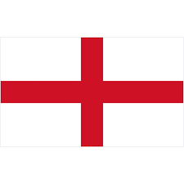
About this topic – Learn about St George, Patron Saint of England and the traditions associated with St George’s Day. Test your memory and knowledge with a quiz and games.
Resources for this topic
- Suggested session plan
- St George’s Day Facts
- St George’s Day Quiz and Answers
- St George’s Day Word Scramble and Answers
- Union Flag Design Test and Creation of the Union Flag

We are happy for you to use the material in this Toolkit exactly as it is or to modify it as required for your purposes. We do however ask that you always acknowledge its source as follows:

“Learning and Sharing Together” Resources (2020)
With thanks to Burnham Health Promotion Trust
Reg. Charity No.1066070 & Reg. Company No.3435602
www.bhpt.org.uk

You may not redistribute, sell or place any part of this Toolkit on any other website or blog without written agreement. Please Contact Us to discuss

Suggested session plan (one and a half hours approx.)
Whilst the plan below has been developed for face to face meetings, all the activities can be used in Virtual meetings too, using the shared screen facility on Zoom for example, and break out rooms for some activities.
- Welcome and introductions
- Working in small groups the children and older people should take turns to read aloud St George’s Day Facts. Encourage them to discuss what they have read as there will be a quiz later. Give out St George’s Day Word Scramble to groups as they finish 2)
- When all the groups have finished 2) collect in St George’s Day Facts and hand out St George’s Day Quiz

- As groups finish the Quiz, they should continue with the
St George’s Day Word Scramble

- Go through the St George’s Day Quiz Answers when all the groups have finished the Quiz

- Hand out Union Flag Design Test and give everyone a few minutes to try and draw the Union Flag.
- Refreshments and discussion about the Union Flag drawings. How do they compare with the Creation of the Union Flag?

- Additional activity if required: Drawings – for example St George and the dragon or a red rose

- Thankyous and goodbyes - Before the children and older people leave you may wish to say something about the topic or activity you have planned for the next session. This gives everyone the opportunity to be more prepared and perhaps to bring photographs or other memorabilia
St George’s Day
Who was St George? - St George is popularly identified with England and English ideals of honour, bravery and gallantry, but in fact he wasn’t English at all.
St George is believed to have been born in Cappadocia (now Eastern Turkey) in the year A.D. 270. He was a Christian and at the age of seventeen he joined the Roman army and soon became well known for his bravery. He served under a pagan Emperor called Diocletian but he never forgot his Christian faith.
When the Emperor started persecuting Christians, St George pleaded with him to spare their lives. However, St George's pleas fell on deaf ears and it is thought that the Emperor tried to make St George deny his faith in Christ, by torturing him. St George showed great courage and faith but was finally beheaded near Lydda in Palestine on 23rd April, 303.
The popularity of St George in England stems from the time of the early Crusades when it is said that the Normans saw him in a vision and were victorious.
St George's emblem, a red cross on a white background, was adopted by Richard The Lion Heart and brought to England in the 12th century. The King's soldiers wore it on their tunics to avoid confusion in battle. St George’s emblem became the flag of England, and in time it became part of the British flag, The Union Flag or Union Jack as it is often known.
Today, St George's Cross is used frequently at football, rugby and cricket matches with fans wearing scarves, painting their faces and flying flags to show their support for England.
Our Patron Saint - In 1222, the Council of Oxford declared 23rd April to be St George’s Day and St George replaced Edward the Confessor as England’s patron saint in the 14th century. In 1415, April 23rd was made a national feast day.
St George is patron saint not only of England but also of Aragon, Catalonia, Georgia, Lithuania, Palestine and Portugal amongst others, although he is celebrated on different days.
St George is also patron saint of Scouts, soldiers, archers, cavalry and chivalry, farmers and field workers, riders and saddlers, and he is also thought to help those suffering from certain diseases such as leprosy.
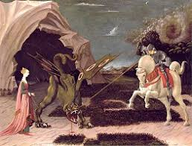
The Legend of St George - One of the best-known stories about St George is his fight with a dragon. In paintings he is typically shown as a knight carrying a shield or a banner with a red cross.
It is also very common to see him sitting upon a horse and killing a dragon. But it is highly unlikely that he ever fought a dragon, and even more unlikely that he ever actually visited England.
Despite this, St George is known throughout the world as the dragon-slaying patron saint of England.
How does England celebrate St George's Day?
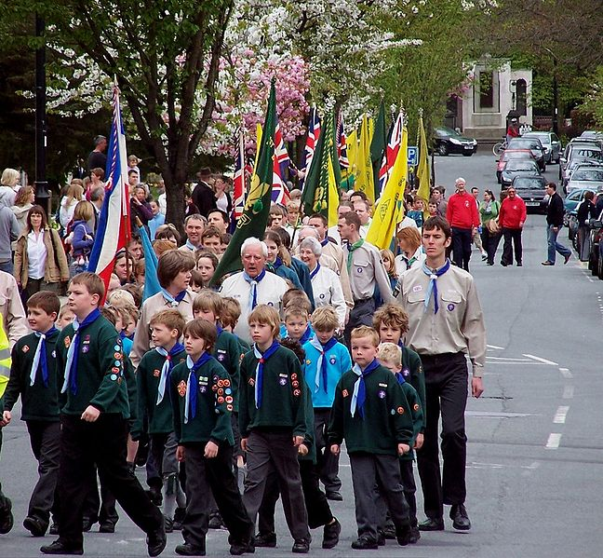

The 23rd April used to be a national holiday in England and was once celebrated as widely as Christmas. But since the 18th century, and the unification of England and Scotland in 1707, celebrations have diminished. However, there are still some parades, music performances and public events held across the country to honour the patron saint. A red rose has also been the national emblem of England since the War of the Roses in the fifteenth century and some people choose to wear this flower on St George's Day. The hymn Jerusalem is traditionally sung on this day and Morris Dancers often perform around the country.
There are also some St George’s Day festivals around London including the Feast of St George. This takes place every year in Trafalgar Square which is packed with delicious food stalls, cooking demonstrations, live music and other entertainment.
On the Sunday nearest to 23rd April, Scouts and Guides throughout England parade through high streets and attend a special St George's Day service at their local church.
A St George’s Day Procession, 2010 ¹
With thanks to Mandy Barrow for permission to include information and images from Project Britain website http://projectbritain.com/stgeorge.html
With thanks to Wikipedia for photo
¹ A St George’s Day Procession, 2010 https://commons.wikimedia.org/wiki/File:StGeorgeScouts.jpg
Entersslerine / CC BY-SA (https://creativecommons.org/licenses/by-sa/3.0)
St George’s Day Quiz (15 possible points)
- Where and when was St George thought to have been born? 2 points

- What did St George do when he was 17? 1 point

- What did St George want Emperor Diocletian to do? 1 point

- What happened to St George on 23rd April 303 AD? 1 point

- What was St George’s emblem? 1 point

- Who brought St George’s emblem to England? 1 point

- Which flower is traditionally associated with St George’s Day in England?
1 point

- What is the name of the British flag? 1 point

- St George is also the patron saint of several groups of people. Can you name five of these? Up to 5 points

- Where in London does the Feast of St George take place? 1 point

St George Quiz Answers (15 possible points)
- Where and when was St George thought to have been born? 2 points
Cappadocia (now eastern Turkey) in AD 270

2. What did St George do when he was 17? 1 point
Joined Roman Army

- What did St George want Emperor Diocletian to do? 1 point
Stop persecuting Christians

- What happened to St George on 23rd April 303 AD? 1 point
He was beheaded

- What was St George’s emblem? 1 point
Red cross on white background

- Who brought St George’s emblem to England? 1 point
Richard the Lion heart

- Which flower is traditionally associated with St George’s Day in England?
1 point
Red rose

- What is the name of the British flag? 1 point
Union Flag or Union Jack

- St George is also the patron saint of several groups of people. Can you name five of these? 1 point for any of the following up to maximum of 5 points
Scouts, soldiers, archers, cavalry and chivalry, farmers and field workers, riders and saddlers and people suffering from certain diseases
- Where in London does the Feast of St George take place? 1 point
Trafalgar Square
St George's Day Word Scramble
1. NINOU AGLF ________________________________________
2. SSUOTC ____________________________________________
3. NTPRAO INAST ______________________________________
4. GANRDO ____________________________________________
5. APEARDS ___________________________________________
6. TESCLBEIRNOA ______________________________________
7. ARBREVY ___________________________________________
8. DRE EROS _________________________________________
9. OACIPAACPD _______________________________________
10. EEMLMB ____________________________________________
11. GNEDLE ____________________________________________
12. FTRRLAAGA ARSQUE __________________________________
13. OSRMRI EADRSCN ____________________________________
14. LESRMEAJU _________________________________________
15. GITKHN ________________________________________ _

St George's Day Word Scramble Answers
1. NINOU AGLF __Union Flag____________________________
2. SSUOTC __Scouts____________________________________
3. NTPRAO INAST __Patron Saint________________________
4. GANRDO __Dragon____________________________________
5. APEARDS __Parades__________________________________
6. TESCLBEIRNOA __Celebrations________________________
7. ARBREVY __Bravery__________________________________
8. DRE EROS __ Red Rose______________________________
9. OACIPAACPD __Cappadocia __________________________
10. EEMLMB __Emblem____________________________________
11. GNEDLE __Legend____________________________________
12. FTRRLAAGA ARSQUE __Trafalgar Square________________
13. OSRMRI EADRSCN __Morris dancers____________________
14. LESRMEAJU __Jerusalem______________________________
15. GITKHN __Knight____________________________________

The Union Flag Design Test
The Union Flag (or Union Jack as it is often known) is the national flag of the United Kingdom. It includes the St George’s Emblem or Cross of England as well as the emblems of Scotland and Ireland.
At the time the flag was created Wales was still considered to be a part of England so it is not represented in the design.
Starting from St George’s Cross can you draw the Union Flag?
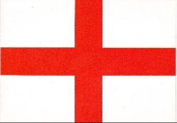

The Creation of the Union Flag

Initially the English and Scottish flags were combined to form the original Union Flag and then when Great Britain and Ireland were united in 1801 the Irish emblem was added to create the Union Flag as we know it today.

 | + | 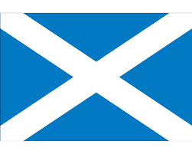 |  | 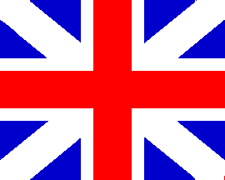 | + | 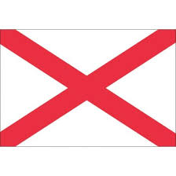
England |  | Scotland |  | Original Union Flag (1606) |  | Ireland

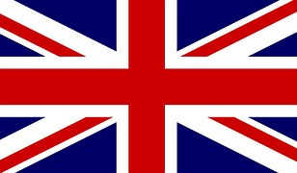
Union Flag or Union Jack
(1801)

The Welsh flag is not included because Wales had been annexed by Edward I of England in 1282 and was still considered to be a part of the Kingdom of England when the original Union Flag of Great Britain was designed in 1606.

