St Patrick’s Day
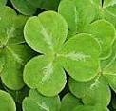

About this topic – Learn about St Patrick and traditions associated with St Patrick’s Day. Test your memory with a quiz, have fun with a wordsearch and discuss some Irish proverbs.
Resources for this topic
- Suggested session plan
- St Patrick’s Day Facts
- St Patrick’s Day Quiz and Answers
- St Patrick’s Day Word Search and Answers
- Irish Proverbs

We are happy for you to use the material in this Toolkit exactly as it is or to modify it as required for your purposes. We do however ask that you always acknowledge its source as follows:

“Learning and Sharing Together” Resources (2020)
With thanks to Burnham Health Promotion Trust
Reg. Charity No.1066070 & Reg. Company No.3435602
www.bhpt.org.uk

You may not redistribute, sell or place any part of this Toolkit on any other website or blog without written agreement. Please Contact Us to discuss

Suggested session plan (one and a half hours approx.)
Whilst the plan below has been developed for face to face meetings, all the activities can be used in Virtual meetings too, using the shared screen facility on Zoom for example, and break out rooms for some activities.
- Welcome and introductions
- Working in small groups the children and older people should take turns to read aloud St Patrick’s Day Facts. Encourage them to discuss what they have read as there will be a quiz later.
- Give out St Patrick’s Day Word Search to groups as they finish 2)
- When all the groups have finished 2) collect in St Patrick’s Day Facts and hand out St Patrick’s Day Facts Quiz

- As groups finish the Quiz, they should continue with the St Patrick’s Day Word Search. Hand out Irish Proverbs for groups to discuss when they have finished the Quiz and Word Search.

- Go through the St Patrick’s Day Quiz Answers when all the groups have finished the Quiz

- Refreshments and discussion about Irish Proverbs – if there is time the children can write out their favourite proverb, perhaps on a piece of card which they can use as a bookmark

- Thankyous and goodbyes - Before the children and older people leave you may wish to say something about the topic or activity you have planned for the next session. This gives everyone the opportunity to be more prepared and perhaps to bring photographs or other memorabilia
St Patrick’s Day
About St Patrick
Saint Patrick is the patron saint of Ireland. St Patrick is thought to have been born in Wales around AD 385 although some records suggest he was born in Scotland. When he was sixteen years old he was taken off to Ireland by pirates and spent six years in slavery. Patrick came to believe that this was a punishment for his lack of faith.
He was put to work for six years herding sheep and pigs on Slemish mountain in County Antrim. While he was a shepherd, Patrick spent much of his time praying.
After six years he managed to escape by stowing away on a boat bound for Britain. The boat landed not far from where his parents lived.
Patrick decided to follow his vocation to become a priest but spent several years studying before he felt ready to take up the life of a missionary.
Patrick eventually returned to Ireland, as the country's second bishop, and brought the message of Christ to many people who had never heard it.
As a missionary Patrick baptised many thousands of people.
Patrick believed that when "every nation" had heard the gospel, Christ would then return, and it seems he believed that he was the person to bring this message of Christianity to the pagan people of Ireland.
St Patrick is traditionally associated with the shamrock, a clover like plant. Patrick used the three-leaved shamrock to explain how the Trinity of the Father, Son and Holy Spirit could exist as separate parts of the same being.
His followers took to wearing a shamrock in celebration, a tradition that has continued on St Patrick’s Day.
One of the stories that is told about St Patrick is that he drove the snakes out of Ireland. However, it is unlikely that there ever were any snakes in Ireland. The snake may be a reference to a serpent which is a symbol of evil. The driving may be a reference to Patrick's mission to rid Ireland of pagan influence.
St Patrick died on 17th March in AD 461 and this day has since been commemorated as St. Patrick’s Day.
St Patrick’s Cross
St Patrick’s Cross is a red saltire (a diagonal cross) on a white background. It was adopted as the emblem of St Patrick in the 1780’s and then in 1800, when the Act of Union joined the Kingdom of Ireland with the Kingdom of Great Britain, it was added to the British flag to form the Union Flag.
St Patrick’s Day Celebrations
St. Patrick's Day was originally created as a feast day by the Catholic Church, honouring the life of Ireland's patron saint. So the holiday was first established as a religious celebration, a time of spiritual renewal. Now the day is also seen as an opportunity to celebrate Irish heritage and solidarity and is widely recognised internationally with celebrations taking place in many countries around the world. There are a number of traditions associated with St Patrick’s Day.
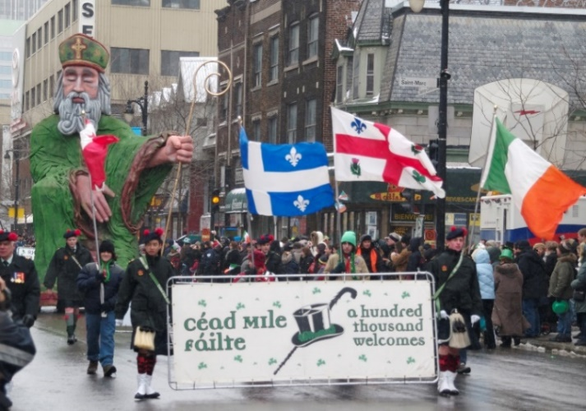
1. Parades
St Patrick’s Day parades are one of the holiday's cherished traditions. The first St. Patrick's Day parade was not staged in Ireland but in New York City. Irish soldiers in the occupying English army marched around New York City in 1762 as a sign of solidarity. Irish patriotism remained strong over the following decades as more immigrants from Ireland continued to arrive in the United States. A couple of Irish Aid societies in New York City worked together to plan a joint parade route for St. Patrick's Day in 1848, establishing what would become the oldest and largest civilian parade in the country.
Today, the three largest St. Patrick's Day parades are held in Dublin in Ireland; New York City in the USA ; and Birmingham in England. Large parades also are held in most major cities throughout the United States as well as in London, Paris, Moscow and Beijing.
St. Patrick's Day Parade, Montreal, 2007 ¹
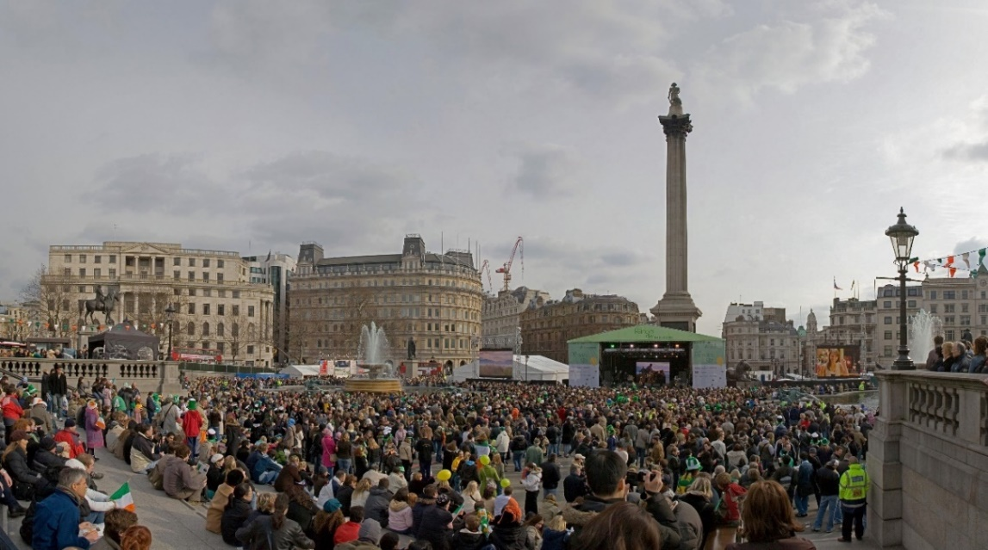
In London the St Patrick's Day Parade includes marching bands, floats and street theatre. All 32 Irish counties are represented, dressed in their traditional county colours, as well as London's Irish community and other Londoners.
As well as the Parade, there is also a festival of Irish music, dance and culture in Trafalgar Square.

St Patrick’s Day Festival, Trafalgar Square, London, 2006 ²
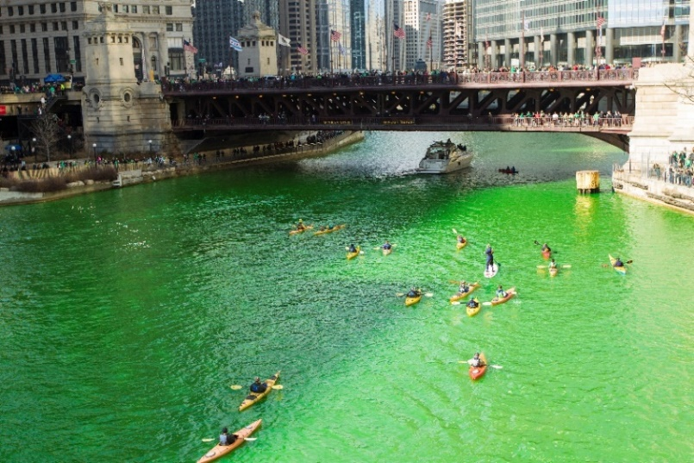
2. Wearing Green
Wearing green is a popular tradition on St. Patrick's Day although this is not actually an Irish custom. The Irish typically wear tricolored shirts of green, white and orange, representing their national colours. The tradition of wearing green clothing was started in the United States. Some people go all out on this holiday, wearing green outfits complete with green hats, gloves and other accessories.
In Chicago the river is even dyed green for a few hours.
The Chicago River dyed green ³

3. Shamrocks
Shamrocks are still traditionally worn because of St Patrick’s association with this plant.
4. Food and drink
One of the traditional foods served on St. Patrick's Day is corned beef and cabbage. The Irish have used cabbage as a staple in their diet for centuries. Quality Irish bacon was originally served with cabbage in Ireland for the St Patrick’s Day festivities, but many of the first Irish immigrants in the United States could not afford bacon so they used corned beef as a substitute. This trend caught on, and corned beef and cabbage is now the standard dish at St. Patrick's Day celebrations.
Traditional drinks for adults on St Patricks Day include Irish beers, such as Guinness, Murphy's, Harp and Smithwick's. Regular beers are often dyed green. Other popular Irish drinks include Jameson's whiskey and Bailey's Irish Cream.

Popular Irish toasts on St Patrick's Day, include:

“may the roof above us never fall in, and may we friends beneath it never fall out”

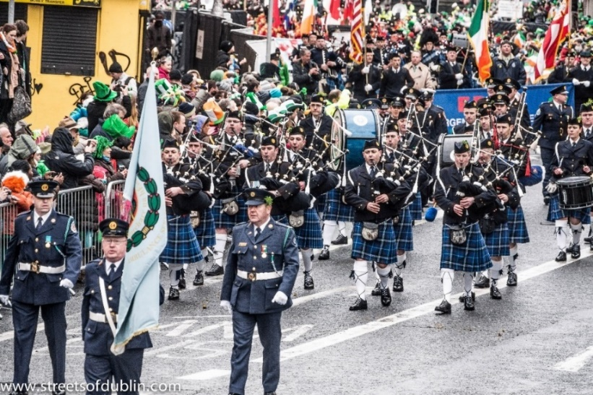
St. Patrick's Day Parade, Dublin, 2013 ⁴

With thanks to Mandy Barrow for permission to include information and images from Project Britain website

http://projectbritain.com/nationaldays/ireland.html

and to Wikipedia for additional information https://en.wikipedia.org/wiki/Saint_Patrick%27s_Day

and photos
¹ St. Patrick's Day Parade, Montreal 2007
https://commons.wikimedia.org/w/index.php?curid=22221449
Sandra Cohen-Rose and Colin Rose from Montreal, Canada / CC BY https://creativecommons.org/licenses/by/2.0

² St Patrick’s Day Festival, Trafalgar Square, London, 2006
https://commons.wikimedia.org/w/index.php?curid=820908
Diliff / CC BY-SA http://creativecommons.org/licenses/by-sa/3.0/

³ The Chicago River dyed green
https://commons.wikimedia.org/w/index.php?curid=42406868
ScottMLiebenson / CC BY-SA https://creativecommons.org/licenses/by-sa/3.0

⁴ St. Patrick's Day Parade (2013) In Dublin https://commons.wikimedia.org/w/index.php?curid=27675891
William Murphy from Dublin, Ireland / CC BY-SA https://creativecommons.org/licenses/by-sa/2.0

St Patrick’s Day Quiz (20 points)
- What happened to Patrick when he was 16? 1 point

- What sort of work did he do as a slave? 1 point

- How did he escape and where did he go? 2 points

- Why is the shamrock associated with St Patrick? Up to 2 points for full answer

- Where was the first St Patrick Day’s parade held? 1 point

- Where are the three largest St Patrick Day’s parades held now? 3 points

- What meal is traditionally eaten on St Patrick’s Day? 1 point

- In which year did St Patrick die? 1 point

- Where could you see a green river on St Patrick’s Day? 1 point

- Complete this popular St Patrick’s Day toast (up to 7 points)
“May the …………….. above us …………… …………… in

and may we ………………….. …………………. it never …………… ……………….”
St Patrick’s Day Quiz Answers (20 points)
- What happened to Patrick when he was 16? 1 point
He was taken off to Ireland by pirates

- What sort of work did he do as a slave? 1 point
He was a shepherd of sheep and pigs

- How did he escape and where did he go? 2 points
By stowing away on a boat bound for Britain.

- Why is the shamrock associated with St Patrick? Up to 2 points for full answer
St Patrick used the three-leaved shamrock to explain how the Trinity of the Father, Son and Holy Spirit could exist as separate parts of the same being.

- Where was the first St Patrick Day’s parade held? 1 point
New York City
- Where are the three largest St Patrick Day’s parades held now? 3 points
Dublin in Ireland; New York City in the USA ; and Birmingham in England.

- What meal is traditionally eaten on St Patrick’s Day? 1 point
Corned beef and cabbage

- In which year did St Patrick die? 1 point
AD 461

- Where could you see a green river on St Patrick’s Day? 1 point
Chicago
- Complete this popular St Patrick’s Day toast up to 7 points
“May the …ROOF……….above us…… NEVER ……… ……FALL ………in and may we……FRIENDS……….. BENEATH ………………. …it………… never………FALL …… …OUT…………….”
St Patrick's Day Word Search
Can you find these 10 words related to St Patrick’s Day in the grid below. They may be going forwards or backwards in a horizontal, vertical or diagonal direction
Festival Dublin Cabbage Patron Saint Trafalgar Square Chicago Parades Celebrations Traditions Shamrock

D | M | H | Q | D | Z | F | N | A | T | D | U | B | L | I | N | I
S | W | W | P | F | X | C | S | I | W | M | Y | S | Y | Q | Z | K
F | E | S | C | E | L | E | B | R | A | T | I | O | N | S | T | C
W | S | D | N | Y | F | C | Q | K | O | Q | H | C | T | R | T | O
Z | T | X | A | O | S | T | V | X | W | A | C | E | A | N | M | R
S | O | C | E | R | B | F | U | F | Z | L | X | F | G | R | B | M
S | W | J | G | T | A | X | M | O | A | K | A | P | S | F | H | A
N | S | U | A | I | V | P | Y | V | G | L | E | Y | G | Q | A | H
O | N | R | B | L | V | U | I | F | G | A | T | R | M | S | M | S
I | C | H | B | V | M | T | P | A | T | G | C | J | R | L | I | C
T | H | R | A | S | S | W | R | T | L | U | D | I | H | U | Y | Z
I | Y | D | C | E | Y | S | Y | Y | I | Z | Z | Q | H | O | F | P
D | W | W | F | X | Q | V | C | O | E | G | O | S | C | C | H | W
A | N | F | Y | U | S | S | Z | V | J | E | F | O | U | I | J | Q
R | H | P | A | T | R | O | N | S | A | I | N | T | Z | C | E | Y
T | Q | R | O | A | K | I | S | Q | K | R | A | S | M | G | H | H
E | E | E | U | E | T | E | F | Y | F | T | G | W | W | M | N | Z

St Patrick's Day Word Search Answers
Festival Dublin Cabbage Patron Saint Trafalgar Square Chicago Parades Celebrations Traditions Shamrock

D | M | H | Q | D | Z | F | N | A | T | D | U | B | L | I | N | I
S | W | W | P | F | X | C | S | I | W | M | Y | S | Y | Q | Z | K
F | E | S | C | E | L | E | B | R | A | T | I | O | N | S | T | C
W | S | D | N | Y | F | C | Q | K | O | Q | H | C | T | R | T | O
Z | T | X | A | O | S | T | V | X | W | A | C | E | A | N | M | R
S | O | C | E | R | B | F | U | F | Z | L | X | F | G | R | B | M
S | W | J | G | T | A | X | M | O | A | K | A | P | S | F | H | A
N | S | U | A | I | V | P | Y | V | G | L | E | Y | G | Q | A | H
O | N | R | B | L | V | U | I | F | G | A | T | R | M | S | M | S
I | C | H | B | V | M | T | P | A | T | G | C | J | R | L | I | C
T | H | R | A | S | S | W | R | T | L | U | D | I | H | U | Y | Z
I | Y | D | C | E | Y | S | Y | Y | I | Z | Z | Q | H | O | F | P
D | W | W | F | X | Q | V | C | O | E | G | O | S | C | C | H | W
A | N | F | Y | U | S | S | Z | V | J | E | F | O | U | I | J | Q
R | H | P | A | T | R | O | N | S | A | I | N | T | Z | C | E | Y
T | Q | R | O | A | K | I | S | Q | K | R | A | S | M | G | H | H
E | E | E | U | E | T | E | F | Y | F | T | G | W | W | M | N | Z

Irish Proverbs
The Irish are well known for their proverbs and sayings, many of which date back hundreds of years. The wisdom that has been passed on through the generations is still just as relevant now as it was when these Irish sayings were first thought up.
Here are just a few examples for you to think about. Which ones do you like best?
- May you get all your wishes but one, so that you will always have something to strive for!
- You’ve got to do your own growing, no matter how tall your grandfather was.

- Who keeps his tongue keeps his friends.

- May your home always be too small to hold all your friends.

- May you have the hindsight to know where you’ve been, the foresight to know where you are going, and the insight to know when you have gone too far.

- A little fire that warms is better than a big fire that burns.

- You’ll never plough a field by turning it over in your mind.

- May the hinges of our friendship never grow rusty!

- The best things in life are the people we love, the places we have been and the memories we have made along the way.

- A friend’s eye is a good mirror

