Memories of our working lives 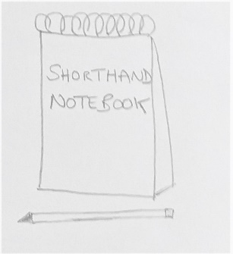 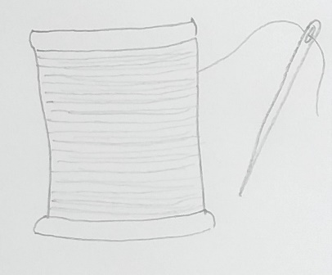 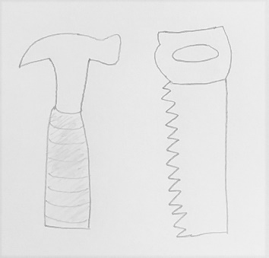
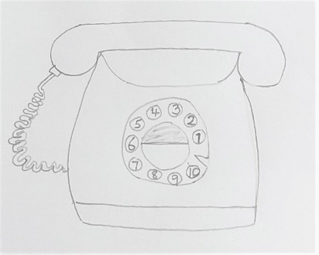 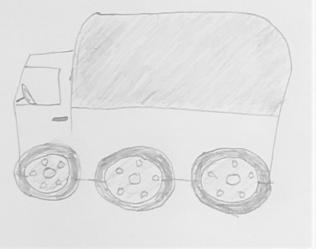
About this topic - The aim of this session is for the children to learn about the older people’s working lives and to think about the range of different occupations that people can have. The children act as reporters, interviewing the older people and then writing and illustrating a report of what they discover. There is also a game for everyone to play.
Resources for this topic
- Suggested session plan
- Did you ever work…..? Types of jobs list (Cut up before session)
- Did you ever work…..? Interview Sheet
- Occupations Game
We are happy for you to use the material in this Toolkit exactly as it is or to modify it as required for your purposes. We do however ask that you always acknowledge its source as follows:

“Learning and Sharing Together” Resources (2020)
With thanks to Burnham Health Promotion Trust
Reg. Charity No.1066070 & Reg. Company No.3435602
www.bhpt.org.uk

You may not redistribute, sell or place any part of this Toolkit on any other website or blog without written agreement. Please Contact Us to discuss
Suggested session plan (one and a half hours approx.)
Whilst the plan below has been developed for face to face meetings, all the activities can be modified for use in Virtual meetings too. Instead of working in pairs or small groups the children could take turns to ask the adults the “Did you ever work?” questions.
The questions on the interview sheet could then be used as a basis for a whole group discussion about the older people’s working lives. The Occupations Game could be played in break out rooms using the shared screen facility on Zoom.
- Welcome and introductions – Explain that the aim of the session is to learn about the older people’s working lives and to think about the range of different occupations that people can have.
- Each child is given one of the “Did you ever work?”….questions. The children should work in pairs if there are more children than older people. The children then walk around the room and ask an older person the question on their piece of paper. When they find someone who replies “Yes”, the child then collects a “Did you ever work? interview sheet” and asks that person about that particular job. The children then write it up neatly and draw a picture. Encourage the older people to help them as required.
- This is then repeated with the children being given a different question. Wherever possible they should interview a different person. Do make sure that all the older people get the opportunity to be interviewed at least once. You may need to help the quieter members of the group with this game.

- Refreshments – During refreshments have a whole group discussion about what the children have found out about the older people’s working lives. For example, have any of the older people had similar jobs? What was the longest time anyone had been in one job? Which jobs had people particularly enjoyed?

- Occupations Game – work in small groups to play this game. Hand out an Occupations Game Sheet to each group. Ask one person to choose a letter of the alphabet. Encourage people to try and think of unusual occupations as they will only get a point if none of the other groups have the same word.

- Thankyous and goodbyes - Before the children and older people leave you may wish to say something about the topic you have planned for the next session. This gives everyone the opportunity to be more prepared and, if appropriate, to bring photographs or other memorabilia.

Did you ever work …..?
Before the session cut along the dotted lines to separate out the questions below. If you know an older person had an unusual occupation, make sure you include an appropriate question so that they have the opportunity to talk about it.
Did you ever work in a factory? .................................................................................................
Did you ever work outdoors?
.................................................................................................
Did you ever work in a shop?
.................................................................................................
Did you ever work in a hospital?
................................................................................................
Did you ever work in an office?
.................................................................................................
Did you ever work in a job where you did a lot of driving?
.................................................................................................
Did you ever work in a hotel or restaurant?
.................................................................................................
Did you ever work with animals?
.................................................................................................
Did you ever work abroad?
.................................................................................................
Did you ever work in a job where you had to wear a uniform?
.................................................................................................
Did you ever work with children?
.................................................................................................
Did you ever work? Interview Sheet
When someone answers “Yes” to a job find out as much as you can about that job, for example:
How old were you when you worked there?

How long did you have the job?

Where was it?

What was the name of the company or organisation you worked for?

What did you do in this job? What was a typical day at work like?

Did you enjoy the work?

Were you sorry to leave this job?

Is there anything else you can remember about this job?

Occupations Game
Think of an occupation beginning with …………….
Someone is asked to choose a letter of the alphabet. Then working in small groups, try and think of a word for each job type that begins with the chosen letter e.g. a job where you wear a uniform beginning with N could be nurse.
Try and think of unusual words. You will only get a point if none of the other groups have the same word.

Job type | Letter | Letter | Letter
Where you wear a uniform
Where you work mainly outside

Where you work with food

Where you work with children

Where you work with animals

Where you may have to work on Christmas Day

Score

