Our Favourite Things

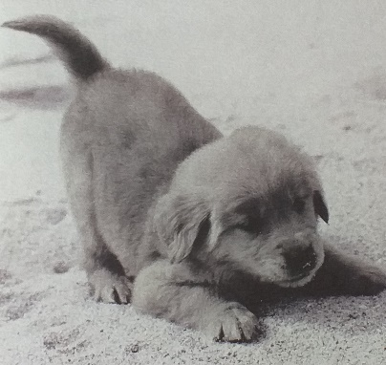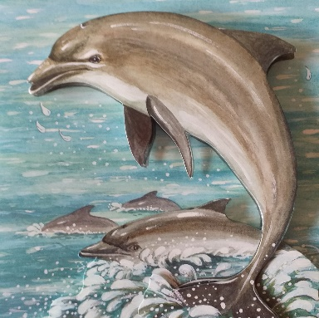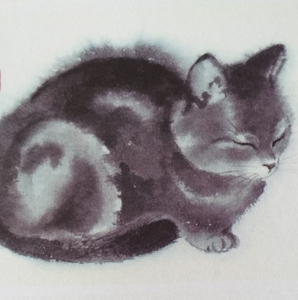
About this topic – Find out about one another’s favourite things and discover the similarities and differences to your own. Choose your favourite popular quote and sing “My Favourite Things” together
Resources for this topic
- Suggested session plan
- What is your favourite? Question sheet
- What is your favourite? Tally Chart
- Popular Quotes (you will also need plain postcards or small pieces of card)
- My Favourite Things lyrics

We are happy for you to use the material in this Toolkit exactly as it is or to modify it as required for your purposes. We do however ask that you always acknowledge its source as follows:

“Learning and Sharing Together” Resources (2020)
With thanks to Burnham Health Promotion Trust
Reg. Charity No.1066070 & Reg. Company No.3435602
www.bhpt.org.uk

You may not redistribute, sell or place any part of this Toolkit on any other website or blog without written agreement. Please Contact Us to discuss

Suggested session plan (one and a half hours approx.)
Whilst the plan below has been developed for face to face meetings, the activities can be modified for use in Virtual meetings too, using the shared screen facility on Zoom and break out rooms for example. Everyone could be given a few minutes to look at the list and think about their favourite things before going into break out rooms to write down and discuss their answers. You could then come together as a whole group and could create a tally chart using the Whiteboard facility on Zoom.
- Welcome and introductions
- For this activity it is ideal for one child to work with one adult.
If this is not possible because of uneven numbers, then divide the
adults and children into small groups, for example one adult and
two children or two children and one adult.
- Hand out What is your favourite? Question sheet/s to each pair or small group. Encourage the children and older people to take it in turns to read aloud and give their answer first.
- When all the groups have finished completing their question sheets find out about the range of answers within the whole group. You can create a tally chart for each of the 12 questions. Are there big differences between people’s choices? Are there any similarities?
- For the next activity work in groups of two to three adults and two to three children. Hand out Popular Quotes and pieces of card - postcard size is ideal. Read and discuss the quotes. Everyone should choose their favourite and write it down on their card as a keepsake. If there is time, add an illustration.
- Refreshments – have a chat about what you’ve discovered about one another’s favourite things. Are there any surprises?
- Sing “My Favourite Things” – for virtual meetings you could play a recording. Everyone could enjoy listening or joining in whilst “muted”
- If you have time to spare everyone could do a drawing of either one of their own or one of someone else’s favourite things
- Thankyous and goodbyes - Before the children and older people leave you may wish to say something about the topic or activity you have planned for the next session. This gives everyone the opportunity to be more prepared and, if appropriate, to bring photographs or other memorabilia

What is your favourite?
What is your favourite? | Name | Name

Colour

TV Programme

Sport or Exercise

Type of Breakfast

Zoo Animal

Type of Sandwich

Football Team

Time of Year

Holiday Destination

Type of Pet

Film

Type of Meal

What is your favourite? Tally chart
Item | Choices | Total for each choice

Colour

TV Programme

Sport or Exercise

Type of Breakfast

Item |  | Choices | Total for each choice

Zoo Animal

Type of Sandwich

Football Team

Time of Year

Holiday Destination
Item | Choices |  | Total for each choice

Type of Pet

Film

Type of Meal

Popular Quotes

Here are some well known quotes from famous people.
Which is your favourite?

- “Every moment is a fresh beginning”. – T.S Eliot
- “Never regret anything that made you smile”. – Mark Twain
- “Whatever you do, do it well”. – Walt Disney
- “What we think, we become”. – Buddha
- “Try to be a rainbow in someone’s cloud”. – Maya Angelou
- “The time is always right to do what is right”. – Martin Luther King Jr.
- “May your choices reflect your hopes, not your fears”. – Nelson Mandela
- “If you tell the truth you don’t have to remember anything”. – Mark Twain

- “ You must be the change you wish to see in the world.” — Gandhi

- “When one door of happiness closes, another opens; but often we look so long at the closed door that we do not see the one which has been opened for us.”– Helen Keller

When you have chosen your favourite quote, write it out on a plain piece of card to save as a keepsake or use as a bookmark perhaps. If there is time, you could add an illustration.

My Favourite Things

from The Sound of Music
by Rodgers and Hammerstein
Raindrops on roses and whiskers on kittens
Bright copper kettles and warm woollen mittens
Brown paper packages tied up with strings
These are a few of my favourite things
Cream-colored ponies and crisp apple strudels
Doorbells and sleigh bells and schnitzel with noodles
Wild geese that fly with the moon on their wings
These are a few of my favourite things
Girls in white dresses with blue satin sashes
Snowflakes that stay on my nose and eyelashes
Silver white winters that melt into springs
These are a few of my favourite things
When the dog bites, when the bee stings
When I'm feeling sad
I simply remember my favourite things
And then I don't feel so bad

