Our Favourite Toys and Games

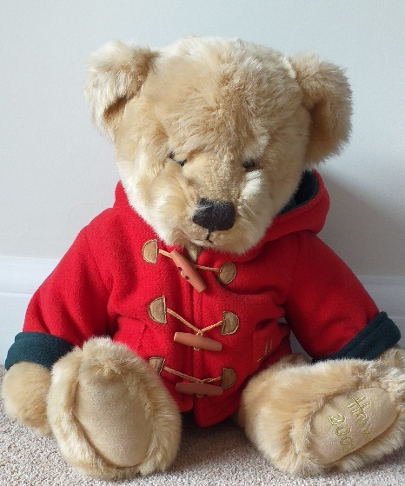
About this topic – Learn about the history of some popular toys and find out about one another’s favourite childhood toys and games. You could ask the children to bring a favourite toy with them, perhaps some of the adults may be able to bring one too!
Resources for this topic
- Suggested session plan
- Childhood Toys and Games Interview Sheets
- The History of Toys
- The History of Toys Crossword and Answers
- Toys and Games Word Scramble and Answers

We are happy for you to use the material in this Toolkit exactly as it is or to modify it as required for your purposes. We do however ask that you always acknowledge its source as follows:

“Learning and Sharing Together” Resources (2020)
With thanks to Burnham Health Promotion Trust
Reg. Charity No.1066070 & Reg. Company No.3435602
www.bhpt.org.uk

You may not redistribute, sell or place any part of this Toolkit on any other website or blog without written agreement. Please Contact Us to discuss
Suggested session plan (one and a half hours approx.)
Whilst the plan below has been developed for face to face meetings, all the activities can be used in Virtual meetings too, using the shared screen facility on Zoom for example, and break out rooms for some activities.
- Welcome and introductions
- For the first activity it is best to work in pairs or in small groups if
there are uneven numbers of older people and children. Hand out
the Childhood Toys and Games Question Sheets to the children.

- Encourage the children to find out as much as they can from the older people about their childhood toys and games. If there are more older people than children, then decide which older person is to answer first – do make sure that everyone gets a chance to share their memories. Encourage the older people to also ask the children about their favourite toys and games – what are the similarities and differences between the generations?

- As the children and older people finish the first activity divide them into small groups. Give out the History of Toys and Games for them to read aloud and discuss in their groups. Explain there will be a quiz afterwards in the form of a crossword.
- Collect in History of Toys and Games from groups when they finish reading it. Hand out History of Toys and Games Crossword.
- Refreshments and Group discussion about everyone’s favourite toys and games. Answers to Crossword.
- Toys and Games Word Scramble if time permits

- Thankyous and goodbyes - Before the children and older people leave you may wish to say something about the topic or activity you have planned for the next session. This gives everyone the opportunity to be more prepared and, if appropriate, to bring photographs or other memorabilia.
Childhood Toys and Games Question Sheet

The aim is for the children and older people to find out as much as they can about each other’s favourite childhood toys and games. For this activity the children and older people should work in pairs if possible, or in small groups. For virtual projects you could work in break out rooms or have a group discussion.

If any of the children or older people have brought along toys or games do make sure they have a chance to show them and talk about them.

Possible questions for the children to ask the older people

- Which toys do you remember from when you were young?
- What was your favourite toy or game when you were 10 or 11?

- Do you remember visiting a Toy Shop when you were a child? What was it like?
- Do you still have any of your toys or games from your childhood?

Possible questions for the older people to ask the children
- Did you have a special toy when you were a baby? Do you still have it?

- What are your favourite toys and games now?

- Where do you buy your toys and games from?

What are the similarities and differences between the generations?

The history of toys and games

A toy cupboard in 1910 might have held a wooden hoop, a spinning top with a whip to make it whirl round, a skipping rope, a bag of glass marbles, a leather football, a rag doll or some painted toy soldiers, perhaps a jigsaw and some board games such as snakes and ladders or the new game of blow football.

Popular outdoor games included leapfrog and hopscotch. Popular craft activities included pressing flowers or cutting and pasting pictures into scrapbooks. Sewing and knitting were also popular and many children made warm knitwear to send to soldiers in the trenches during the First World War.

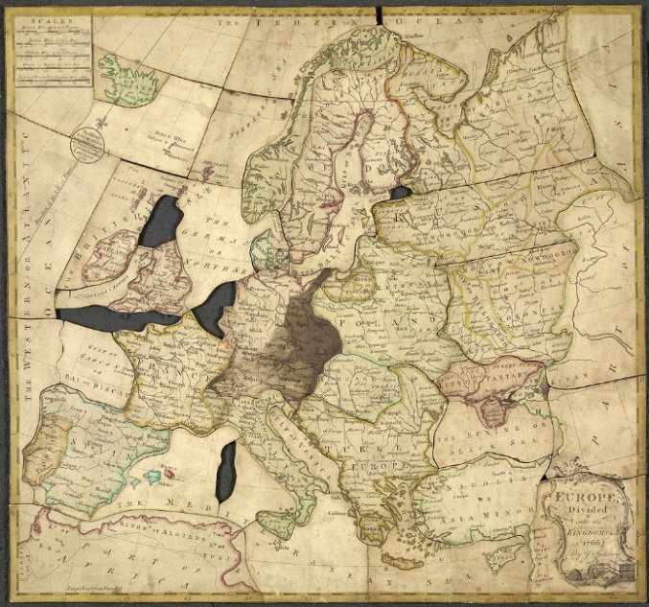
Jigsaws - The engraver and cartographer John Spilsbury, of London, is believed to have produced the first jigsaw puzzle around 1760. These early jigsaws were known as dissections. They were produced by mounting maps on sheets of hardwood and cutting along national boundaries, creating a puzzle useful for the teaching of geography.
Such "dissected maps" were used by the royal governess to teach the children of King George III and Queen Charlotte.

Europe divided into its kingdoms – John Spilsbury ¹
Jigsaw puzzles soared in popularity during the Great Depression of the 1930’s,
as they provided a cheap, long-lasting, recyclable form of entertainment.
It was around this time that jigsaws evolved to become more complex and more appealing to adults.
They were also given away in product promotions, and used in advertising, with customers completing an image of the product being promoted.
Very recently the demand for jigsaw puzzles again saw a surge when people were forced to stay at home during the 2020 coronavirus pandemic.
With thanks to https://en.wikipedia.org/wiki/Jigsaw_puzzle for information
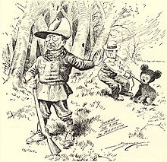
Teddy bears - Teddy bears became a new craze in the early 1900s. In November 1902 Theodore ‘Teddy’ Roosevelt, the President of the United States, had gone on a bear hunting trip to Mississippi. The President had failed to make a kill so his hosts caught and tied up a bear and told the President to shoot it. The President refused but following this incident Clifford Berryman drew a cartoon of the scene, which was published in the Washington Post newspaper.
“Drawing the Line” cartoon ²
The cartoon was seen by a Brooklyn businessman Morris Michtom and his wife Rose. They created a tiny soft toy bear cub and put it in their shop window with a sign "Teddy's bear", after sending a bear to Roosevelt and receiving permission to use his name. The toys were an immediate success.
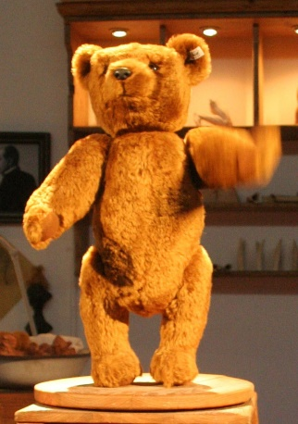
Meanwhile on the other side of the Atlantic in Germany, the Steiff Toy Company had produced a soft bear (Model 55PB) which they exhibited at the Leipzig Toy Fair in March 1903. Here it was seen by a buyer from New York who ordered 3,000 to be sent to America.
No original examples of the original Steiff bear model 55PB are known to have survived but many other models have been created since, all with their characteristic metal button in the ear. Steiff bears remain very popular today.
Photo of a replica Steiff bear model 55PB ³
With thanks to https://en.wikipedia.org/wiki/Teddy_bear#cite_note-5
for information
Lego - The Lego Group began in the workshop of Ole Kirk Christiansen, a carpenter from Billund, Denmark, who began making wooden toys in 1932. In 1934, his company came to be called "Lego", derived from the Danish phrase leg godt, which means "play well". In 1947, Lego expanded to begin producing plastic toys and in 1949 the company began producing an early version of the now familiar interlocking bricks, calling them "Automatic Binding Bricks".

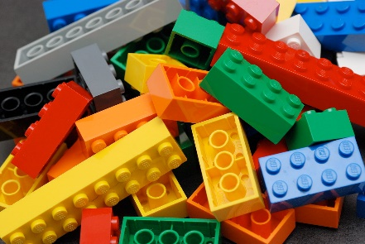
By 1954, Christiansen's son, Godtfred, had become the junior managing director of the Lego Group. It was his conversation with an overseas buyer that led to the idea of a toy system. Godtfred saw the immense potential in Lego bricks to become a system for creative play, but there were still some technical issues with the bricks and it took five years to find the right material. The modern Lego brick design was patented on 28 January 1958.
Lego bricks quickly caught on throughout Europe and in 1968 the first Legoland theme park opened in Billund. In 1969 the company started selling the Duplo range of larger bricks for young children. Nine years later Minifigures were introduced and soon there followed an increasing range of themed playsets. In the 21st century the company introduced electronic games and most recently LEGO films.
Lego coloured bricks ⁴
With thanks to https://en.wikipedia.org/wiki/History_of_Lego for information
Dolls - The earliest documented dolls date back to the ancient civilizations of Egypt, Greece and Rome. These first dolls were made from available materials such as clay, stone, wood, bone, ivory, leather or wax. Wooden dolls have been found in Egyptian tombs dating back to about 2000 BC whilst dolls with movable limbs and removable clothing date back to at least 200 BC.

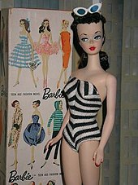
China dolls made wholly or partially of glazed porcelain became very popular in the 19th Century. Hard plastic dolls started to become popular in the 1940’s but it was the development of vinyl in the early 1950’s that had a major impact on doll production. Vinyl was very versatile because it could be a "soft" material (used for heads and limbs), or "hard" (used for the body). It also allowed for a major development in dolls’ hair which could be "rooted" into the head. Before this, dolls had worn wigs, or had their hair moulded into, or painted on their heads.

In March 1959, the American Toy Company Mattel launched its teenage fashion doll Barbie. The first Barbies wore a black and white zebra striped swimsuit and were available with either blonde or brunette hair. They were manufactured in Japan and their clothes were hand-stitched by Japanese homeworkers. Around 350,000 Barbies were sold during the first year of production. It is estimated that since 1959 over a billion Barbies have been sold worldwide in over 150 countries.
First edition of brunette Barbie doll, 1959 ⁵
With thanks to https://en.wikipedia.org/wiki/Doll#cite_note-Fraserpg7-1 and https://en.wikipedia.org/wiki/Barbie for information

Photographs and images with thanks to Wikipedia
¹ Europe divided into its kingdoms – John Spilsbury
https://en.wikipedia.org/wiki/Jigsaw_puzzle#/media/File:Spilsbury_jigsaw_-_John_Spilsbury,_1766_-_BL.jpg
From the British Library made available under the Creative Commons CCO 1.0 Universal Public Domain Dedication
² Drawing the line – Clifford K Berryman
https://commons.wikimedia.org/wiki/File:TheodoreRooseveltTeddyBear.jpg
Clifford K. Berryman / Public domain
³ Replica Steiff bear model 55PB displayed at the Steiff- Museum, Giengen, Germany, 2006
https://commons.wikimedia.org/w/index.php?curid=586388
MatthiasKabel / CC BY-SA http://creativecommons.org/licenses/by-sa/3.0/

⁴ Lego Colour Bricks Photograph by Alan Chia https://commons.wikimedia.org/w/index.php?curid=6068229

Alan Chia / CC BY-SA (https://creativecommons.org/licenses/by-sa/2.0)

⁵ First edition of brunette Barbie doll, 1959
https://en.wikipedia.org/wiki/File:MattelBarbieno1br.jpg

Licensed under the Creative Commons Attribution 3.0 License – Fair use under US Copyright Law

Toys and Games Crossword
 |  |  |  |  |  |  |  |  |  |  | ₁
 |  |  |  | ₂
 |  |  |  |  |  |  |  |  |  |  |  |  |  |  |  | ₃
 |  |  |  | ₄ |  |  | ₅
 |  |  | ₆
₇
 |  |  |  |  |  | ₈
 |  |  |  |  |  |  |  |  |  |  | ₉
 |  |  |  |  |  | ₁₀
 |  |  |  |  |  |  |  |  |  | ₁₁
 |  |  |  |  |  |  |  | ₁₂
ACROSS  2. 19th Century dolls often made of this (9)  6. First jigsaw was produced by this man  (4, 9)  8. Toy Fair held here in 1903 (7)  10. Location of first Lego Theme Park (7)  11. German Toy Company (6)  12. Country where Lego comes from (7) |  |  |  |  |  |  |  |  | DOWN  1. Company that makes Barbie (6)  3. English for "leg godt" (4,4)  4. Teddy Bears named after him (9)  5. Original name for jigsaws (11)  7. Barbie's hair could be this colour (6)  9. What you might find in a bear's ear (6)

Toys and Games Crossword Answers
 |  |  |  |  |  |  |  | 1 M
 |  | 2 P | O | R | C | E | L | A | I | N
 |  |  |  |  |  |  |  | T |  |  |  |  | 3 P
 |  | 4 R |  |  | 5 D |  |  | T |  |  |  |  | L
 |  | O |  |  | I |  |  | E |  |  |  |  | A
 | 6 J | O | H | N | S | P | I | L | S | B | U | R | Y
7 B |  | S |  |  | S |  |  |  |  |  |  |  | W
L |  | E |  | 8 L | E | I | P | Z | I | G |  |  | E
O |  | V |  |  | C |  |  |  |  |  |  |  | L
N |  | E |  |  | T |  |  | 9 B |  |  |  |  | L
D |  | L |  | 10 B | I | L | L | U | N | D
E |  | T |  |  | O |  |  | T
 |  |  |  |  | N |  | 11 S | T | E | I | F | F
 |  |  |  |  | S |  |  | O
 |  |  |  |  |  | 12 D | E | N | M | A | R | K

Across  2. 19th Century dolls were often made of this (9)  6. First jigsaw was produced by this man (4, 9)  8. Toy Fair held here in 1903 (7)  10. Location of first Lego Theme Park (7)  11. German Toy Company (6)  12. Country where Lego comes from (7) | Down  1. Company that makes Barbie dolls(6)  3. English for "leg godt" (4,4)  4. Teddy Bears are named after him (9)  5. Original name for jigsaws (11)  7. Barbie's hair could be this colour (6)  9. What you might find in a bear's ear (6)

Toys and Games Word Scramble
Here are twelve toys or games but they
have all been jumbled up. Can you unscramble them?
1. PMLOYOON __________________________________________
2. BBECALSR __________________________________________
3. NNSINPIG OTP ______________________________________
4. GPPKSIIN AMGES ____________________________________
5. TYEDD RBEA ________________________________________
6. LDLOS ESHUO _______________________________________
7. BASRMLE ___________________________________________
8. GAIPNYL RASDC _____________________________________
9. WOEDON RCSBKI ____________________________________
10. NHYBOR ANITR ETS __________________________________
11. OAAPNTTSLYI _______________________________________

12. TOFBOLLA __________________________________________

Toys and Games Word Scramble Answers

1. PMLOYOON Monopoly

2. BBECALSR Scrabble

3. NNSINPIG OTP Spinning Top

4. GPPKSIIN AMGES Skipping Games

5. TYEDD RBEA Teddy Bear

6. LDLOS ESHUO Dolls house

7. BASRMLE Marbles

8. GAIPNYL RASDC Playing Cards

9. WOEDON RCSBKI Wooden bricks

10. NHYBOR ANITR ETS Hornby Train Set

11. OAAPNTTSLYI PlayStation

12. TOFBOLLA Football

